Home Learning Plans
Willow Class
Week Beginning: Monday 6th July 2020

Dear Willow Class parents/carers and children,

The core learning for this week is set out below.

Reading

- All children should read an age appropriate text for a minimum of 20 minutes per day. This can be a reading book or sharing a picture book with an adult. When completing guided or supported reading of an age appropriate text, focus on factual questioning. Use the factual section of this questioning tool to generate questions that challenge your child to recall what has happened in the story.
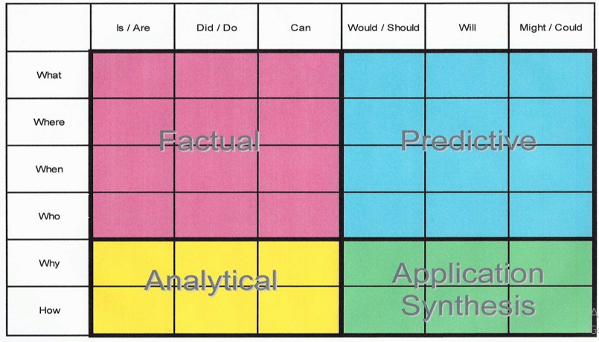
For example:
-When did the character go to the shops?
-What did they do next?
-Who is in the shop?
-Where are the characters going?

- You can also visit the Oxford Owl website. https://www.oxfordowl.co.uk/
Username: willow101
Password: pupil

Phonics
This week’s phonics work will concentrates on alternative spellings for the ‘oo’ and ‘yoo’ sounds.

Below are some activities that you could use for phonics/spellings. Remember, each day you can continue to explore the letter sounds by using chalks, magnetic letters, playdough or you could write them in flour, sand or with a pencil. You could play a game of “snap” or “pairs” with the sounds you have learnt so far.
Monday | Tuesday | Wednesday | Thursday | Friday
Teach alternative spelling of /yoo/ = ‘u-e’  https://www.youtube.com/watch?v=CQXnqp8g9WM  Practise reading words: use, muse, duke, value, cube, tune  Colour ‘oo’ sounds | Teach alternative spelling of /oo/ = ‘u-e’  Practise reading words: flute, spruce, plume, rule, rude, brute  Matching cards activity | Teach alternative spelling of /yoo/ = ‘ue’  https://www.youtube.com/watch?v=JtbWNyyctzU  Practise reading words: cue, venue, rescue, due, hue  Roll and Read activity | Teach alternative spelling of /oo/ = ‘ue’  Practise reading words: clue, blue, true, flue, issue  Matching cards activity | Teach alternative spelling of /yoo/ = ‘ew’ p155  Practise reading words: stew, few, new, nephew, renew  Alternative spelling sheet

Writing
This week please continue completing activities from the Talk for Writing pack about Brian Bear’s Picnic. You could:

- Write an invitation to a picnic. Remember to include the time, place and what people need to bring. You could include a map of where to go.
- Write a thank you letter to Gertie, Bertha and Curtis from one of the groups of animals. There is a sample one in the pack. Do not forget to include capital letters at the start of each sentence and punctuation at the end of each sentence.
- Write a postcard to Brian Bear from Gertie, Bertha and. There is a sample one in the pack. Do not forget to include capital letters at the start of each sentence and punctuation at the end of each sentence.
- Write a recipe for your favourite picnic snack. Remember to include what you need and what to do. There is a recipe for teddy bear toast in the pack.
- Imagine you are taking a walk in Friary Wood. What would you collect to remember you of the walk in the woods? Can you use exciting adjectives to describe them?
Maths:
This week we are revisiting finding a half and a quarter of shapes are objects. There are some activity sheets and video links included with this pack.
Lesson 1 - Finding a half of a shape
https://vimeo.com/434744785
Lesson 2 - Finding a quarter of a group of objects
https://vimeo.com/434744785
Lesson 3 - Finding a quarter of a shape
https://vimeo.com/434745167
Lesson 4 - Finding a quarter of a group of objects
https://vimeo.com/434745348

Wider Curriculum
Please pick activities of your choice from the wider curriculum matrix included in last week’s pack.

