Week 3 – Saying thank you – why does it matter?

Look carefully at these images. They both are illustrations of the same Bible story.
- What do you notice?
- Who do you think the people in the image are?
- What do you think is happening?
- What do you wonder about the image?
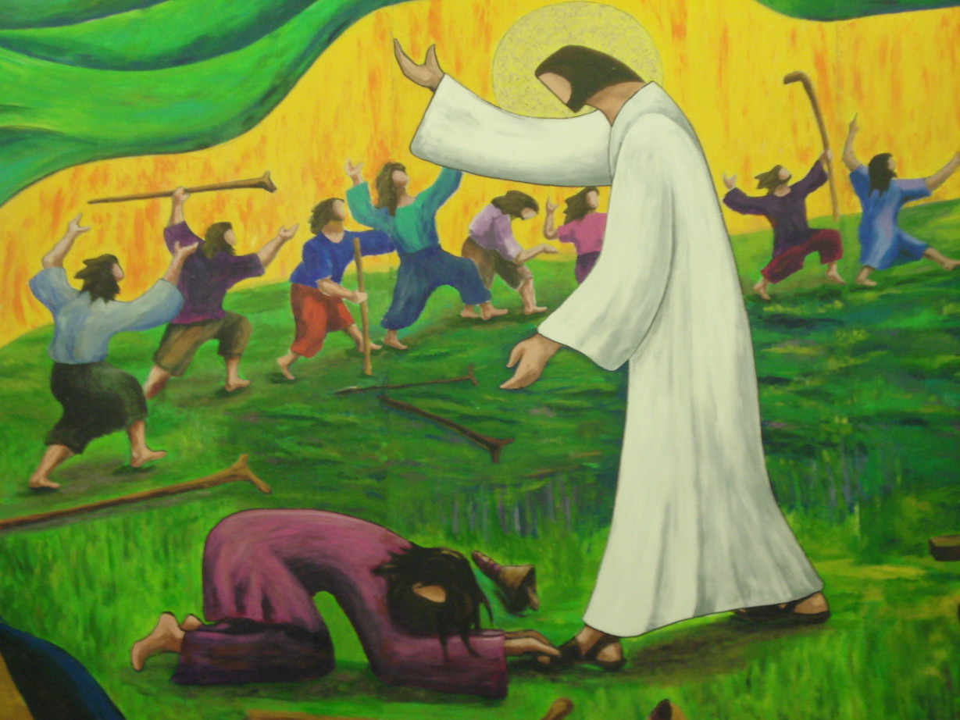

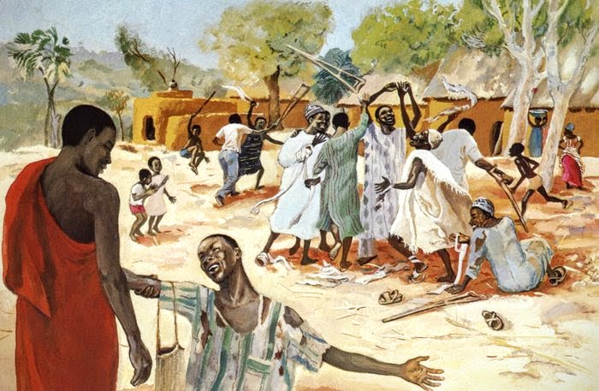

The Bible story today is a recount of an event of when Jesus healed 10 men who had leprosy. This story can be found in the book of Luke in the New Testament of the Bible.
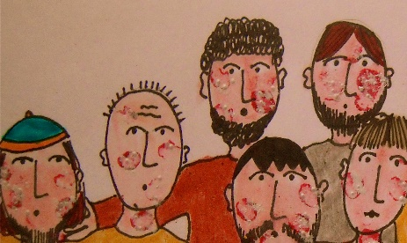
Leprosy, or Hansen disease, is a disease of the skin and nerves. In advanced cases, the disease disfigures the body, or ruins its normal appearance.
In Bible times, those suffering from the disease used to be called lepers and were often separated from the rest of society, living away from their families, on the outskirts of the towns or villages to prevent other people from catching it. People believed it was highly infectious, so wouldn’t touch or go near people out of fear of becoming infected themselves. There were no cures for Leprosy in Bible times, so those suffering lived a miserable, painful life unable to work or spend time with their families. Those few who did get better had to prove they were free of Leprosy by being checked by the Temple Priest. It is actually quite hard to catch leprosy from someone else. Today, there are very few cases of leprosy as it can be treated effectively with antibiotics.
Read the story from the Bible.

Luke 17: 11-19
Be Thankful
While Jesus was on his way to Jerusalem, he was going through the area between Samaria and Galilee. As he came into a small town, ten men who had a skin disease called Leprosy met him there. They did not come close to Jesus but called to him, “Jesus! Master! Have mercy on us!”
When Jesus saw the men, he said, “Go and show yourselves to the priests.”
As the ten men were going, they were healed. When one of them saw that he was healed, he went back to Jesus, praising God in a loud voice. Then he bowed down at Jesus’ feet and thanked him. (And this man was a Samaritan.) Jesus said, “Weren’t ten men healed? Where are the other nine? Is this Samaritan the only one who came back to thank God?” Then Jesus said to him, “Stand up and go on your way. You were healed because you believed.”

- Why do you think Jesus healed the men?
- What difference do you think being healed had on the men?
- How do you think Jesus felt when only one man came back to say thank you?

Add speech bubbles and thought bubbles to this image of Jesus healing the 10 men of leprosy.
What are the characters in the story thinking/ feeling and saying?
thought

speech
e
speech

Thinking about the things you have thought about and read in this lesson –
- Why is it important to say thank you?

