Re-read or listen again to Chapters 1 and 2 of Matilda. Collect words and phrases that Roald Dahl uses to describe Matilda and add them to this mind-map.

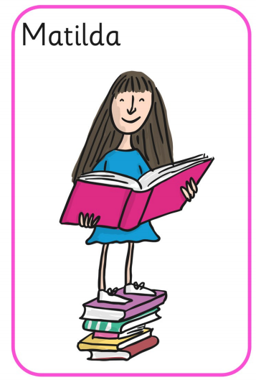

Extension: Add your own words and phrases that you would use to describe Matilda.

