Home Learning Plans
Willow Class
Week Beginning: Monday 30th March
Dear Willow Class parents/carers and children,
The core learning for this week is set out below.
Reading:
Continue reading daily – choose any stories from home and read them together. Talk about what you have read – retell the story. What did you like? What didn’t you like? Can you draw a picture of your favourite story? Can you make your own book?
All children should read an age appropriate text for a minimum of 20 minutes per day. This can be a reading book or sharing a picture book with an adult. When completing guided or supported reading of an age appropriate text, focus on predictive questioning. Use the predictive section of this questioning tool to generate questions that challenge your child to consider what may happen next in the story.

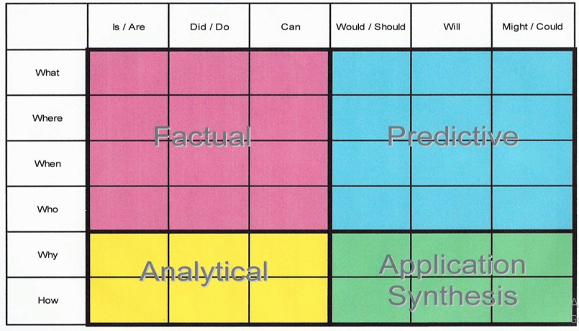
For example: What might happen next? Who could come with them? Where should they go?
I have included a story and some reading comprehension questions with this letter. There are 3 levels of questions included for you to try.
You can continue using the online resources I suggested last week such as https://connect.collins.co.uk/school/Portal.aspx
Click on the Teacher portal and enter
Username parents@harpercollins.co.uk
Password Parents20!
And click Login
Explore the different book banks and choose books which are right for you. The pink book bands are the most simple and the lime the most complex. If you want to study a book in more detail, click on the resources section for detailed notes on how to do so.

Spelling/Phonics
Log on to Purple Mash and complete the spelling ‘2Dos’ which have been selected for you for letter sound ‘ay’ and ‘oy’ There is also a ‘ea’ wordsearch in this week’s pack that you could use.
Below is a suggested format that you could use for phonics although there is no obligation to complete all the activities:
‘ay’ sound: Play flash cards/speed trial on phonics play phase 5a (https://www.phonicsplay.co.uk/ Username:march20 Password:home). Talk about the ‘ay’ sound. Can you say the sound? Can you write the sound? You could use chalks, glitter, make it out of playdoh, write it in flour, use magnetic letters. Can you write some words with these sounds in? Hide the word around the house. Can you find it? Can your child read these real and nonsense words with the sound in it: Real words- spray, play, delay, crayon, tray, may, stray. Nonsense words- scray, thinay, thray, chay. Can you write the real words in a sentence using a capital letter and full stop?
‘oy’ sound: Start off by practising reading a mix of sounds. Play flash cards/speed trial on phonics play phase 5a. Talk about the ‘oy’. Can you say the sound? Can you write the sound? You could use chalks, pens, write it in flour, use magnetic letters. Can you write some words with these sounds in? Hide the word around the house. Can you find it? Can your child read these real and nonsense words with the sound in it: Real- boy, toy, enjoy, annoy, royal, voyage, oyster. Nonsense- gloy, denoy, floy, zoy, scroy, broy, foyat, Can you write the real words in a sentence using a capital letter and full stop? Can you play dragons den on phonics play, phase 5a games.
‘ea’ sound: Can you read the tricky words? What sound do the grapheme ‘ea’ make when they are together? Can your child read these real and nonsense words with the sound in it: Real- repeat, beach, beast, feast, meat, stream, least, steam Nonsense- sheal, meask, blean, releat, sweast, yeak Can you write the real words in a sentence using a capital letter and full stop? Can you make one into a question ? or an exclamation ! Can you find the ‘ea’ words in the wordsearch?
Writing: This week there are several activities you could try:
- Write a postcard about Traction Man’s adventures to someone (template with the pack). Can you remember where the address goes? Read the modelled postcard that has been sent out with this set of plans. Use this model to help you write your own postcard. Try to follow the same structure (address of the recipient on the right hand side, the name of who you are writing to on the left hand side, details of what Traction Man has been doing and who the postcard is from). You can write your postcard to whoever you like.
- Have a go at writing another postcard to a friend telling them what you have been doing.
- Look out the window and find some signs of spring. Can you write some sentences? – ‘I can see...’ Try to use some descriptive words.
- Write a shopping list for your family. Can you put the shopping list in alphabetical order?
- Plan another story on Purple Mash. I enjoyed looking at the ones you did last week.
- Use the handwriting sheets to practise your cursive letter formation.
- If you do one of the writing tasks, why not email it to the class email address willow@st-barnabas.kent.sch.uk so I can read it.
Maths: This week we are learning about length and height. Remember to use the maths vocabulary longer (length), shorter (height & length) and taller (height). Below are some activities you could try:
Activity 1: Can you measure some things in your house using different objects? (e.g. Lego bricks, straws, spoons, felt tips etc). Record your measuring in one of your exercise books. Have a go at estimating how many objects you will use before you start measuring.
Activity 2: Can you try using a ruler or tape measure to measure things around the house? Record your measuring in one of your exercise books. Make sure you have a go at estimating first.
Activity 3: Choose a cuddly toy. Can you make a collection of things longer or shorter or the same length as your toy? Take a photo of your collections and send Mrs Pring a picture to the class email address (willow@st-barnabas.kent.sch.uk).
Activity 4: Can you draw around your hand and measure how long objects are with your hand span e.g. length of your bed or a cushion.
You could also complete the introduction to length activities on Maths with Parents - class code 193691 https://www.mathswithparents.com/KWeb
In this week’s pack, I have also included some sheets on length that you could talk through.
Number Fluency
Log on to My Maths and complete the homework and lessons which have been selected for you.
You could also practise finding number pairs for 10 and 20. e.g. 4 + 6 = 10 14 + 6 =20 and investigate how many different ways you can make the numbers below 20 e.g. 1+7=8, 2+6=8, 3+5=8, 4+4=8, 8+0=8.
Wider Curriculum
Please pick activities of your choice from the Wider Curriculum Home Learning Matrix which you were sent last week as it provides a fortnight of activities.
BBC Super Movers for KS1 – has lots of active videos that reinforce Maths and English skills. Children could also develop their fine motor skills by doing jigsaw pictures, threading beads or pasta onto dry spaghetti or string or having a go at Dough Disco (playdough) on YouTube. I have attached a list of other useful websites.
My best wishes to you and your family. I am hoping that we can see each other again soon.
Mrs Pring

