Here are the skills that I focussed on:

I can use subheadings to organise my ideas.
I can start sentences with adverbials which express time.
I can use conjunctions to add clauses to my sentences.
I can use adjectives to create expanded noun phrases.
I can use exclamation sentences.
I can include sentences which communicate directly to the reader.

A Trip to Scotland
The day after we finished building the shed, my wife, baby Alfred and I went on a trip to Scotland. First of all, we got the train into London and got the underground to Euston train station. It was really good fun because Alfred had never been on a train before. The station was big, busy and exciting.
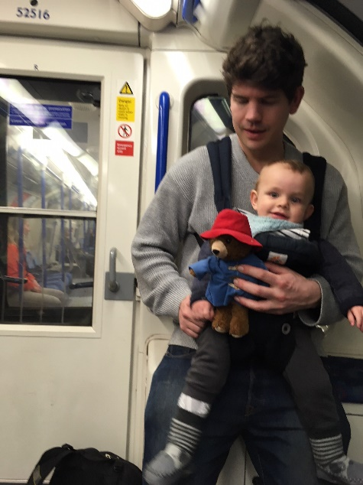
At 9pm, we got on the sleeper train. The carriage was tiny and cramped but we all managed to fit in. Alfred was very tired because it was past his bedtime so we all went to sleep straight away.
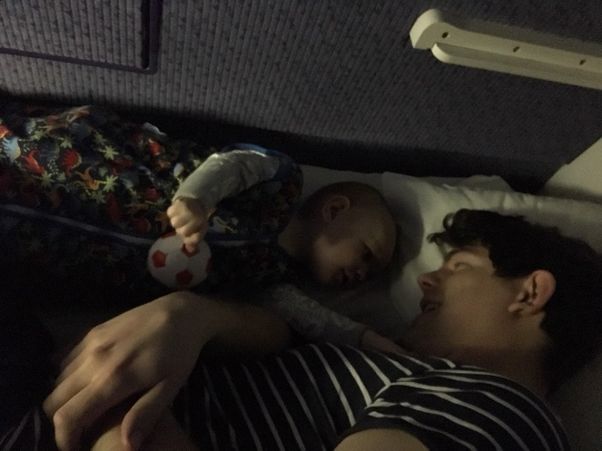
The next day, we woke up at sunrise and realised that we were in the snowy highlands of Scotland. When we were all dressed and ready, we went to the dining car and ate delicious bacon sandwiches for breakfast. The views were amazing!
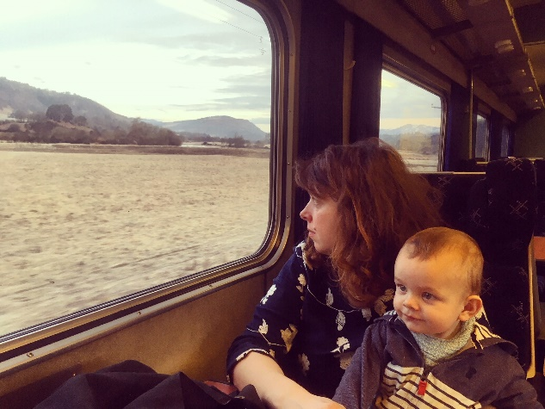
As soon as we arrived in Scotland, we travelled to my auntie’s house. Fred loved meeting her because she read lots of stories to him.
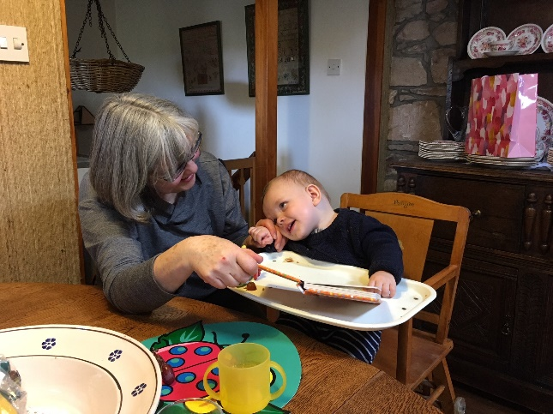
During our trip to Scotland, we did some really interesting activities. We visited Loch Ness but we didn’t see the monster. We went to the beautiful, sandy beach and played with a football. One day, we even go to make a snowman because it snowed so much!
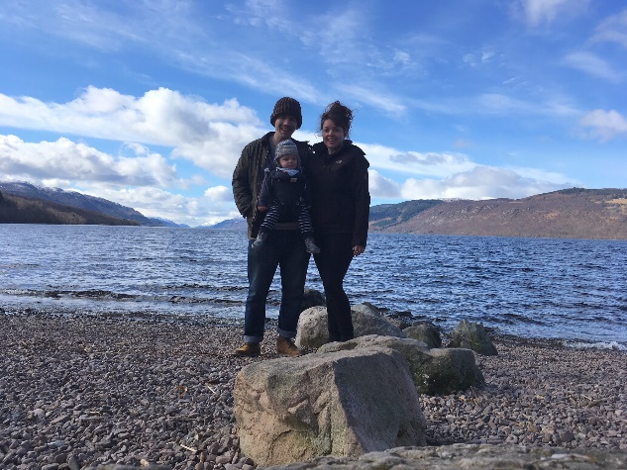

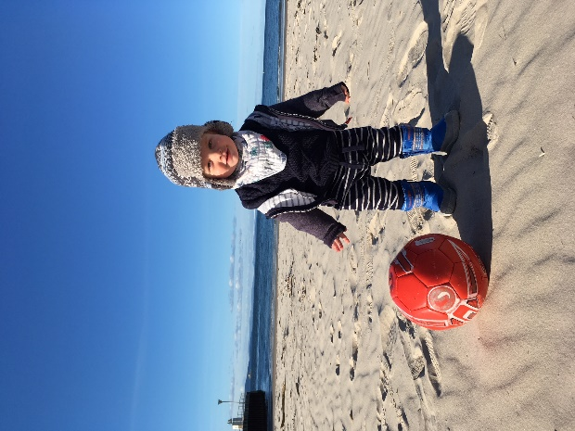 | 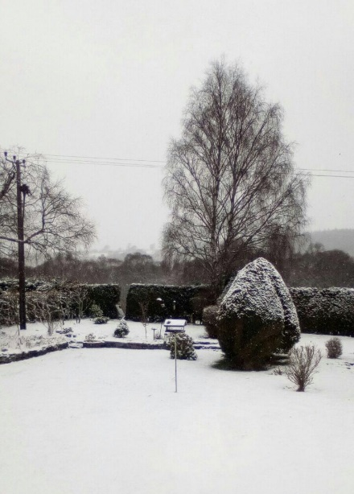
Finally, we flew back home. It was Alfred’s first time on an aeroplane so we were a bit nervous but he really enjoyed it.
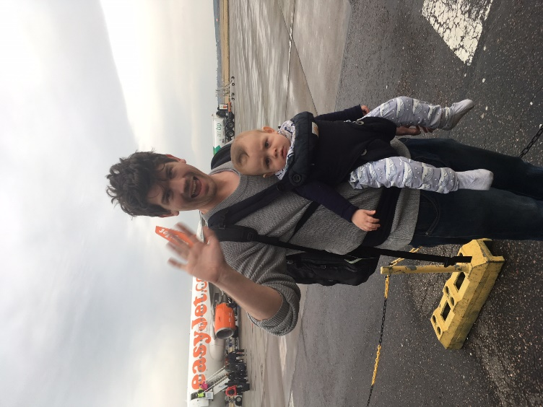
What a fantastic trip it was! Have you ever been on a really interesting trip? Could you write a recount of your experiences?

