MAKING A WHOLE FROM DECIMALS - REASONING

Refresh your memory by asking yourself these questions:

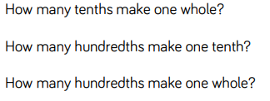

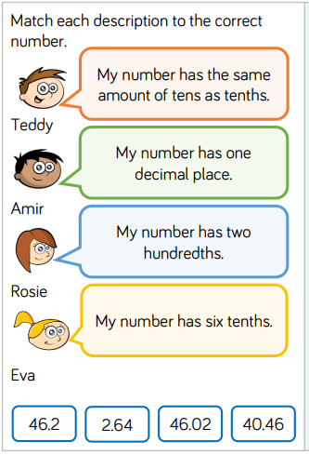

USE YOUR UNDERSTANDING OF MAKING A WHOLE TO TACKLE THESE REASONING TASKS!

