This month would be the 204th Birthday of the famous scientist Charles Darwin. So all of you Friday challenges are inspired by the work of Charles Darwin.
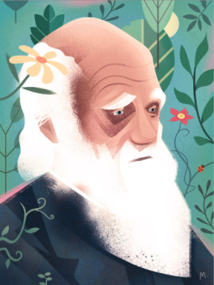
Charles Darwin travelled all over the world in his boat, The Beagle.
For your Friday Challenges this week, we have been inspired by the work of Charles Darwin and would like for you to follow in his footsteps.
Here are the activities that you can choose from:

Wonderful Worms!
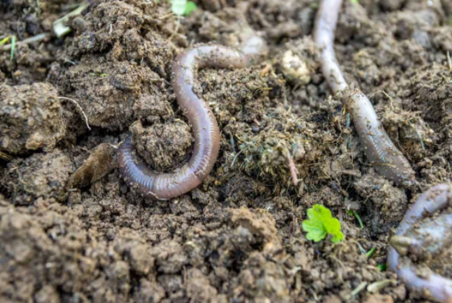
When Charles Darwin wasn’t voyaging around the world on his boat, The Beagle, you may well have found him in his garden looking for worms. Darwin became obsessed with earthworms. He decided to count how many were in his garden then moved most of them into his study to investigate them. Here is how you can follow in his footsteps:
Step 1: Catch a Worm
Worm charmers have many techniques to coax worms out of their burrows, including dancing on the ground to create vibrations. Try some different techniques to charm the worms in your garden or in the park. What is the most effective technique?
Step 2: Draw Like Darwin
The secret to Darwin’s success as a scientist was his use of careful observation and the detailed records he kept of his findings. Here is an example of one of Darwin’s sketches of a worm:
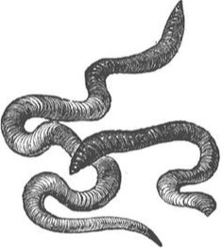

Step 3: Let’s Investigate
Charles Darwin noticed that the soil in some areas of his garden seemed to contain more worms than others. Use your worm charming technique in various different locations around your garden and/or park. Are some types of soil more likely to have worms in? Can you use graphs or charts to present your findings?

Clever Camouflage
Darwin found out that animals that were able to hide really well were more difficult to catch and were more likely to survive. These animals were then able to pass these characteristics onto the next generation.
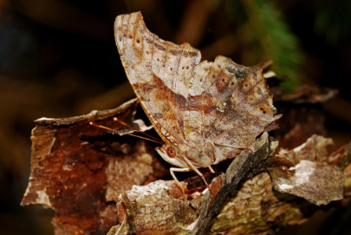
You can follow in Darwin’s footsteps and find out for yourself how important camouflage is by completing this activity.
Step 1: Lay out pieces of newspaper across an entire table or surface.
Step 2: Cut out 10 identical butterflies from newspaper.
Step 3: Cut out 10 identical butterflied in bright coloured paper.
Step 4: Place all 20 butterflies on the newspaper covered surface and cover them with a blanket or sheet.
Step 5: Get another member of your family to act as a predator. Uncover the butterflies and challenge your family member to see how many butterflies they can catch in 10 seconds.
Step 6: Count up the butterflies. How many did they catch up altogether? How many newspaper butterflies? How many bright butterflies?
Step 7: Repeat this investigation several times with different members of your family. What do you notice about your results? Did you spot any patterns? Can you explain why your results happened?

Darwin’s Finches
Darwin discovered creatures were more likely to survive if they were well suited to their environment. He discovered this by closely looking at the beaks of finches. Here are some sketches that he made:
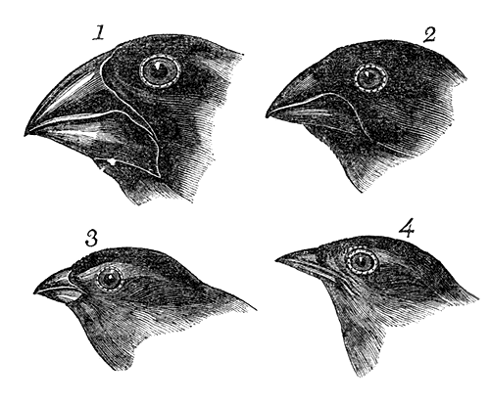
You can follow in his footsteps and find out for yourself why the size and shape of beaks is important by completing this activity:
You will need
-Different sized seeds/beans or pasta – pumpkins seeds, sunflower seeds and flax seed are good choices. Small toy insects are also fun to try. (this is to represent the food)
-Different sized pairs of tweezers or scoopers (this is to represent the beaks)
-Pots
-A stop watch
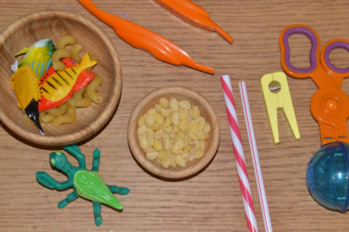
Step 1. Pick a scoop or pair of tweezers
Step 2: Set yourself a time limit- 30 seconds for example. See how many of each item you can pick up and put in a pot.
Step 3: Repeat this activity with all the different scoops and tweezers.
Step 4: Think of a way of recording your results and presenting your findings.
Now it’s time to draw a conclusion. Imagine that each different tweezer or scoop was the beak of a bird. Which of these birds do you think would be able to get the most food and be most likely to survive?
Extension: Design a bird with a beak shaped like the most successful scoop or tweezer.

