Making a Times Tables Numberline

Here are the steps you need to make a times tables number line which will help you learn your 2,5 and 10 times tables.

Step 1: Cut out 12 pieces of card.
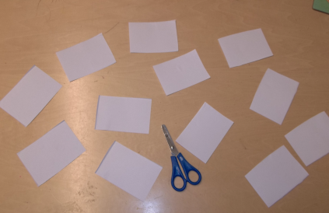

Step 2: Start with the 2x table. Write the multiples of 2 on one side of each piece the card. Here is what it should look like:
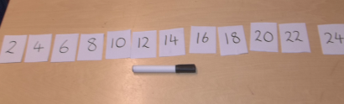

Step 3: Flip all the cards over and record the number of multiples represented on each card. e.g. For the 2 card, write 1x. For the 8 card, write 4x. Here is what it should look like:
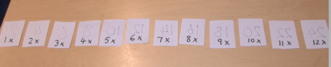

Easier Skill: To count forwards and backwards in multiple of 2, 5 and 10.

Set out your cards as shown in step 2. Practise counting forwards and backwards in multiples of 2. As you become more fluent, you can start to cover the cards up.

Harder Skill: To quickly recall multiplication facts for the 2, 5 and 10 times tables.

Set out the cards as shown in step 3. Pick a card and read out the number of multiples. e.g. 7x2 Then flip over the card and read out the product of this calculation e.g. = 14. Repeat with all the different cards as many times as possible. As you become more fluent, you can start saying the product before you flip over the card.

Once you have mastered your 2x table, you can repeat each step for the 5x tables and 10x tables.

