Beech Class Home Work
(Due in Monday 26th September)
This week in our Phonics lessons, we are revisiting Level 4 consonant blends (like the ones in the grid below).
Activity 1: Practise your sounding out skills by randomly connecting a consonant blend with the parts of the words labelled 1 to 8. Can you create any interesting ‘alien’ words?
e.g. grop
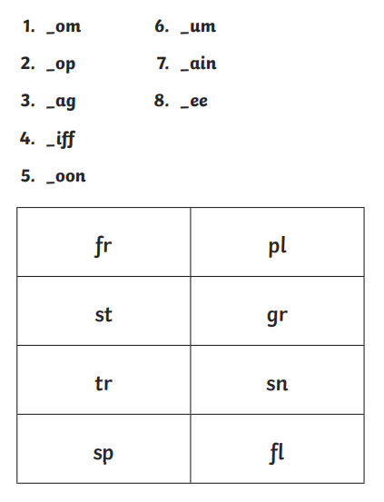
Activity 2: Now use the consonant blends to create 8 real words.
e.g. 1. from

EXTENSION: Now you have created 8 real words. Can you use these words to create 3 sentences?
e.g. He sat on a train.
TOP TIP: Don’t forget to use capital letters and full stops.

