Home Learning Plans
Lilac Class
Week Beginning: Monday 29th June
Reading:
- Carry on with your daily independent reading.
- If you want to enter the writing competition about your experience of Lockdown remember you need to submit your entry by Friday 17th July

- Our new whole class reading text is Shackleton’s Journey by William Grill. This is a true story about an expedition crossing Antarctica from one pole to the other. Read pages 13-24 of and answer the comprehension questions. I have also recorded me reading the pages to you so you can follow the text Learning Video: Reading pages 13-24 from Shackleton’s Journey. Re-read the text again and occasionally stop and ask your child what they think the meaning of a tricky word could be, looking at the context of the sentence. As with Street Child, most of the questions are open ended and there may be several answers to the questions. The purpose of the exercise is to develop reading comprehension skills and to discuss the text – that is why I have not given you an answer sheet.

If you have not so, please sign up for this year’s Summer Reading Challenge. It started on Friday 5th of June and runs throughout the summer holidays, finishing at the end of September. It is aimed at children aged 4 – 11 and is completely free! The challenge features games, quizzes and downloadable activities to incentivise and encourage children and their families to take part in reading related activities at home. Children can choose their own reading goals, create book reviews, play games and collect virtual rewards. Parents and guardians can register their children online at www.sillysquad.org.uk Please see attached information.

- Visit the Oxford Owl website. https://www.oxfordowl.co.uk/ Click on the My Class Login section
Use the following details to log in to the newly created Lilac Class section.
Username: lilac101
Password: pupil
Click on the ‘My Bookshelf’ section and select reading books that are right for you. Use the ‘Age Groups’ section to help narrow down the search.
- When completing guided or supported reading of an age appropriate text, focus on analytical questioning. Use the analytical section of this questioning tool to generate questions that challenge your child to analyse what has happened in the story.
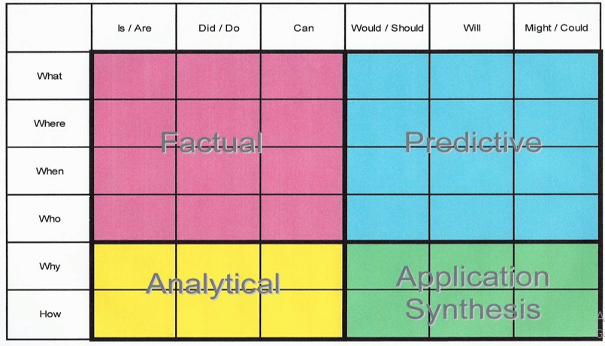
For example:
-Why did they do that?
-How can you tell that…?

Spelling, Punctuation and Grammar:
- On Purple Mash I have set the following ‘2Dos’: I think it’s your birthday – Apostrophes; Bella on the Farm – Expressing time, place and cause using prepositions; Flora’s Trouble – Use of semi-colons, colons and dashes.
- This week I would like to create your own sentences using apostrophes, semi-colons, colons and dashes correctly.
Writing:
- LO: To draft a non-chronological report using sub-headings. I would like you to now draft a non-chronological report about Henderson Island in the South Pacific Ocean. To recap, a non-chronological report is a non-fiction text which gives information on a particular subject without referring to the order in which things happen. Revisit the Newsround Video about Henderson Island https://www.bbc.co.uk/newsround/39921749. Re-read your notes and look at your planning sheet. Also look again at my planning notes. Now start to write your report using sub-headings. Give your report a title. Remember the use of sentence openers and fronted adverbials to hook the reader in.

Maths: This week we are learning to add and subtract decimals with the same and different decimal places.
Watch my learning video - LO: To add and subtract decimals with different decimal places.
- I have given you Classroom Secrets worksheets with answers about adding decimals with the same decimal places using pictorial representations. I have also given you a selection of other worksheets about decimals: Adding and Subtracting Decimals 1; Adding and Subtracting Decimals 2; Decimal Place Value Challenge. I have included some Varied Fluency and Reasoning and Problem Solving sheets to do from White Rose if you want some extension work!
- Complete your new Maths with Parents activity that is column subtraction with decimals. Class code is 48372.

- Number Fluency and Revision: I have set you a MyMaths Activity - estimates with decimals.

- Wider Curriculum: Pick activities from the Wider Curriculum Learning Matrix. The new Wider Curriculum Learning Matrix contains activities for the rest of the term.

- I have will no longer attach my regular Homework sheet that your child would normally receive every Thursday as we have covered all the spelling patterns and words from the Year 5/6 Spelling List.

- PLEASE SEND ME ANY WORK YOU WOULD LIKE ME TO SEE OR YOU WOULD LIKE PUT ON OUR CLASS BLOG.

