Challenge 5: Tug of War
Here is a game for two players.
You will need a counter (or something similar), paper and two 1-6 dice.

How to play:
Draw a number line on paper like this and place the counter on the number 14 (the red circle in the picture represents the counter):
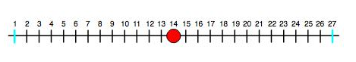
One player is called 'Plus' and the other is called 'Minus'. Decide who is who.
Plus moves the counter from left to right and Minus moves the counter from right to left.
Take it in turns to throw the two dice and add up the two numbers.
Move the counter that number of places in your direction.
If the counter reaches 1, Minus has won and so, of course if the counter reaches 27, Plus has won.

Once you have got used to the game, you might like to make some changes. You can decide. Perhaps you might have one counter each and see who gets to their end first; perhaps you might find the difference between the two numbers on the dice; perhaps you might use three dice; perhaps you might use one dice and a shorter line...
When you've changed the rules you can talk about whether or not your change makes the game better to play.

