Home Learning Plans
Willow Class
Week Beginning: Monday 20th April 2020
Dear Willow Class parents/carers and children,
The core learning for this week is set out below.
Reading:
- Visit the Oxford Owl website. https://www.oxfordowl.co.uk/ Click on the My Class Login section
Use the following details to log in to the newly created Willow Class section.
Username: willowclass101
Password: pupil
Click on the ‘My Bookshelf’ section and select reading books that are right for you. Use the ‘Age Groups’ section to help narrow down the search.

- All children should read an age appropriate text for a minimum of 20 minutes per day. This can be a reading book or sharing a picture book with an adult. When completing guided or supported reading of an age appropriate text, focus on analytical questioning. Use the analytical section of this questioning tool to generate questions that challenge your child to analyse what has happened in the story.

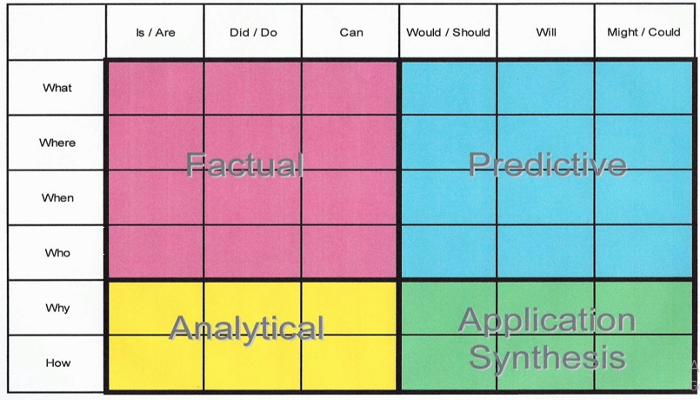
For example:
-Why did they do that?
-How can you tell that…?
I have included a fact sheet about bats and some reading comprehension questions with this letter
Spelling/Phonics
Log on to Purple Mash and complete the spelling ‘2Dos’ which have been selected for you for the letter sounds ‘ue’, ‘ew’, ’wh’ and ‘ph’.
Below is a suggested format that you could use for phonics although there is no obligation to complete all the activities:
‘ue’ sound: Play flash cards/speed trial on Phonics Play phase 5a (https://www.phonicsplay.co.uk/ Username:march20 Password:home). Talk about the ‘ue’ sound. Can you say the sound? Can you write the sound? You could use chalks, glitter, make it out of playdoh, write it in flour, use magnetic letters. Can you write some words with the sound in? Hide the word around the house. Can you find it? Can you read these words that have the sound in them: clue, blue, issue, true, glue, Sue. Can you write a sentence using some ‘ue’ words and including a capital letter and full stop?
‘ew’ sound: Start off by practising reading some tricky words on Phonics Play tricky word trucks. Talk about the ‘ew’ sound. Can you say the sound? Can you write the sound? You could use chalks, pens, write it in flour, use magnetic letters. Can you write some words with the sound in? Hide the word around the house. Can you find it? Can you read these words that have the sound in them: blew, chew, grew, drew, screw, crew. Play Dragons’ Den on Phonics Play to practise reading words.
‘wh’ sound: Play flash cards/speed trial on Phonics Play phase 5a (https://www.phonicsplay.co.uk/ Username:march20 Password:home). What sound do the graphemes ‘wh’ make when they are together? Talk about the difference between this and ‘w’. ‘wh’ always comes at the start of the word. ‘w’ can come at start, middle or end. Can you read these words that have the sound in them: whisper, where, what. Can you spell these words: when, which, wheel. Can you use some ‘wh’ words in a sentence using a capital letter and full stop? Can you make one into a question ? or an exclamation !
‘ph’ sound: Can you read the tricky words? Start off by practising reading some tricky words on Phonics Play tricky word trucks. Compare ‘ph’ to ‘f’. Can you read these words that have the sound in them: dolphin, alphabet, elephant. Can you sound out and spell: phonics, phantom, Philip. Can you write the tricky words ‘some’ and ‘come’.
Writing: This week we are moving onto a new topic. I have enclosed some extracts from The Great Explorer by Chris Judge about a boy’s adventure looking for his dad. There are several activities you could try:
- Pretend to be Tom and write a diary entry (or two) from the North Pole. Remember to write in the past tense because the things you are describing have already happened. Remember to describe what he saw, heard and felt.
- Plan a story about what might happen next in Tom’s adventure using Purple Mash. I enjoyed looking at the ones you did previously.
- Write the rest of the story of Tom’s adventure. Remember to write in sentences using a capital letter to start each sentence and a full stop or an exclamation mark at the end of each sentence. Remember to put a finger space between each word.
- If you do one of the writing tasks, why not email it to the class email address willow@st-barnabas.kent.sch.uk so I can read it.
Maths:
This week we are learning about counting in 10s and finding and adding equal groups as we move towards learning about multiplication and division. There are 4 worksheets attached from the White Rose Home learning pack for you to complete.
Activity 1: Lesson 2: Counting in 10s
Activity 2: Lesson 3: Make equal groups
Activity 3: Lesson 4: Add equal groups
Activity 4: Lesson 5: Make arrays
The White Rose website also has instructional videos which can be found in Week 2 by following this link:
https://whiterosemaths.com/homelearning/year-1/
You could also complete the array activities and multiplication by repeated addition activities on Maths with Parents - class code 193691 https://www.mathswithparents.com/KWeb
In this week’s pack, I have also included some sheets on length that you could talk through.
Number Fluency
Log on to My Maths and complete the homework and lessons which have been selected for you.
You could continue practising finding number pairs for 10 and 20. e.g. 4 + 6 = 10, 14 + 6 =20 and investigate how many different ways you can make the numbers below 20 e.g. 1+7=8, 2+6=8, 3+5=8, 4+4=8, 8+0=8 and counting in 2s, 5s and 10s.
Wider Curriculum
Please pick activities of your choice from the Wider Curriculum Home Learning Matrix which is with this letter. It provides a fortnight of activities.
Don’t forget to share pictures of your completed work with me or any other activities you have been doing. My email is: willow@st-barnabas.kent.sch.uk

Best wishes and stay safe.

Mrs Pring

