Wider Curriculum Home Learning Matrix: Class (2 Weeks)
Weeks Beginning: 20th April and 27th April
This week, Beech Class are beginning a new topic entitled ‘At Home and Abroad’. This topic focuses on a study of two contrasting locations- Tunbridge Wells and Ho Chi Minh City. As part of this topic, we will explore the plant and animal life of our locality. We will use maps and atlases to locate these two locations and develop the geographical vocabulary required to describe them. We will used rainfall and temperature data to compare and contrast their climate and create information texts explaining our findings. We will be introduced to some of the residents of Ho Chi Minh City and write letters to these new pen-pals. Finally, we will explore the art, culture and cuisine of Vietnam.
 | Create | Investigate | Explain | Perform
Science and Computing | Create your own surrealist picture using Purple Mash, 2Paint a picture – eCollage.  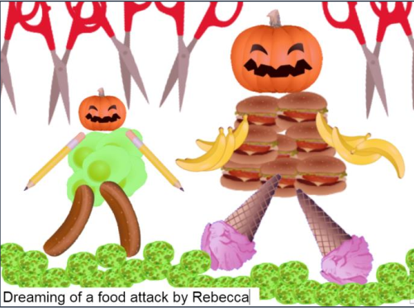 | On Purple Mash, 2Paint a picture– eCollage.  Investigate the different features– combining picture from clipart or your own computer/ undo/ stamping effects. | Write a set of instructions explaining to someone how to create a piece of surrealist art using 2Paint a picture on Purple Mash | Can you teach a member of your family how to create their own surrealist picture using the computer?
Time and Place | Create a map of your immediate local environment. Use google maps to explore what your immediate surroundings look like from above. Consider the use of a key to add information about significant locations in your locality. Consider using grid lines and references to make the information on your map easier to interpret. | Type in ‘An Phu, District 2, Ho Chi Minh City, Vietnam’ into google maps. Find the Imperia An Phu Apartments. This is where Mr M used to live. Explore the area around the apartments to find out what it is like to live in Ho Chi Minh City. If you have any questions about living in Ho Chi Minh City, email them to Mr M via the class email address. | Explain the similarities and differences that you have identified form examining your own locality compared to Ho Chi Minh City. Present your ideas however you want. You could create a set of bullet points or a mind map. It is up to you! | Find your house on goggle maps and enter street view. Pick a nearby location that you know really well and give a family member directions for how to get there. Take it in turns to give directions to different familiar places in your locality.
Design and the Arts | Design and create your own surrealist picture, either by drawing or cutting out picture from magazines.  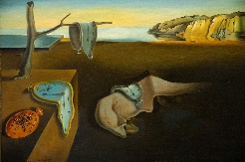  Can you create a piece of work in the style of:  -Salvador Dali?  -René Magritte?  -Joan Miró? | Investigate the work of different surrealist artists.  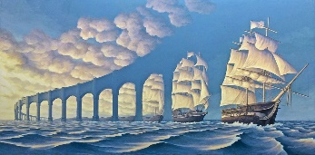  For example:  -Salvador Dali,  -René Magritte  -Joan Miró.  Which one do you prefer and why? | Create a fact file on the history of surrealist art.  What do you think about surrealist art? Why? | Discuss with a member of your family different dreams/ideas you both have had that could be used as the basis for surrealist art.  Can you create a collaborative piece of surrealist art together?
Religion and Values | Write and illustrate the story of creation on a scroll. Use a lolly stick to point to the words as you read them to a family member. | Investigate the special Jewish book called the Torah.  Look at the creation story in the Torah. How is it the same as the creation story in the Christian Bible? How is it different? | Look at the Christian and Jewish stories of creation.  Explain to a family member what is important about the 7th day. | Make up and perform a creation story dance showing what happens on each day.
Sport Exercise and Health | With the help of an adult, select a simple recipe to follow. For example https://www.bbcgoodfood.com/recipes/classic-scones-jam-clotted-cream  Use your weighing skills to help follow the recipe. | Imagine that you wanted to make your recipe for twice the number of people. Work out how much of each ingredient would be required for this new recipe. | Write a recipe for someone else to follow. It could be to make something delicious or disgusting. You might even like to seek inspiration from our class book- George’s Marvellous Medicine. | Perform a daily exercise routine with members of your family.  For example, you could join in with Jo Wicks daily 9am sessions on Youtube.
Outdoor Learning | Use the map that you have created to plan a route to complete for your daily exercise. Collect pictures of interesting objects or items along the route and mark their location on your map. When you get home, print out or sketch the pictures and use them to add detail to your map. | Visit the woodland trust website or download their free app.  https://www.woodlandtrust.org.uk/trees-woods-and-wildlife/british-trees/how-to-identify-trees/  On your daily exercise, see how many different trees you can identify. Use the woodland trust resources to help you identify them. | Use the woodland trust resources to provide tips on tree identification to a family member. | Use the map that you have created to plan a route to complete for your daily exercise. Identify points along route to stop and discuss your surrounds. What plant and animal life can you see/hear?

