Acorn Class Home Learning Plans – 18.05.2020 (week 7)
Thank you to all those parents who have been in contact via email or Tapestry or have contacted the school to say they need further support. So far I have had 8 out of 30 parents post on Tapestry since the start of ‘lockdown’ 6 of these have been at least twice a week. Only 2 out of 30 children have accessed work via Purple Mash. It would be great if we could get these figures much higher over the next two weeks!
Things written in red have been sent home with week 1 plans or detailed on Acorn Class Home Learning Weekly Schedule or Wider Curriculum Home Learning Matrix
Things written in green have been sent home with week 2 plans
Things highlighted in yellow were sent home on Thursday 19th March in brown envelopes for ‘home learning’
Things written in pink have been sent home with week 3 plans
Things written in blue have been sent home with week 4 plans
Things written in orange have been sent home with week 5 plans
Things written in purple have been sent home with week 6 plans
Things written in grey have been sent home with week 7 plans

Please continue to upload anything you do at home on to Tapestry or email them to acorn@st-barnabas.kent.sch.uk , we would love to see what you and your child have been getting up to
If you need any advice or support email – acorn@st-barnabas.kent.sch.uk and I will do my best to help.
Paper copies of plans and resources can be obtained from School Office.
Here is our ‘usual’ class timetable if you would like the follow this at home:
 | Monday | Tuesday | Wednesday | Thursday | Friday
8.45-9.10 | Morning activities and daily mile (6 laps running or walking round the playground)
9.10-9.40 | Phonics | Phonics | Phonics | PE | Phonics
9.40-11.20 | Child Initiated Learning Time |  |  |  | Child Initiated Learning Time
11.20-11.45 | Teacher directed activity – Story | Teacher directed activity – Writing | Teacher directed activity – RE | Teacher directed activity – Story | Teacher directed activity – Maths
11.45-12 | Get ready for lunch – sing counting songs, nursery rhymes or watch Geraldine the Giraffe
12-12.45 | Lunchtime
12.45-1 | Chat about lunch, Wake and Shake
1-1.30 | Maths | Maths | Maths | Phonics | Library
1.30-2.30 | Child Initiated Learning Time
2.30-3 | Get ready for home, story

- Use the teacher directed story times to share a story with your child and discuss some of the questions listed on the Acorn Class Home Learning Weekly Schedule. Please refer to the document title ‘Reading’ to support you further. The story ‘Coronavirus – A Book for Children’ has been included in this weeks resources.

- Use the teacher directed writing time to do a piece of writing or mark making (refer to the Acorn Class Home Learning Weekly Schedule for ideas). There is also the ‘how to draw’ pictures we use in class, your child can then write a short sentence about their picture

- Use the daily mile and PE times to do Joe Wick’s PE lessons via https://www.youtube.com/user/thebodycoach1 at 9am each day or some Yoga via https://www.youtube.com/user/CosmicKidsYoga or use the PE challenges cards or use the ‘Keep Well and Active at Home’ poster

- Use the ‘Wake and Shake’ time to do some of ‘Just Dance’ routines or GoNoodle which can be found on www.youtube.com or make up your own dance routines to a song

- Use the child initiated learning time to allow your child access to the toys, games and resources they have at home or pick some activities from the:
- Wider Curriculum Home Learning Matrix – Week 1
- Wider Curriculum Home Learning Matrix – Week 3
- Wider Curriculum Home Learning Matrix – Week 5
- Science week activities
- Practical ideas booklet
- Any of the other activities that are sent home via Parentmail or in the home learning pack.
- Any of the Easter holiday activities uploaded to Tapestry
- Some of the activities added to the ‘activity’ tab on Tapestry
- Some of the activities set via 2dos on www.purplemash.com - log in sent home on Thursday 19th March
- https://abcdoes.com/home-learning/

- The following social media pages may be helpful for other ideas to do with your child:

Facebook

Mrs Smiths Online Phonics

Instagram

Miss_funro

Seize.the.play

Sarahjudge27

Mrs_simmons_says_

Leighwoodseyfs

Minicheddarz0412

Youtube.com

Woolro & Co

Mr Mc

RE – What can we learn from the Old Testament?
Remind yourselves of last week’s story of Noah’s Ark and that God’s promise looked like a rainbow.

Talk about what a promise is, some people give each other rings as a promise, others might join Rainbows or Beavers where they have to make a promise and wear a badge.

Explain that Christians trust God to keep their promises. Show your child a bible (if you have one) and remind them that the front is about life before Jesus and is about Jewish people.

Read the story, Abraham and Sarah or watch https://www.youtube.com/watch?v=NdqrwGJYePQ

Explain that Abraham cold see the starts in the sky and the grains of ground but he could not see how many children/grandchildren/great-grandchildren he would have. God made a promise to Abraham and Abraham trusted God. Sometimes people find it hard to keep promises though even when they cannot see God they know the promise is still there.

Decorate a picture of a star to remind yourself of the story.

Monday 18th May
Phonics
Please use this planning for Tuesday and Wednesday’s Phonics lessons too.

Recap
Put the flash cards in alphabetical order and sing the alphabet while pointing to the correct letter or listening to https://www.youtube.com/watch?v=jPVbJ-IaHIw
Recap sounds and words taught so far using the flash cards or www.phonicsplay.co.uk (see week 1 home learning plans) – once your child can identify particular sounds, take these out and only recap the ones they have struggled with
You may want to watch the video ‘Phonics with Miss Traviss – Full Phase 3 recap’ on Tapestry (uploaded 4th May).
Sound pronunciation - https://www.youtube.com/watch?v=IwJx1NSineE
Sounds taught so far - s a t p i n m d g o c k ck e u r h b f ff l ll ss j v w x y z zz qu ch sh th ng ai ee igh oa oo ar or ur ow oi ear air ure er
Words taught so far - The I to a to go no into put of he she we me be my was you they all are

Teach
We have now learnt all the Phase 3 sounds and will now be recapping them. I will focus on a few sounds each week – please let me know if there is some sounds in particular that, your child is struggling with.
This week’s focus…… ch sh th ng

Practise and Apply – Choose one of the activities below (or any from previous packs sent home)
Choose one of these activities…….
- Pick game to play from www.phonicsplay.com
- Play one of the games from Phase 2 or Phase 3 on http://www.letters-and-sounds.com/
- Play the u r game or ch sh or th game on www.purplemash.com – log in sent home on Thursday 19th March, access via 2dos
- Dictate words for your child to write
- Ask your child to write a sentence using one of the words
- Write the words out for your child to read
- List the sounds learnt so far, can you think of a word containing each sound
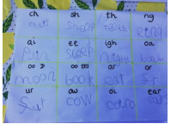

Complete one of the activities from the home learning pack….
- Play what’s in the box –use the phase 2 word cards and pictures or phase 3 word cards and pictures. Put the words in a box, children read the words and find the matching picture or object
- Play Phase 2 Phonopoly
- Play the Secret Word game – you need to write the first sound for each word which then reveals another word
- Play I spy and read
- Complete the phase 2 or 3 picture and caption matching
- Complete the ck e u r workbook
- Complete Cirlce the Word
- Play Roll a Sound
- Watch Miss Traviss’ story on Purple Mash about Bob the Cat. Then create your own story.
- Watch Miss Traviss’ phonics reading games videos on Tapestry

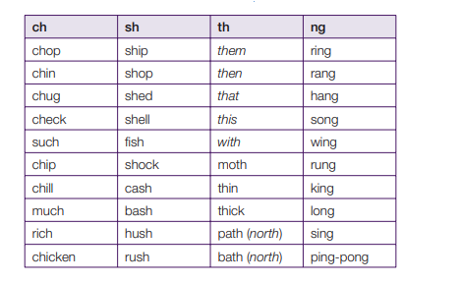
Suggested words:

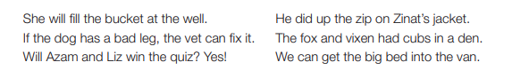
Suggested sentences:

Letters and Sounds Recap Videos

https://wandleenglishhub.org.uk/lettersandsounds/reception

Maths

Recap
Give your child a number, can they represent that number by drawing (e.g. number 6, your child might draw 6 dots, 6 hearts, 6 lines etc)
Teach
Watch the video on Tapestry called Number 11
Or
Show you child the number 11 flashcard. Have they seen the number before?
Write out the numbers 0-20 in order. Can your child find number 11?
Count to 11 together, you may want to collect 11 things in your house (e.g. fruit, pens, plates)
Using objects demonstrate that 11 is made up of 10 and 1. (you may want to bundle 10 straws together, and have 1 its own).
Watch https://www.youtube.com/watch?v=pcAc9-85ZEY or show them the picture of the character
Then ask your child to find 11 objects, can they show that 11 means 10 and 1.
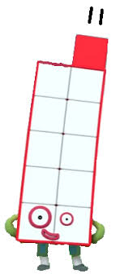
Complete the number 11 page of ‘All About Numbers 11 worksheet’ activity pack or make a poster all about 11. An example for number 10 is below.
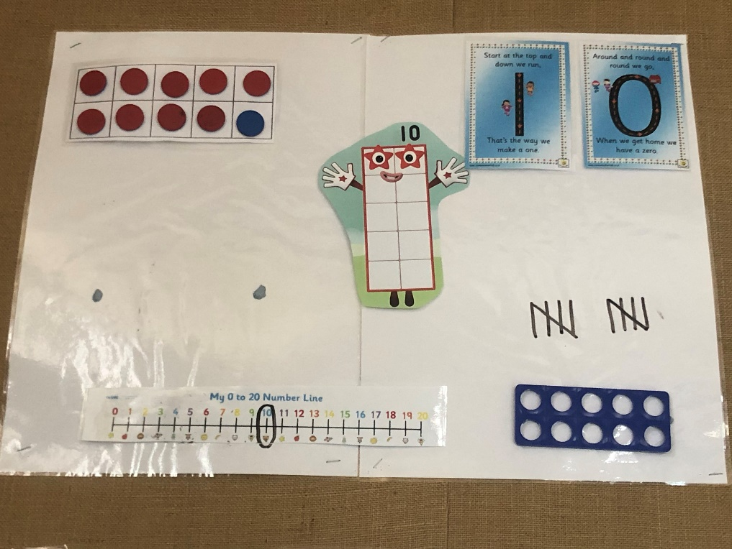

Tuesday 19th May
Phonics

Please use Monday’s planning and select a different activity to complete from the list – if you need further support or ideas please email acorn@st-barnabas.kent.sch.uk

Maths

Recap
Can your child find all the images that represent 11?

Teach
Watch the video on Tapestry called Number 12
Or
Show you child the number 12 flashcard. Have they seen the number before?
Write out the numbers 0-20 in order. Can your child find number 12 ?
Count to 12 together, you may want to collect 12 things in your house (e.g. fruit, pens, plates)
Using objects demonstrate that 12 is made up of 10 and 2. (you may want to bundle 10 straws together, and have 2 its own).
Watch https://www.youtube.com/watch?v=UQZuEuRLZq4 or show them the picture of the character
Then ask your child to find 12 objects, can they show that 12 means 10 and 2.
Complete the number 12 page of ‘All About Numbers 12 ’worksheet or make a poster all about number 12.
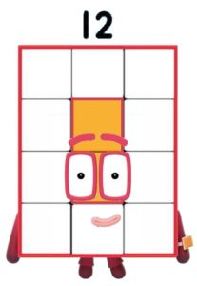

Wednesday 20th May
Phonics
Please use Monday’s planning and select a different activity to complete from the list – if you need further support or ideas please email acorn@st-barnabas.kent.sch.uk

Maths
Recap
Hide a teddy in the room, choose a number of seconds between 10 and 20 and see if your child can find the teddy before the time is up. Count down from the number to 0.
Teach
Watch the video on Tapestry called Number 13
Or
Show you child the number 13 flashcard. Have they seen the number before?
Write out the numbers 0-20 in order. Can your child find number 13?
Count to 13 together, you may want to collect 13 things in your house (e.g. fruit, pens, plates)
Using objects demonstrate that 13 is made up of 10 and 3. (you may want to bundle 10 straws together, and have 3 its own).
Watch https://www.youtube.com/watch?v=Np24uSP7TP0 or show them the picture of the character
Then ask your child to find 13 objects, can they show that 13 means 10 and 3.
Complete the number 13 page of ‘All About Numbers 13 ’worksheet or make a poster all about number 13.

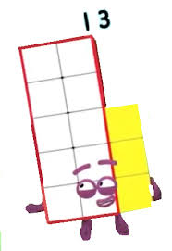

Thursday 21st May
Phonics
Put the flash cards in alphabetical order and sing the alphabet while pointing to the correct letter or listening to https://www.youtube.com/watch?v=jPVbJ-IaHIw
Recap sounds and words taught so far using the flash cards or www.phonicsplay.co.uk (see week 1 home learning plans) – once your child can identify particular sounds, take these out and only recap the ones they have struggled with
Sound pronunciation - https://www.youtube.com/watch?v=IwJx1NSineE
Sounds taught so far - s a t p i n m d g o c k ck e u r h b f ff l ll ss j v w x y z zz qu ch sh th ng ai ee igh oa oo ar or ur ow oi ear air ure air er
Words taught so far - The I to a to go no into put of he she we me be my was you they all

Teach
We have now learnt all of the non-decodable high frequency words (tricky words) for Phase 3 and will now focus on the decodable ones:
will, this, that, now, for, her, them, with, down, look, see
And recap the previous high frequency and tricky words:
The I to a to go no into put of he she we me be my was you they all
Practise and Apply
Choose one of these activities…….
- Practise writing all and other tricky and high frequency words learnt so far
- Hide words around the house for your child to find and read
- Write a sentence with the word one of this week’s words in
- Complete the high frequency word sentences
- Watch the Tapestry video, Guess the Clues or read the ‘Guess the Clues’ writing (see below) and see if you can guess the thing I am describing. Then have a go at writing your own, encouraging your child to use some of the high frequency words we have learnt.

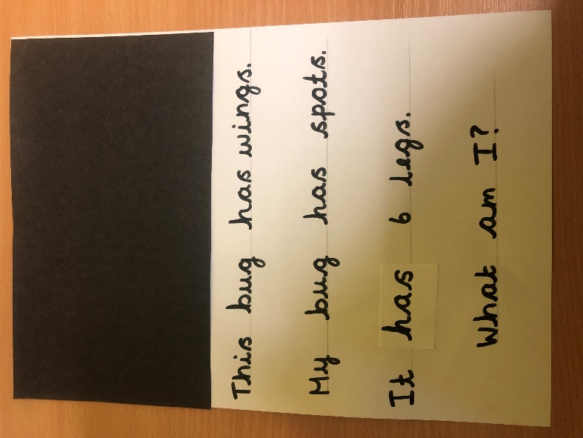

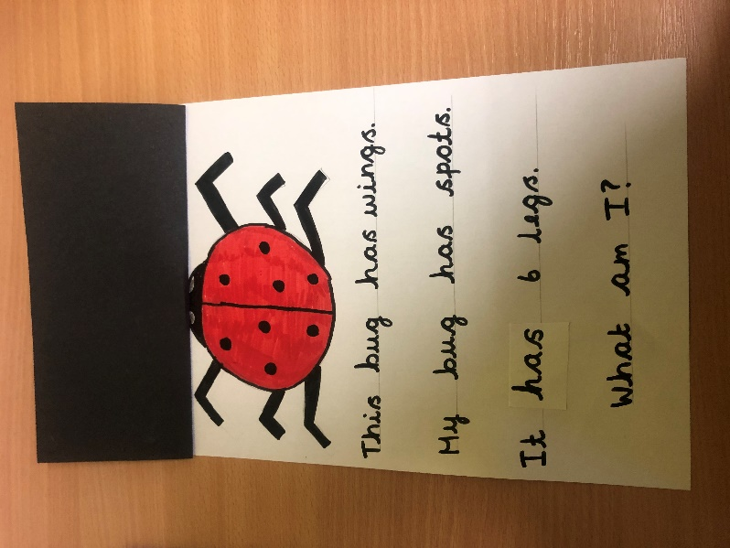

Friday 22nd May
Phonics
Recap
Put the flash cards in alphabetical order and sing the alphabet while pointing to the correct letter or listening to https://www.youtube.com/watch?v=jPVbJ-IaHIw
Recap sounds and words taught so far using the flash cards or www.phonicsplay.co.uk (see week 1 home learning plans) – once your child can identify particular sounds, take these out and only recap the ones they have struggled with
You may want to watch the video ‘Phonics with Miss Traviss – Full Phase 3 recap’ on Tapestry (uploaded 4th May).
Sound pronunciation - https://www.youtube.com/watch?v=IwJx1NSineE
Sounds taught so far - s a t p i n m d g o c k ck e u r h b f ff l ll ss j v w x y z zz qu ch sh th ng ai ee igh oa oo ar or ur ow oi ear air ure er
Words taught so far - The I to a to go no into put of he she we me be my was you they all are

Teach
Friday’s phonics lessons are going to be drawing a picture and writing a sentence. The sentence we will write will use at least one of the sounds we have been recapping this week.
Two writing templates have been provided – one has the phoneme frames and one is a single line.
Either use the step-by-step drawing below or watch the video ‘Writing 2’ on Tapestry.
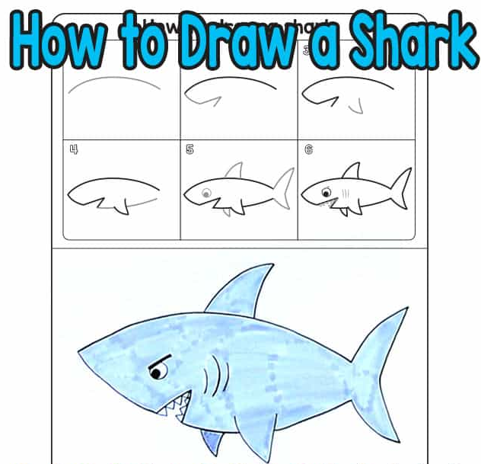

Once you have finished drawing the shark, you have two options
- Use the phoneme frame writing template provided and…
Say the sentence ‘This shark has big teeth.’ Repeat the sentence several times and get your child to join in.
Once they can confidently say the sentence on their own, ask them to write it down making sure there is one sound in each box.
- Use the line writing template provided and….
Think of your own sentence about the bee. Say the sentence several times and get your child to join in.
Once they can confidently say the sentence on their own, ask them to write it down. Make sure they are hearing all the sounds in the word.

Remind your child to use correct letter formation and encourage them to hear all the sounds in each word. Remember tricky words get written on a line and if you are writing a digraph, both letters go in the same box.

Please refer to the ‘Acorn Class Daily Schedule’ or http://www.st-barnabas.kent.sch.uk/page/?title=Acorn+Class&pid=40 on how to support your child with their writing.

Maths
Recap
Complete Superhero I Spy, how many of each picture can you find?

Teach
Watch the video on Tapestry called Number 14
Or
Show you child the number 14 flashcard. Have they seen the number before?
Write out the numbers 0-20 in order. Can your child find number 14?
Count to 14 together, you may want to collect 14 things in your house (e.g. fruit, pens, plates)
Using objects demonstrate that 14 is made up of 10 and 4. (you may want to bundle 10 straws together, and have 4 its own).
Watch https://www.youtube.com/watch?v=xjGIx5f4uYgo r show them the picture of the character
Then ask your child to find 14 objects, can they show that 14 means 10 and 4.
Complete the number 14 page of ‘All About Numbers 14 ’worksheet or make a poster all about number 14.
