Home Learning Plans
Chestnut Class

Week Beginning: 29th June
Dear Chestnut parents/carers and children,
Your core learning for the week is set out in this letter.
Reading: You now have your own copy of The Outlaw Varjak Paw, so please read chapters 1 and 2 in order to answer the questions I have set. Remember that in class we always read a chapter several times before we tackle the questions.
On Friday 3rd July I will be doing another googlemeet story session at 9am. I will be reading more from The Outlaw Varjak Paw. You will be sent the access details for this session by parentpay.
Don’t forget to sign up for this year’s Summer Reading Challenge. It started on Friday 5 June and runs throughout the summer holidays, finishing at the end of September. It is aimed at children aged 4 – 11 and is completely free! The challenge features games, quizzes and downloadable activities to incentivise and encourage children and their families to take part in reading related activities at home. Children can choose their own reading goals, create book reviews, play games and collect virtual rewards. Parents and guardians can register their children online at www.sillysquad.org.uk
Please also make sure you are carrying out additional reading each day. You could use the grid below to explain what you are reading to an adult. Challenge yourself to ask questions based on each area of the chart. For example, you could ask a ‘where?’ question from the left side, or combine it with a ‘should’ question from the top section to create a ‘where should ‘ question.
Oxford Owls This website provides access to free reading material. You will need to use the log on: chestnut101 and the password: pupil
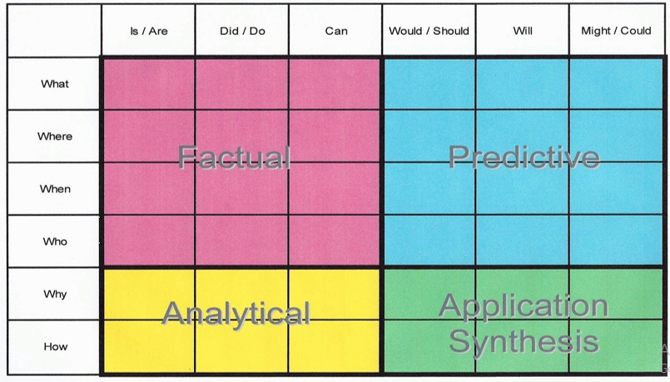

You have a Purple Mash grammar activity relating to consolidating prepositions.
You have a spelling quiz on Purple Mash and a ‘look, say, cover, write’ sheet to practise with.
Writing This is linked to your reading text - The Outlaw Varjak Paw. Re-read the fight scene between Varjak and Razor. I would like you to rewrite this from Razor’s point of view. Think about the different stages of the fight. How would Razor have felt at these different points and how did he feel when it was finally over? Would he have been aware that Varjak was using the Skills? Really try to imagine it from an opposing point of view!
chestnut@st-barnabas.kent.sch.uk
Maths:
Mr M has made some more learning videos to accompany the maths work - they can be accessed via the Chestnut Class home learning section of the school website.
POUNDS AND PENCE
POUNDS AND PENCE - REASONING AND PROBLEM SOLVING
ORDERING MONEY
ORDERING MONEY - REASONING AND PROBLEM SOLVING
ESTIMATING MONEY
Maths fluency: You have a MyMaths activity relating to money calculation. You also have a Purple Mash game dealing with giving change from £1
Wider Curriculum -
You have a new matrix to last the next 2 weeks
I hope you are all well.
Take care,
Mrs Barter

