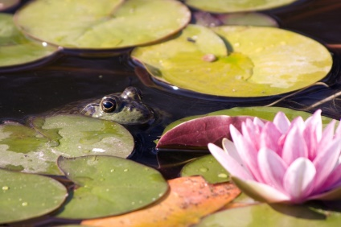
The Frog
The little frog sat in the pond.
The frog sat very still.
A little fly flew by.
The frog jumped up and ate the fly.
Then the frog swam away.

1. Where did the frog sit?
——————————————————————-
2. What size was the frog?
——————————————————————-
3. How did the frog sit?
——————————————————————
4. What flew by?
——————————————————————
5. What did the frog do to the fly?
——————————————————————

