DECIMALS ON A NUMBER LINE
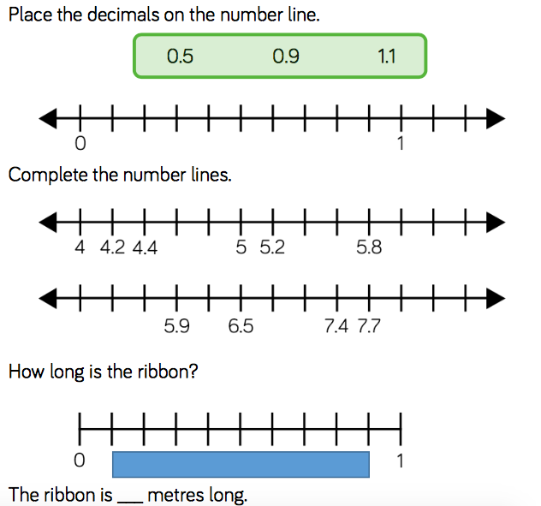
***REMEMBER TO CHECK WHERE THE MEASURMENT STARTS!***

