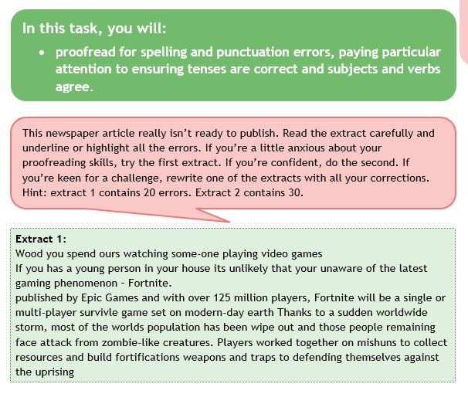
Your corrected version ………………………………………………………………………………………………………………………………………………………………………………………………………………………………………………………………………………………………………………………………………………………………………………………………………………………………………………………………………………………………………………………………………………………………………………………………………………………………………………………………………………………………………………………………………………………………………………………………………………………………………………………………………………………………………………………………………………………………………………………………………………………………………………………………………………………………………………………………………………………………………………………………………………………………………………………………………………………………………………………………………………………………………………………………………………………………………………………………………………………………………………………………………………………………………………………………………………………………………………………………………………………………………………………………………………………………………………………………………………………………………………………………………………………………………………………………………………………………………………………………………………………………………………………………………………………………...........................................................................................................................................................................
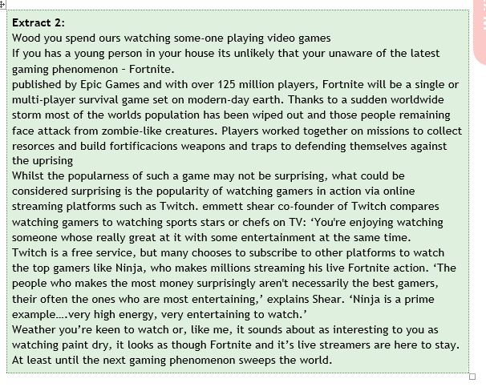
Your corrected version ………………………………………………………………………………………………………………………………………………………………………………………………………………………………………………………………………………………………………………………………………………………………………………………………………………………………………………………………………………………………………………………………………………………………………………………………………………………………………………………………………………………………………………………………………………………………………………………………………………………………………………………………………………………………………………………………………………………………………………………………………………………………………………………………………………………………………………………………………………………………………………………………………………………………………………………………………………………………………………………………………………………………………………………………………………………………………………………………………………………………………………………………………………………………………………………………………………………………………………………………………………………………………………………………………………………………………………………………………………………………………………………………………………………………………………………………………………………………………………………………………………………………………………………………………………………………………………………………………………………………………………………………………………………………………………………………………………………………………………………………………………………………………………………………………………………………………………………..………………………………………………………………………………………………………………………………………………………………………………………………………………………………………………………………………………………………………………………………………………………………………………………………………………………………………………………………………………………………………………………………………………………………………………………………………………………………………………………………………………………………………………………………………………………………………………………………………………………………………………………………………………………………………………………………………………………………………………………………………………………………………………………………………………………………………………………………………………………………………………………………………………………………………………………………………………………………………………………………………………………………………………………………………………………………………………………………………………………………………………………………………………………………………………………………………………………………………………………………………………………………………………………………………………………………………………………………………………………………………………………………………………………………………………………………………………………………………………………………………………………………………………………………………………………………………………………………………………………………………………………………………………………………………………………………………………………………………………………………………………………………………………………………………………………………………………………..………………………………………………………………………………………………………………………………………………………………………………………………………………………………………………………………………………………………………………………………………………………………………………………………………………………………………………………………………………………………………………………………………………………………………………………………………………………………………………………………………………………………………………………………………………………………………………………………………………………………………………………………………………………………………………………………………………………………………………………………………………………………………………………………………………………………………………………………………………………………………………………………………………………………………………………………………………………………………………………………………………………………………………………………………………………………………………………………………………………………………………………………………………………………………………………………………………………………………………………………………………………………………………………………………………………………………………………………………………………………………………………………………………………………………………………………………………………………………………………………………………………………………………………………………………………………………………………………………………………………………………………………………………………………………………………………………………………………………………………………………………………………………………………………………………………………………………………..………………………………………………………………………………………………………………………………………………………………………………………………………………………………………………………………………………………………………………………………………………………………………………………………………………………………………………………………………………………………………………………………………………………………………………………………………………………………………………………………………………………………………………………………………………………………………………………………………………………………………………………………………………………………………………………………………………………………………………………………………………

