Home Learning Plans
Lilac Class

Week Beginning: Monday 23rd March
Reading:
- In Year 5, it is expected that your child will read independently for at least 20 minutes a day. They should read their class reading book but also feel free to supplement this with additional material, for example comics and magazines or a book that they may also reading at home. After your child has read, use the factual section of this questioning tool below to generate questions to ensure that they have fully understood what they are reading. I know that some children have a Kindle.
- I have given your child a piece of reading comprehension based on a poem to complete.
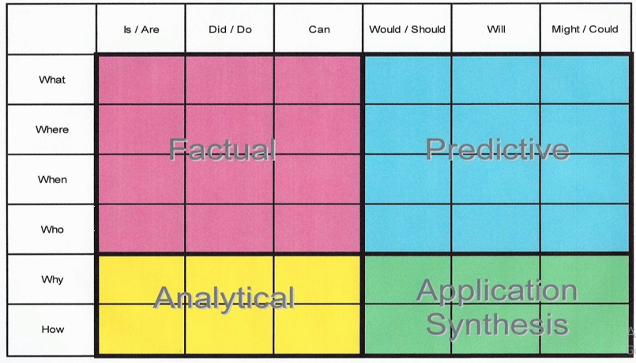

Spelling
- I have set a spelling activity on your child’s Purple Mash Account as one of their ‘2Dos’.
Writing
- I would like your child to write a letter to the editor of The Times about the negative effects of the railways on the population of Victorian Britain. They have already written a letter about the positive effects; I want them now to explore the other side of the argument. They know that the date must be Wednesday 23rd January 1901 as we are looking back on what has happened during the reign of Queen Victoria. They know that the letter must start with Dear Sir and end with Yours Faithfully. Last week as a class we discussed the persuasive language we would use to support our point of view.

- Maths: I have set a Times Tables Test on your child’s Purple mash Account. I have also set a fraction activity (with parent guidance) and a multiplying 4 digits by 2 digits activity on Maths with Parents (you need to sign up for this and details have been sent to you) Class Code 483721.

- Wider Curriculum: Pick activities from the Wider Curriculum Learning Matrix.

- I have also attached my regular Homework sheet that your child receives every Thursday.

