Home Learning Plans
Chestnut Class

Week Beginning: 30th March
Dear Chestnut parents/carers and children,
Your core learning for the week is set out in this letter.
Reading: Read Chapter 17 of Varjak Paw, which is provided for you. There are also some questions to answer. See if you can follow the pattern we have adopted of reading and re-reading before answering the questions.
Please also make sure you are carrying out additional reading each day. You could use the grid below to explain what you are reading to an adult. For this week, focus on the factual aspects - these questions are referenced in the pink section.

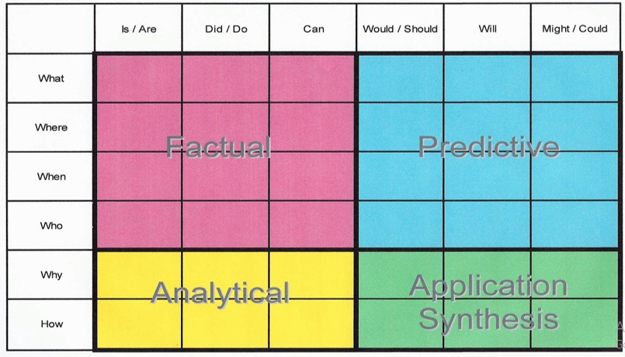

Spelling - Please log onto Purple Mash and complete the spelling 2DO. Continue to practise these words as you would in class, using a range of strategies such as pyramid words. You have also been set 2 grammar activities(Purple Mash).

Writing - Having written a sensory description of the rainforest, I would like you to use these skills to create a sensory poem related to Easter. I have attached a planning template to help you generate some ideas.
I would also like you to write a book review of the last book you read. I have included a format to help you structure it.

Maths:
I have provided 3 sheets: Sudoku, missing number multiplication and division wheels.
You also have 2 tasks set on the website Mathswithparents. You will need to log on using the Chestnut Class code: 946434

Number Fluency: There are 4 tasks set on MyMaths. Both are revision of work we covered in class last term. In addition, you can use Purple Mash to practise times tables fluency.

Wider Curriculum
- Wider curriculum activities should be selected from the matrix you have also been sent. The matrix provides a fortnight of activities.

I will be thinking of you all and can’t wait to see you again as soon as possible,
Mrs Barter

