Challenge 2:
Go wild flower hunting.
Pick the 6 most beautiful flowers that you can find.
Split the 6 flowers into 3 vases.
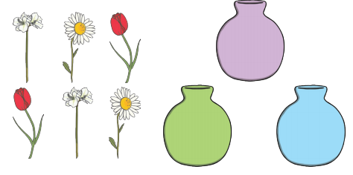
Can you split them into equal groups?
Can you split them into unequal groups?
How many different ways can you split them?

