Comparing Shapes: Help Sheet
Circle | Triangle | Quadrilateral
Square | Rectangle | Pentagon
Hexagon | Octagon | 2D 3D

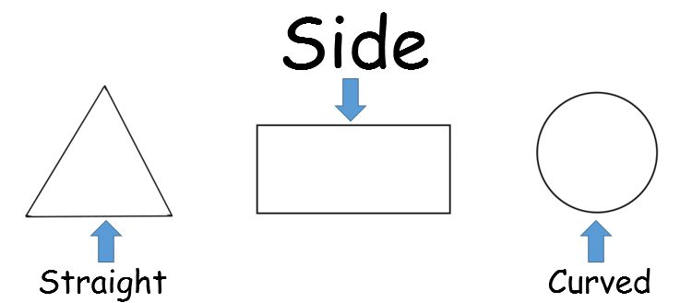
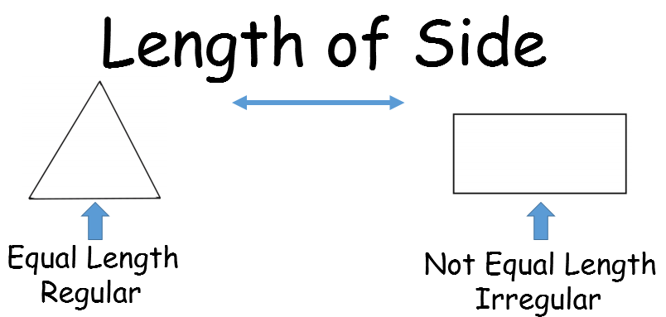
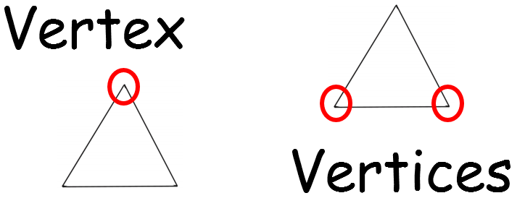

-Do all of these shapes have the same name?
-Are they all 2D or 3D?
-How many sides do they have?
-Are all the sides the same length/shape?
-Are they all regular?
-How many vertices do they have?

