Beech Homework: Tuesday 9th October (to be handed in Monday 15th October)

This year, Beech Class need to learn their 2,5 and 10 times tables.

Step 1: Decide which times table you want to practise. e.g. 2x table

Step 2: Cut out 10 pieces of paper or card and write the multiples of your chosen times table on them.
e.g. 2, 4, 6, 8, 10, 12, 14, 16, 18, 20

Step 3: Mix them up and practise putting them back in order again.

Step 4: Lay the cards out in a line and practise counting them in sequence.
e.g. 2, 4, 6, 8, 10, 12, 14, 16, 18, 20

Step 5: Lay the cards out in a line and practise chanting the times table.
e.g. 1 times 2 is 2, 2 times 2 is 4, 3 times 2 is 6 etc.

Step 6: Lay the cards out in order and test yourself with a partner.

Step 7: Lay the cards out in order. Turn over some or all of the cards and test yourself with a partner.

MyMaths: Try using the tools you have made to complete these MyMaths activities.
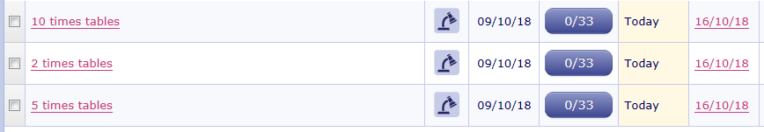

Class Blog: We will also put some extra times tables resources on the blog.

