Beech Home Learning (Due in Tue 4th May)
This week we are focusing on creating descriptions of the characters in our class quest. For your homework, we want you to come up with your own description of Lady Emma.
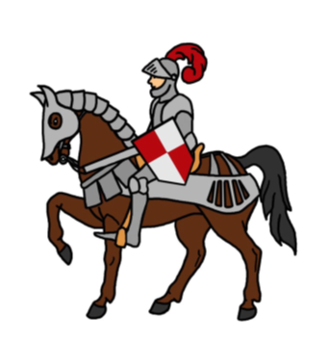
Here is the description that we came up with as a class. Feel free to use it as inspiration for your own piece of descriptive writing.
Long ago, in a land of monsters and mystery there lived a Knight named Lady Emma. She was a brave and fearless Knight. She was the sort of knight who helped people and saved kings. She was the sort of knight who charged into battle and killed her enemies. She was as fierce as a tiger and as clever as a fox. In her hand, she held a razor sharp sword which she used to kill dragons. On her head, there was a shiny helmet which protected her from harm. Below her, was a strong, brown horse which she used to charge into battle. What an incredible Knight she was! However, Lady Emma had a problem. High in the Misty Mountains there lived…a Yeti!

