Home Learning Plans
Lilac Class
Week Beginning: Monday 18th May
Reading:
- Carry on with your daily independent reading.
- I have typed out Chapters 26 and 27 (the final chapters) of Street Child by Berlie Doherty for your child to read. To recap: During your child’s reading sessions the model is that you initially read one chapter, one session and the next, the other. Each session lasts approximately 30 minutes. Remember to occasionally stop and ask your child what they think the meaning of a tricky word could be, looking at the context of the sentence. The next two sessions will involve them re-reading the two chapters. During the final session your child needs to complete the reading comprehension questions that I have attached and then go over the answers with you. Most of the questions are open ended and there may be several answers to the questions. The purpose of the exercise is to develop reading comprehension skills and to discuss the text – that is why I have not given you an answer sheet.
- Visit the Oxford Owl website. https://www.oxfordowl.co.uk/ Click on the My Class Login section
Use the following details to log in to the newly created Lilac Class section.
Username: lilac101
Password: pupil
Click on the ‘My Bookshelf’ section and select reading books that are right for you. Use the ‘Age Groups’ section to help narrow down the search.
- When completing guided or supported reading of an age appropriate text, focus on analytical questioning. Use the analytical section of this questioning tool to generate questions that challenge your child to analyse what has happened in the story.
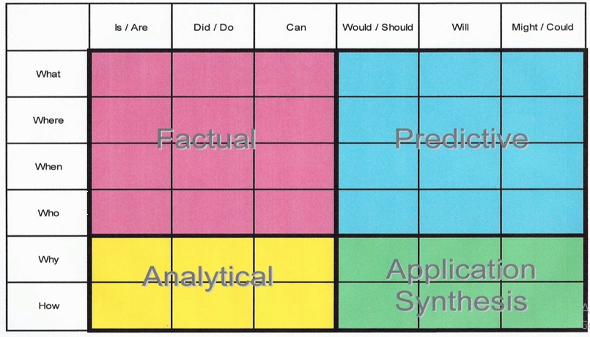
For example:
-Why did they do that?
-How can you tell that…?

Spelling, Punctuation and Grammar:
- On Purple Mash I have set as a ‘2do’ an activity about using adverbs to show degrees of possibility. There is also a worksheet for you to complete with answers.
- I have also given you some Classroom Secrets worksheets about recognising adverbs to indicate degrees of possibility. These include the answers. There is no need to print out the sheets as you can write the answers in your exercise book. You know what sheets you normally work from.
- As a ‘2Do’ on Purple Mash I have set an activity entitled ‘Samantha’s Day’. It is about cohesion- using words to make paragraphs flow well. There is also a worksheet to complete with answers.
- As a ‘2Do’ on Purple Mash I have set an activity entitled ‘In the Countryside’. This is still about cohesion but this time it is about using adverbials to create cohesion across paragraphs. We have used adverbials before in our writing. An adverbial is a word or phrase that has been used like an adverb to add detail or other information to a verb. Adverbials are words that are used to explain how, where or when something happened. There is a worksheet for you to complete with answers.
Writing:

- Just in case you need one, I have again attached a book review worksheet for you to use. It might be about a book you have read from the Oxford Owl selection or one that you have recently finished

- This week I want you to continue with your extended writing task about creating a newspaper report about the sinking of the Titanic. Last week, I wanted you to complete a comprehension sheet about the Titanic. Then I asked you to read the notes you made from the power point slides I gave you and to make a list of facts using bullet points that you would like to include in your newspaper report. For example: When and where did it happen? How long did it take for the ship to sink? How many people died and survived? Explain why it was meant to be ‘unsinkable’. I wanted you to include some facts about how the Titanic was built and some background information about the ship. I also wanted you to consider the different theories as to why the Titanic sank. I wanted you to think about a possible headline and the name of your newspaper. You could choose a U.S.A. newspaper or a British one. Last week, I attached some copies of original front covers of U.S.A. and British newspapers at the time of the tragedy. This week I want you to plan your newspaper report. I have attached two planning sheets where you can jot down your ideas using bullet points. L0: To plan a newspaper report. Please watch my learning video LO: To know how to write a newspaper report.

- You may start to write your newspaper report once you feel happy with your plan. If that is the case I have attached ‘Features of a Newspaper Report Checklist’ that I talked about in my learning video for you to fill in. I have also attached if you want to use them, templates for your reports. LO: To write a newspaper report.

Maths: This week we are learning how to subtract mixed numbers with different denominators.

- Watch my learning video LO: To subtract two mixed numbers with different denominators.
- I have given you some Classroom Secrets worksheets. As you know they become more challenging. I would like all of you to start with the easier questions and then work through. The final questions are extremely hard – I do not expect many of you to do these! There is no need to print out the sheets - just write out your calculations into your exercise book. The answers are attached.
- I have also set a MyMaths highest common factors activity to help you with your fractions work. Please see attached the Homework sheet for details.

- Numbers Fluency: Complete your new Maths with Parents activity I have set you about negative numbers. Class Code 48372. Remember your ‘Maths Games and Activities Pack’ that you can dip into from time to time.

- Wider Curriculum: Pick activities from the Wider Curriculum Learning Matrix for our Science Week.

- I have also attached my regular Homework sheet that your child would normally receive every Thursday.

