Home Learning Plans
Willow Class
Week Beginning: Monday 27th April 2020
Dear Willow Class parents/carers and children,
The core learning for this week is set out below.
Reading:
- Visit the Oxford Owl website. https://www.oxfordowl.co.uk/ Click on the My Class Login section
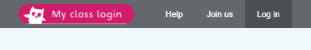
Use the following details to log in to the Willow Class section.
Username: willow101
Password: pupil
Click on the ‘My Bookshelf’ section and select reading books that are right for you. Use the ‘Age Groups’ section to help narrow down the search.

- All children should read an age appropriate text for a minimum of 20 minutes per day. This can be a reading book or sharing a picture book with an adult. When completing guided or supported reading of an age appropriate text, focus on application/synthesis questioning. Use the application/synthesis section of this questioning tool to generate questions that challenge your child to apply or synthesise what has happened in the story.


For example:
-Why should they do that?
-Why might they not want to do that?
-How might the character feel here?
I have also attached a reading comprehension about dogs for children to complete.

Spelling/Phonics
Log on to Purple Mash and complete the spelling ‘2Dos’ which have been selected for you for the letter sounds ‘aw’, ‘au’, ’ie’ and ‘i-e’. I have also set a tricky words spelling 2Do on Purple Mash.
Below is a suggested format that you could use for phonics although there is no obligation to complete all the activities. Remember, each day you can explore the letters sounds by using chalks, magnetic letters, playdough or you could write them in flour, sand or with a pencil.

Play flash cards/speed trial on Phonics Play phase 5a (https://www.phonicsplay.co.uk/ Username: march20 Password: home). | Start off by practising reading some tricky words on Phonics Play tricky word trucks. (https://www.phonicsplay.co.uk/ Username: march20 Password: home). | Use flashcards (included in this week’s pack) to practice letter sounds for Phase 3  The link below shows how to pronounce the sounds correctly:  https://www.youtube.com/watch?v=BqhXUW_v-1s | Use flashcards (included in this week’s pack) to practice letter sounds for Phase 5
Teach ‘aw’ and compare to the word ‘or’  Read words: saw, law, crawl, yawn, raw, claw  Spell words: paw, claw, lawn, shawl, draw, jaw | Teach ‘au’ and compare to ‘or’ and ‘aw’. ‘au’ never comes at the end of a word.  Read words: Paul, haul, launch.  Spell words: August, author, automatic. | Teach ‘ie’ and compare to ‘I’. I is a word on its own, ‘ie’ makes the sound in other words – usually at the end.  Read words: tie, pie, lie, tried, pie, spied  Spell words: die, cried, fried, denied. | Teach ‘i-e’ and talk about the word ‘I’ and the GPCs ‘ie’ and ‘igh’ p135  Read words: like, time, slide  Spell words: pine, ripe, invite
Try the aw spelling sheet | Try the au spelling sheet | Try the ie wordsearch | Colour in the real and nonsense words for  i-e.

Writing: This week we are going to do some more activities about The Great Explorer by Chris Judge. This week the focus is on using adjectives (describing words) in writing. Here are some activities to try:
- Look at the photograph of what Tom packed and make a list of the items using adjectives to add more detail. You can add new items not in the photograph if you like.
- Look at the photograph of the night sky and describe what you can see. How would you describe the stars? What do the Northern Lights look like? How does the ice look in the darkness? What is Tom wearing?
- Look out of your window or take a photograph on one of your walks. Can you use adjectives to describe what you see? Can you write some sentences to tell someone about it?
- Look at the photograph of the polar bear and describe it. Can you think of a word to describe how big it is? How would you describe its face? What is its fur like?
- If you do one of the writing tasks, why not email it to the class email address willow@st-barnabas.kent.sch.uk so I can read it.
Maths:
This week we are learning about doubling numbers and finding a half and a quarter of shapes and a number of objects.
The White Rose website also has instructional videos and worksheets to supplement the activities below. These can be found in Summer Term Week 1 (Lessons 1 and 4) and Summer Term Week 2 (Lessons 1,2,3) by following this link:
https://whiterosemaths.com/homelearning/year-1/
Activity 1: Making doubles (White Rose Summer Term 1 Week 1 Lesson 1)
The focus today is on doubling numbers. It is important for the children to understand that ‘double’ is two groups of a number or an amount. Find some small objects (such as lego bricks, cubes, dried pasta) and make 2 equal piles of a number between 1 and 5. Explain that 2 equal amounts means it is a double. Then record doubling using the sentence, ‘Double ___ is ____’ and use an adding number sentence to represent the double. Try completing the doubling sheet.

Activity 2: Finding half (White Rose Summer Term 1 Week 1 Lesson 4)
The focus today is on halves of shapes. Start by talking about what a half is. Make sure you are using the vocabulary whole, half and quarter and reinforcing that all parts must be equal and how many equal pieces you have. For half you have 2 equal pieces. For quarters you have 4 equal pieces. You could explore shapes around your house and draw around them. Make sure they are ones that will be able to be folded in half equally once they’re drawn around and cut out (bottom of a cup/glass for a circle, use a book or cereal box for a rectangle). The idea is to find half of a picture/shape. Once you have drawn around the shape, fold or cut it in half. There are some activities for you to try on the attached worksheet. Questions to explore: can all shapes be divided in half? Why do you think this is?

Activity 3: Finding half (White Rose Summer Term 1 Week 2 Lesson 1)
The focus today is on finding halves of amounts. Find some small objects (such as lego bricks, cubes, dried pasta). Count up how many you have in total. Make sure it’s an even number! How are we going to find half? How many pieces did we cut shapes into for yesterday’s activity? Children should then start to share their chosen objects into 2 equal groups. Reinforce that it must be shared equally, 1 for you, 1 for me, 1 for you, 1 for me etc. You could write some sentences, for example ‘There are 10 beads. Half of 10 is 5’. Look at the worksheet and try completing it. Question to explore: can an odd number of objects be divided into two equal groups?

Activity 4: Finding a quarter (White Rose Summer Term 1 Week 2 Lesson 2)
The focus today is on quarters of shapes. Draw around some objects so you get equal circles, squares and rectangle shapes. Remind children that a quarter is when something has been shared equally into 4 groups or pieces. This means their cut out shape will have to be folded into 4 equal pieces. Take the shape cut out and fold it in half and then whilst it’s still folded, fold it in half again. Open it and show them that it is now in 4 equal pieces. Colour in a quarter. Repeat this and remind the children that each quarter should be equal. Try the White Rose worksheet to reinforce what you have been doing. Question to explore: can all shapes be divided into quarters? Why do you think this is?

Activity 5: Finding a quarter (White Rose Summer Term 1 Week 2 Lesson 3)
The focus today is on finding quarters of amounts. In a similar way to activity 3, gather 8 or 12 small objects from around your home (such as lego bricks). Count up how many you have in total. How are we going to find a quarter? How many pieces did we fold our shapes into yesterday? (4) Children should then start to share their chosen objects into 4 equal groups. Reinforce that it must be shared equally. You could write some sentences, for example ‘There are 8 beads. A quarter of 8 is 2’. Have a go at completing the White Rose worksheet attached. Question to explore: can all even numbers of objects be divided into four equal groups? Why do you think that is?

Other maths things to practice to help you
You could also complete the doubling and halving within 20 and halves and quarters activities on Maths with Parents - class code 193691 https://www.mathswithparents.com/KWeb
There is also some homework on My Maths Log which has been selected for you.
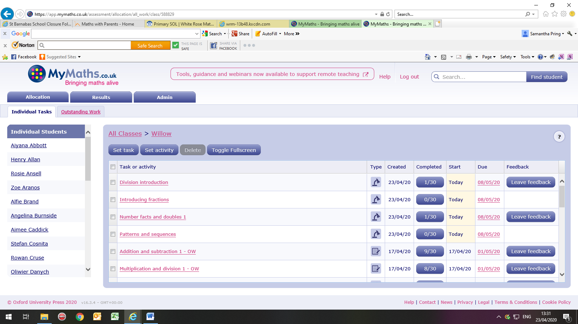
Wider Curriculum
Please pick activities of your choice from the Wider Curriculum Home Learning Matrix which is with this letter. It provides a fortnight of activities.
Don’t forget to share pictures of your completed work with me or any other activities you have been doing. My email is: willow@st-barnabas.kent.sch.uk

Best wishes and stay safe.

Mrs Pring

