Acorn Class Home Learning Plans – 13.07.2020 (week 14)
Please continue to upload anything you do at home on to Tapestry or email them to acorn@st-barnabas.kent.sch.uk , we would love to see what you and your child have been getting up to
Please note – anything uploaded to Tapestry after Friday 3rd July may not appear in your child’s journal. We will be closing Tapestry in school in order to create PDFs of your child’s journal for you to download.
If you need any advice or support email – acorn@st-barnabas.kent.sch.uk and I will do my best to help.
Paper copies of plans and resources can be obtained from School Office on Mondays between 1pm – 3pm.
This is the timetable we are following in class with the children that are back in school; you may wish to follow this at home:

 | Monday |  | Tuesday | Wednesday |  |  | Thursday |  | Friday
9.15-9.30 | Morning activities |  |  |  |  |  |  |  | Use this time to recap and consolidate learning done this week and previous weeks. Complete any activities that have not been done.
9.30-9.50 | Phonics |  | Phonics | Phonics |  |  | Phonics
9.50-10.30 | Child Initiated Learning Time
10.30-10.45 | Snack, story
10.45-11.30 | Child Initiated Learning Time
11.30-12 | Teacher directed activity - | Teacher directed activity - PE |  | Teacher directed activity - |  | Teacher directed activity - RE
12-12.30 | Outside Play
12.30-12.50 | Eat lunch
12.50-1.00 | Wake and shake
1.00-1.20 | Maths | Maths |  |  | Maths |  |  | Maths
1.20-1.50 | Child Initiated Learning Time
1.50-2.10 | Story
Summer holidays – no formal work is to be set, however Mr Mackinnon will be adding some ‘Summer Challenges’ to the school website from Wednesday 22nd July or pick some activities from previous weeks learning that you have not completed.
Reading
- Use the teacher directed story times to share a story with your child and discuss some of the questions listed below:

- (Looking at the front cover) – What do you think this story is about?
- What did __________ (character) just do?
- Why do you think they did that?
- What do you think ________ (character is like?
- What do you think will happen next?
- Why do you think that?
- Which part of the story did you like the best? Why?
- Which part of the story did you like the least? Why?
- How did the story start?
- What happened at the end of the story?
- What happened in the middle of the story?
- What does _______ (character) feel like at the end?
- How did this story make you feel?
- Who are the characters in the story?
- If you were _________ (character), what would you have done?
You may also like to do a separate reading time where your child reads to you. You can access….
Big Cat reading ebooks - https://connect.collins.co.uk/school/Portal.aspx select ‘Teacher’ and use the log in Username: parents@harpercollins.co.uk Password: Parents20!
Oxford Owl ebooks - https://www.oxfordowl.co.uk/ select ‘My class login’ and use the log in Username: stbacornclass1 Password: dog123
Phonics Play Comics - https://phonicsplaycomics.co.uk/comics.html
I will also send home one phonics mini book each week (starting with week 10) for you to cut out and read at home.
Please also look at the ‘Summer Reading Challenge’ letter sent home with Week 10 pack.
Wake and Shake
- Use the ‘Wake and Shake’ time to do some of ‘Just Dance’ routines or GoNoodle which can be found on www.youtube.com or make up your own dance routines to a song

Child Initiated
- Use the child initiated learning time to allow your child access to the toys, games and resources they have at home. You may wish to use any of the resources sent out in previous weeks or complete the daily challenge

Things highlighted in yellow were sent home on Thursday 19th March in brown envelopes for ‘home learning’. Phase 4 tricky word flashcards sent home week in week 8.
Things written in red have been included with this week’s pack.
Assessment
Phonics activites have no split into phases.
If your child cannot identify the sounds s a t p I n confidently, they are working at phase 1
If your child can identify some of the sounds s a t p i n m d g o c k ck e u r h b f ff l ll ss, they are working at phase 2
If your child can identify most or all of the sounds s a t p i n m d g o c k ck e u r h b f ff l ll ss j v w x y z zz, they are working at phase 2 and the beginning of phase 3
If your child can identify some of the sounds ss j v w x y z zz qu ch sh th ng ai ee igh oa oo ar or ur ow oi ear air ure er, they are working at phase 3
If your child can identify most or all of the sounds j v w x y z zz qu ch sh th ng ai ee igh oa oo ar or ur ow oi ear air ure er, they are working at phase 3 and beginning phase 4.
If your child is working beyond phase 3 or 4 and you need more activity ideas, please contact Miss Traviss on acorn@st-barnabas.kent.sch.uk

You may want to watch the video ‘Phonics with Miss Traviss – Full Phase 3 recap’ on Tapestry (uploaded 4th May).
Sound pronunciation - https://www.youtube.com/watch?v=IwJx1NSineE
Sounds taught so far - s a t p i n m d g o c k ck e u r h b f ff l ll ss j v w x y z zz qu ch sh th ng ai ee igh oa oo ar or ur ow oi ear air ure er
Tricky words taught so far - The I to a to go no into put of he she we me be my was you they all are said
High frequency words taught so far – mum in at on an if off his had it got back can dad get him big and up as but not will see now for her down look that too with them then this said have
 | Monday 13th | Tuesday 14th | Wednesday 15th | Thursday 16th | Friday 17th
Phonics | Recap letter names, sounds and high frequency (see below) learnt so far.  letter names, sounds and high frequency (see below) learnt so far.  Teach  Choose the sounds or tricky words you feel your child needs to practise and recap. Talk about the chosen sound which letters make it up and think of words containing that sound. Talk about why a word is tricky, which letters make it tricky. How does it look like you should say it? |  |  |  | Use this time to recap and consolidate learning done this week and previous weeks.
Phonics | Choose one of these activities to complete each day:  - Play game on https://www.phonicsplay.co.uk/login or https://www.phonicsbloom.com/  - Play some of the listening games from Mister Teach - https://www.youtube.com/channel/UChf0ErPjca3wGIuaBlOrMhg  - Create a treasure hunt around the house – how many words can you read? How many words can you match to pictures? How many sounds can you find?  - Sort a collection of objects based on a starting (phase 2) or middle sound (phase 3)  - Complete the summer phonics activity booklet  - Complete one of the word searches  - Complete one of the comprehension activities  - Write words or sentences for each picture  - Play i-spy (either sound out, say an initial sound, or write the word for your child to find)
Maths | Recap  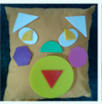  What shapes can you see? | Recap  Find a pencil or pen…  Can you find 3 things smaller than a pencil/pen?  Can you find 3 things bigger than a pencil/pen? | Recap  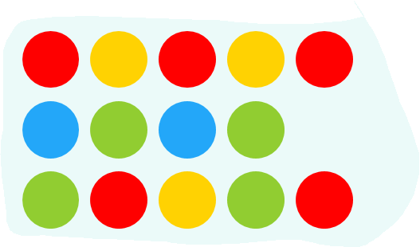  What comes next in the pattern? Draw it out if you need to | Recap  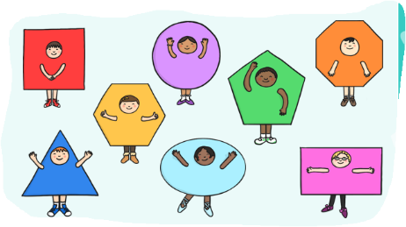  Can you name the shapes the children are dressed up as? Can you describe the shapes? | Use this time to recap and consolidate learning done this week and previous  weeks.
Maths | Teach  Choose a teen number each day to recap with your child. Can they say one more or one less than the number, can they find the number on the number line? Can they show you that number of objects? Can they write that number? Can they create a number sentence with two numbers that add together to make that number? Can they create the number using numicon or bundles of pens/straws? Can they draw that amount of stars, dots etc  Or  - Complete the i-spy and count or summer themed maths booklet or sandcastle counting to 20 or colour by numbers

Teacher Directed | Writing  Go on a picnic to the park or pretend you are planning a picnic in the park with your friends or family.  Write a list of the food you would like at your picnic.  Use the writing template provided. | PE  Have a go at ‘Popcorn and the Pirates’ Cosmic Yoga - https://www.youtube.com/watch?v=T_0P5grVoyg | Understanding the World  We will be releasing our (now) froglets back into the pond.  Visit a pond, beach, rock pool, river or lake.  What animals can you see? | RE  Watch ‘The parable of the mustard seed’ - https://www.youtube.com/watch?v=IZEO_Ls2ERs  Talk about seeds being planted as a sign of hope. We hope that they will grow into something bigger and better?  Have you ever planted a seed? Did you look after it and care for it in the hope it would grow?  If not perhaps you could plant a seed – a pretty flower or vegetable plant
Challenge | End of Year Journal  Complete the end of EYFS journal |  | All About Me Bunting  Colour, add information and a photo to your bunting so Mrs Pring can get to know you and display it in the classroom.  Bring it back to school with you in September.

