Acorn Class Home Learning Plans – 06.07.2020 (week 13)
Please continue to upload anything you do at home on to Tapestry or email them to acorn@st-barnabas.kent.sch.uk , we would love to see what you and your child have been getting up to
Please note – anything uploaded to Tapestry after Friday 3rd July may not appear in your child’s journal. We will be closing Tapestry in school in order to create PDFs of your child’s journal for you to download.
If you need any advice or support email – acorn@st-barnabas.kent.sch.uk and I will do my best to help.
Paper copies of plans and resources can be obtained from School Office on Mondays between 1pm – 3pm.
This is the timetable we are following in class with the children that are back in school; you may wish to follow this at home:

 | Monday |  | Tuesday | Wednesday |  |  | Thursday |  | Friday
9.15-9.30 | Morning activities |  |  |  |  |  |  |  | Use this time to recap and consolidate learning done this week and previous weeks. Complete any activities that have not been done.
9.30-9.50 | Phonics |  | Phonics | Phonics |  |  | Phonics
9.50-10.30 | Child Initiated Learning Time
10.30-10.45 | Snack, story
10.45-11.30 | Child Initiated Learning Time
11.30-12 | Teacher directed activity - | Teacher directed activity - PE |  | Teacher directed activity - |  | Teacher directed activity - RE
12-12.30 | Outside Play
12.30-12.50 | Eat lunch
12.50-1.00 | Wake and shake
1.00-1.20 | Maths | Maths |  |  | Maths |  |  | Maths
1.20-1.50 | Child Initiated Learning Time
1.50-2.10 | Story

Reading
- Use the teacher directed story times to share a story with your child and discuss some of the questions listed below:

- (Looking at the front cover) – What do you think this story is about?
- What did __________ (character) just do?
- Why do you think they did that?
- What do you think ________ (character is like?
- What do you think will happen next?
- Why do you think that?
- Which part of the story did you like the best? Why?
- Which part of the story did you like the least? Why?
- How did the story start?
- What happened at the end of the story?
- What happened in the middle of the story?
- What does _______ (character) feel like at the end?
- How did this story make you feel?
- Who are the characters in the story?
- If you were _________ (character), what would you have done?
You may also like to do a separate reading time where your child reads to you. You can access….
Big Cat reading ebooks - https://connect.collins.co.uk/school/Portal.aspx select ‘Teacher’ and use the log in Username: parents@harpercollins.co.uk Password: Parents20!
Oxford Owl ebooks - https://www.oxfordowl.co.uk/ select ‘My class login’ and use the log in Username: stbacornclass1 Password: dog123
Phonics Play Comics - https://phonicsplaycomics.co.uk/comics.html
I will also send home one phonics mini book each week (starting with week 10) for you to cut out and read at home.
Please also look at the ‘Summer Reading Challenge’ letter sent home with Week 10 pack.
Wake and Shake
- Use the ‘Wake and Shake’ time to do some of ‘Just Dance’ routines or GoNoodle which can be found on www.youtube.com or make up your own dance routines to a song

Child Initiated
- Use the child initiated learning time to allow your child access to the toys, games and resources they have at home. You may wish to use any of the resources sent out in previous weeks or complete the daily challenge

Things highlighted in yellow were sent home on Thursday 19th March in brown envelopes for ‘home learning’. Phase 4 tricky word flashcards sent home week in week 8.
Things written in red have been included with this week’s pack.
Assessment
Phonics activites have no split into phases.
If your child cannot identify the sounds s a t p I n confidently, they are working at phase 1
If your child can identify some of the sounds s a t p i n m d g o c k ck e u r h b f ff l ll ss, they are working at phase 2
If your child can identify most or all of the sounds s a t p i n m d g o c k ck e u r h b f ff l ll ss j v w x y z zz, they are working at phase 2 and the beginning of phase 3
If your child can identify some of the sounds ss j v w x y z zz qu ch sh th ng ai ee igh oa oo ar or ur ow oi ear air ure er, they are working at phase 3
If your child can identify most or all of the sounds j v w x y z zz qu ch sh th ng ai ee igh oa oo ar or ur ow oi ear air ure er, they are working at phase 3 and beginning phase 4.
If your child is working beyond phase 3 or 4 and you need more activity ideas, please contact Miss Traviss on acorn@st-barnabas.kent.sch.uk

You may want to watch the video ‘Phonics with Miss Traviss – Full Phase 3 recap’ on Tapestry (uploaded 4th May).
Sound pronunciation - https://www.youtube.com/watch?v=IwJx1NSineE
Sounds taught so far - s a t p i n m d g o c k ck e u r h b f ff l ll ss j v w x y z zz qu ch sh th ng ai ee igh oa oo ar or ur ow oi ear air ure er
Tricky words taught so far - The I to a to go no into put of he she we me be my was you they all are said
High frequency words taught so far – mum in at on an if off his had it got back can dad get him big and up as but not will see now for her down look that too with them then this said have
 | Monday 6th | Tuesday 7th | Wednesday 8th | Thursday 9th | Friday 3rd
Phonics | Recap letter names, sounds and high frequency (see below) learnt so far.  You can use the flashcards or Phonics Play (flashcards or tricky word trucks).  Teach  Choose the sounds you feel your child needs to practise and recap  Activity  Phase 1:  Play can you find a? – using the smaller pictures provided can you name what they are and then find them in the larger picture. What sound do all the pictures start with? Instructions provided.  Phase 2:  Complete Phase 2 – pictures to matching phrase  Phase 3:  Complete Phase 3 – pictures to matching phrase | Recap letter names, sounds and high frequency (see below) learnt so far.  Teach  Choose the sounds you feel your child needs to practise and recap  Activity  Phase 1:  Play Listening Game https://www.youtube.com/watch?v=rVwAvifDARA  Phase 2 and 3:  Write a sentence about the picture. | Recap letter names, sounds and high frequency (see below) learnt so far.  Teach  Choose the sounds you feel your child needs to practise and recap  Activity  Phase 1:  Collect some items that can we sounded out (with 3 sounds). Sound out the word and ask children to identify the object  Phase 2:  Read questions and decide whether the answer is year or no  Phase 3:  Complete animal comprehension | Recap letter names, sounds and high frequency (see below) learnt so far.  Teach  Choose the sounds you feel your child needs to practise and recap.  Talk about why it is tricky  Activity  Phase 1:  Find a selection of resources that match to nursery rhymes (e.g. star – twinkle twinkle little star, sheep – ba ba black sheep, clock – hickory dickory dock etc). Can you child guess the nursery rhyme based on the object? When they’ve guess it have a go at singing it  Phase 2 and 3:  Write a sentence about the picture. | Use this time to recap and consolidate learning done this week and previous weeks.
Maths | Recap  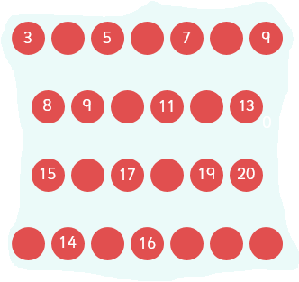  Complete the missing numbers | Recap  What is one less than these numbers….  7 5 8 2 9 1 6  Use a number line to help if needed. | Recap  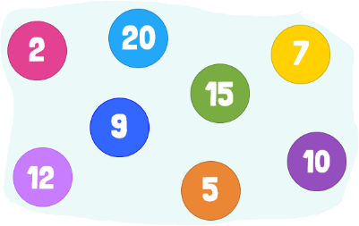  Put these numbers in order | Recap  Can you order these animals from smallest to largest?  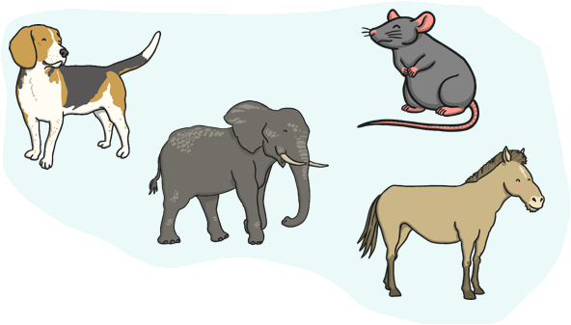 | Use this time to recap and consolidate learning done this week and previous  weeks.
Maths | Teach  Choose a teen number each day to recap with your child. Can they say one more or one less than the number, can they find the number on the number line? Can they show you that number of objects? Can they write that number? Can they create a number sentence with two numbers that add together to make that number? Can they create the number using numicon or bundles of pens/straws? Can they draw that amount of stars, dots etc  Or  - Complete the maths problem solving cards or maths activity mats or talking about size challenges

Teacher Directed | Writing  Follow the ‘How to draw a dog’ instructions.  A writing template has been provided for you.  Then think of a sentence about the car to write. Remember to use your phonics sounds, adults – do not worry if not everything is spelt correctly! | PE  Warm up – how many star jumps/hops/jumps/far can you run in 10 seconds? Ask a grown up to time and count for you  You will nees 5 cones or markers and a football.  Can you dribble the ball around the cones and markers, making sure you are using your feet to control the ball  Have a go at ‘Frank the Frog’ Cosmic Yoga - https://www.youtube.com/watch?v=TY8xx7c6_z0 | Communication and Language/Reading  Read or listen to the story ‘Little Red Riding Hood’ https://www.youtube.com/watch?v=0W86K1jBJFI.  Then think about the order of how things happened in the story and stick the pictures in the correct order on the story map. | RE  Ask your child what they think the word love means?  Explain there is lots of different types of love – family, friend, romantic, really enjoying an activity or food.  Can your child think of examples of things they love?
Challenge | Summer Activity Booklet  Complete the summer activity booklet |  | Reading/Writing  After reading the story ‘Kit and Sam got….’  Have a go at writing your own sentences to match the pictures using the writing book. | Communication and Language/Writing  Have a go at writing your own version of Little Red Riding Hood.  Or  Think of words to describe each character.

