Acorn Class Home Learning Plans – 29.06.20 (week 11)
Please continue to upload anything you do at home on to Tapestry or email them to acorn@st-barnabas.kent.sch.uk , we would love to see what you and your child have been getting up to
Please note – anything uploaded to Tapestry after Friday 3rd July may not appear in your child’s journal. We will be closing Tapestry in school in order to create PDFs of your child’s journal for you to download.
If you need any advice or support email – acorn@st-barnabas.kent.sch.uk and I will do my best to help.
Paper copies of plans and resources can be obtained from School Office on Mondays between 1pm – 3pm.
This is the timetable we are following in class with the children that are back in school; you may wish to follow this at home:

 | Monday |  | Tuesday | Wednesday |  |  | Thursday |  | Friday
9.15-9.30 | Morning activities |  |  |  |  |  |  |  | Use this time to recap and consolidate learning done this week and previous weeks. Complete any activities that have not been done.
9.30-9.50 | Phonics |  | Phonics | Phonics |  |  | Phonics
9.50-10.30 | Child Initiated Learning Time
10.30-10.45 | Snack, story
10.45-11.30 | Child Initiated Learning Time
11.30-12 | Teacher directed activity - | Teacher directed activity - PE |  | Teacher directed activity - |  | Teacher directed activity - RE
12-12.30 | Outside Play
12.30-12.50 | Eat lunch
12.50-1.00 | Wake and shake
1.00-1.20 | Maths | Maths |  |  | Maths |  |  | Maths
1.20-1.50 | Child Initiated Learning Time
1.50-2.10 | Story

Reading
- Use the teacher directed story times to share a story with your child and discuss some of the questions listed below:

- (Looking at the front cover) – What do you think this story is about?
- What did __________ (character) just do?
- Why do you think they did that?
- What do you think ________ (character is like?
- What do you think will happen next?
- Why do you think that?
- Which part of the story did you like the best? Why?
- Which part of the story did you like the least? Why?
- How did the story start?
- What happened at the end of the story?
- What happened in the middle of the story?
- What does _______ (character) feel like at the end?
- How did this story make you feel?
- Who are the characters in the story?
- If you were _________ (character), what would you have done?
You may also like to do a separate reading time where your child reads to you. You can access….
Big Cat reading ebooks - https://connect.collins.co.uk/school/Portal.aspx select ‘Teacher’ and use the log in Username: parents@harpercollins.co.uk Password: Parents20!
Oxford Owl ebooks - https://www.oxfordowl.co.uk/ select ‘My class login’ and use the log in Username: stbacornclass1 Password: dog123
Phonics Play Comics - https://phonicsplaycomics.co.uk/comics.html
I will also send home one phonics mini book each week (starting with week 10) for you to cut out and read at home.
Please also look at the ‘Summer Reading Challenge’ letter sent home with Week 10 pack.
Wake and Shake
- Use the ‘Wake and Shake’ time to do some of ‘Just Dance’ routines or GoNoodle which can be found on www.youtube.com or make up your own dance routines to a song

Child Initiated
- Use the child initiated learning time to allow your child access to the toys, games and resources they have at home. You may wish to use any of the resources sent out in previous weeks or complete the daily challenge

Things highlighted in yellow were sent home on Thursday 19th March in brown envelopes for ‘home learning’. Phase 4 tricky word flashcards sent home week in week 8.
Things written in red have been included with this week’s pack.
Assessment
Phonics activites have no split into phases.
If your child cannot identify the sounds s a t p I n confidently, they are working at phase 1
If your child can identify some of the sounds s a t p i n m d g o c k ck e u r h b f ff l ll ss, they are working at phase 2
If your child can identify most or all of the sounds s a t p i n m d g o c k ck e u r h b f ff l ll ss j v w x y z zz, they are working at phase 2 and the beginning of phase 3
If your child can identify some of the sounds ss j v w x y z zz qu ch sh th ng ai ee igh oa oo ar or ur ow oi ear air ure er, they are working at phase 3
If your child can identify most or all of the sounds j v w x y z zz qu ch sh th ng ai ee igh oa oo ar or ur ow oi ear air ure er, they are working at phase 3 and beginning phase 4.
If your child is working beyond phase 3 or 4 and you need more activity ideas, please contact Miss Traviss on acorn@st-barnabas.kent.sch.uk

You may want to watch the video ‘Phonics with Miss Traviss – Full Phase 3 recap’ on Tapestry (uploaded 4th May).
Sound pronunciation - https://www.youtube.com/watch?v=IwJx1NSineE
Sounds taught so far - s a t p i n m d g o c k ck e u r h b f ff l ll ss j v w x y z zz qu ch sh th ng ai ee igh oa oo ar or ur ow oi ear air ure er
Tricky words taught so far - The I to a to go no into put of he she we me be my was you they all are said
High frequency words taught so far – mum in at on an if off his had it got back can dad get him big and up as but not will see now for her down look that too with them then this said have
 | Monday 29th | Tuesday 30th | Wednesday 1st | Thursday 2nd | Friday 3rd
Phonics | Recap letter names, sounds and high frequency (see below) learnt so far.  You can use the flashcards or Phonics Play (flashcards or tricky word trucks).  Teach  Choose the sounds you feel your child needs to practise and recap  Activity  Phase 1:  Play https://www.starfall.com/h/ltr-classic/?mg=m – match the initial sound to complete the word  Phase 2:  Play https://www.phonicsbloom.com/uk/game/match-cards?phase=2 – read the word and match the correct picture  Phase 3:  Play https://www.phonicsbloom.com/uk/game/phonics-frog?phase=3 – read the words correctly to help the frog cross the road | Recap letter names, sounds and high frequency (see below) learnt so far.  Teach  Choose the sounds you feel your child needs to practise and recap  Activity  Phase 1:  Read the story ‘Peace at Last’, https://www.youtube.com/watch?v=9U9y35kWBvM encourage your child to join in with the sounds made in the story.  Phase 2:  Cut out and hid the 5 pictures around the house. Ask your child to go and find all the pictures and write them down.  Then choose one and write a sentence containing that word.  Phase 3:  Use the writing frame prompts to complete the sentence. | Recap letter names, sounds and high frequency (see below) learnt so far.  Teach  Choose the sounds you feel your child needs to practise and recap  Activity  Phase 1:  Play can you find s? – using the smaller pictures provided can you name what they are and then find them in the larger picture. What sound do all the pictures start with?  Phase 2 and 3:  Cut out the sentence building cards and create your own sentences that make sense. | Recap letter names, sounds and high frequency (see below) learnt so far.  Teach  Choose the sounds you feel your child needs to practise and recap.  Talk about why it is tricky  Activity  Phase 1:  Think of a sentence using the tricky word you have chosen to focus on. Ask an adult to write the sentence for you. Then draw a picture to illustrate your sentence.  Phase 2 and 3:  Write some tricky words on pieces of paper using white wax crayon. Then using water colour paints, ask your child to paint over the words, to reveal and read them.  Or  Complete the hidden words. | Use this time to recap and consolidate learning done this week and previous weeks.
Maths | Recap  https://www.topmarks.co.uk/learning-to-count/blast-off | Recap  Show your child 10 objects, ask them to close their eyes. Take some of the objects away. Can they work out how many you took based on how many are left? | Recap  Show your child a given number of objects, ask them to close their eyes. Add some more objects. Can they tell you how many altogether? Can they tell you how many you have added? | Recap  Ask your child to count out a number of sweets into a pot. Then ask them to eat a number of sweets. How many do they have left? | Use this time to recap and consolidate learning done this week and previous  weeks.
Maths | Teach  Choose a teen number each day to recap with your child. Can they say one more or one less than the number, can they find the number on the number line? Can they show you that number of objects? Can they write that number? Can they create a number sentence with two numbers that add together to make that number? Can they create the number using numicon or bundles of pens/straws? Can they draw that amount of stars, dots etc  Or complete the following activities:  - Hide number cards 0-20 around the house for your child to find, can they then put them all in order?  - Play https://pbskids.org/curiousgeorge/busyday/ten/  - Play https://www.topmarks.co.uk/subtraction/subtraction-to-10 - you may want to find some objects to help you work out the answers  - Complete dot to dot or missing number tracks or number representation or

Teacher Directed | Writing  Follow the ‘How to draw a cat’ instructions.  A writing template has been provided for you.  Then think of a sentence about the car to write. Remember to use your phonics sounds, adults – do not worry if not everything is spelt correctly! | PE  Warm up – how many star jumps/hops/jumps/far can you run in 10 seconds? Ask a grown up to time and count for you  You will need 2 cones or markers. Starting behind one cone, bend your knees and use your arms to jump forward. Use the second cone to mark where you got to. Have another go, can you jump further this time?  Have a go at ‘Parsnip the Cat’ Cosmic Yoga - https://www.youtube.com/watch?v=9raabnW0L-4 | Literacy  Read the story of ‘Mavis Magical the Cat’ and complete some of the activities | RE  What do you think of when you hear the word courage? What does it mean?  Christians believe that we should offer our skills, talents and abilities to God in all situations.  Can you think of a time in your life when you at to be courageous?  Read the story of David and Goliath or watch https://www.youtube.com/watch?v=7zLAcUZkxHA  Why did David have to have courage?
Challenge | Literacy  Continue some of the ‘Mavis the Magical Cat’ activities | Creative  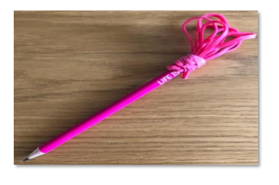  Create an elastic band paintbrush using a stick and some elastic bands. Paint yourself a picture. Could you make any other home made paint brushes?  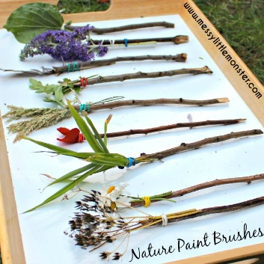 | Literacy  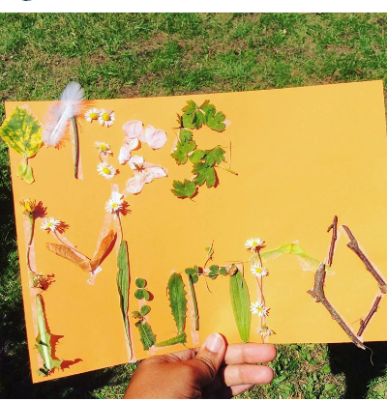  Using double sided tape, make your name. Then peel off the paper and find things around the garden or park to stick on to the tape to create your name. | Understanding the World  Use the plants and flowers hunt sheet or the i-spy scavenger hunt sheet to find different things around the garden or park. | Maths  Use the outdoor maths trail cards.

