Acorn Class Home Learning Plans – 15.06.20 (week 10)
Please continue to upload anything you do at home on to Tapestry or email them to acorn@st-barnabas.kent.sch.uk , we would love to see what you and your child have been getting up to
If you need any advice or support email – acorn@st-barnabas.kent.sch.uk and I will do my best to help.
Paper copies of plans and resources can be obtained from School Office on Mondays between 1pm – 3pm.
This is the timetable we are following in class with the children that are back in school; you may wish to follow this at home:

 | Monday |  | Tuesday | Wednesday |  |  | Thursday |  | Friday
9.15-9.30 | Morning activities |  |  |  |  |  |  |  | Use this time to recap and consolidate learning done this week and previous weeks. Complete any activities that have not been done.
9.30-9.50 | Phonics |  | Phonics | Phonics |  |  | Phonics
9.50-10.30 | Child Initiated Learning Time
10.30-10.45 | Snack, story
10.45-11.30 | Child Initiated Learning Time
11.30-12 | Teacher directed activity - | Teacher directed activity - PE |  | Teacher directed activity - |  | Teacher directed activity - RE
12-12.30 | Outside Play
12.30-12.50 | Eat lunch
12.50-1.00 | Wake and shake
1.00-1.20 | Maths | Maths |  |  | Maths |  |  | Maths
1.20-1.50 | Child Initiated Learning Time
1.50-2.10 | Story
Reading
- Use the teacher directed story times to share a story with your child and discuss some of the questions listed below:

- (Looking at the front cover) – What do you think this story is about?
- What did __________ (character) just do?
- Why do you think they did that?
- What do you think ________ (character is like?
- What do you think will happen next?
- Why do you think that?
- Which part of the story did you like the best? Why?
- Which part of the story did you like the least? Why?
- How did the story start?
- What happened at the end of the story?
- What happened in the middle of the story?
- What does _______ (character) feel like at the end?
- How did this story make you feel?
- Who are the characters in the story?
- If you were _________ (character), what would you have done?
You may also like to do a separate reading time where your child reads to you. You can access….
Big Cat reading ebooks - https://connect.collins.co.uk/school/Portal.aspx select ‘Teacher’ and use the log in Username: parents@harpercollins.co.uk Password: Parents20!
Oxford Owl ebooks - https://www.oxfordowl.co.uk/ select ‘My class login’ and use the log in Username: stbacornclass1 Password: dog123
Phonics Play Comics - https://phonicsplaycomics.co.uk/comics.html
I will also send home one phonics mini book each week (starting with week 10) for you to cut out and read at home.
Please also look at the ‘Summer Reading Challenge’ letter sent home with this week’s pack.
Wake and Shake
- Use the ‘Wake and Shake’ time to do some of ‘Just Dance’ routines or GoNoodle which can be found on www.youtube.com or make up your own dance routines to a song

Child Initiated
- Use the child initiated learning time to allow your child access to the toys, games and resources they have at home. You may wish to use any of the resources sent out in previous weeks or complete the daily challenge

Things highlighted in yellow were sent home on Thursday 19th March in brown envelopes for ‘home learning’. Phase 4 tricky word flashcards sent home week in week 8.
Things written in red have been included with this week’s pack.
Phonics activites have no split into phases.
If your child cannot identify the sounds s a t p I n confidently, they are working at phase 1
If your child can identify some of the sounds s a t p i n m d g o c k ck e u r h b f ff l ll ss, they are working at phase 2
If your child can identify most or all of the sounds s a t p i n m d g o c k ck e u r h b f ff l ll ss j v w x y z zz, they are working at phase 2 and the beginning of phase 3
If your child can identify some of the sounds ss j v w x y z zz qu ch sh th ng ai ee igh oa oo ar or ur ow oi ear air ure er, they are working at phase 3
If your child can identify most or all of the sounds j v w x y z zz qu ch sh th ng ai ee igh oa oo ar or ur ow oi ear air ure er, they are working at phase 3 and beginning phase 4.
If your child is working beyond phase 3 or 4 and you need more activity ideas, please contact Miss Traviss on acorn@st-barnabas.kent.sch.uk

You may want to watch the video ‘Phonics with Miss Traviss – Full Phase 3 recap’ on Tapestry (uploaded 4th May).
Sound pronunciation - https://www.youtube.com/watch?v=IwJx1NSineE
Sounds taught so far - s a t p i n m d g o c k ck e u r h b f ff l ll ss j v w x y z zz qu ch sh th ng ai ee igh oa oo ar or ur ow oi ear air ure er
Tricky words taught so far - The I to a to go no into put of he she we me be my was you they all are said
High frequency words taught so far – mum in at on an if off his had it got back can dad get him big and up as but not will see now for her down look that too with them then this said
 | Monday 15th | Tuesday 16th | Wednesday 17th | Thursday 18th | Friday 19th
Phonics | Recap letter names, sounds and high frequency (see below) learnt so far.  You can use the flashcards or Phonics Play (flashcards or tricky word trucks).  Teach  Choose the sounds you feel your child needs to practise and recap  Activity  Phase 1:  Play who am i? Cut up the cards and lay out the pictures. Adult reads the cards, can your child guess the animal?  Phase 2:  Complete caption and picture matching or word and picture matching activities  Phase 3:  Complete caption and picture matching or I can read activities | Recap letter names, sounds and high frequency (see below) learnt so far.  Teach  Choose the sounds you feel your child needs to practise and recap  Activity  Phase 1:  Play I spy, sound out the words instead of saying the word. E.g. I spy with my little eye a c-a-t  Phase 2:  Dictate some words or sentence for your child to write. Use the phase 2 words and sentences to support. Or use the phase 2 pictures and caption writing frames.  Phase 3:  Dictate some words or sentence for your child to write. Use the phase 3 words and sentences to support. Or use the phase 3 pictures and caption writing frames. | Recap letter names, sounds and high frequency (see below) learnt so far.  Teach  Choose the sounds you feel your child needs to practise and recap  Activity  Phase 1:  Find the rhyming pairs using the rhyming cards.  Phase 2:  Complete I can read or snakes and ladders.  Phase 3:  Complete the phonics activity mat. | Recap letter names, sounds and high frequency (see below) learnt so far.  Teach  Teach tricky word ‘have’ – introduce with the flashcard. Talk about why this word is a tricky word? It sounds like it should be written h-a-v  Activity  Phase 1:  Think of a sentence using the tricky word have.  Can you find different things around the house that make a sound? Talk about how the sounds sound different.  Phase 2:  Think of a sentence using the tricky word have.  Complete Phase 2 tricky word activity book  Continue  Phase 3:  Write a two sentences using the tricky word ‘have’. | Use this time to recap and consolidate learning done this week and previous weeks.
Maths | Recap  Play Ladybird counting on topmarks https://www.topmarks.co.uk/learning-to-count/ladybird-spots  Teach  Using the number flash card ask your child to put the numbers 0-20 in the correct order (or as high as they can go) then using small objects (e.g. lego buttons counters) put the correct number of items next to the number | Recap  Play number ispy  Teach  Cut out the numicon and find different ways of making 10 (or teen numbers of your choice). Can you challenge yourself and use more than two numbers? | Recap  Show your child 10 objects, ask them to close their eyes. Take some of the objects away. Can they work out how many you took based on how many are left?  Teach  Complete subtraction sheet | Recap  Show you child a number flashcard, can they show you that many objects either by drawing or collecting them  Teach  Give your child a number, can they tell you what one less than that number is. | Use this time to recap and consolidate learning done this week and previous weeks.
Teacher Directed | Writing  Follow the ‘How to draw a car’ instructions to draw a car or watch Miss Traviss’ video on Tapestry called ‘Writing 4’.  A writing template has been provided for you.  Then think of a sentence about the car to write. Remember to use your phonics sounds, adults – do not worry if not everything is spelt correctly! | PE  Go to the park.  Warm up – jog on the spot. Ask a grown up to tell you where to put your hands while jogging e,g, on your head, tummy, shoulders, nose etc.  Running - Decide on a start and finish line. Think about how you would start, how would you feet be postioned? Think about using your arms to help you run faster. Now have a race against someone in your family. Talk about who ran the fastest so they came 1st, 2nd etc  Throwing – Using balls or beans bags. Get members of your family to throw them. Who could throw theirs the furthest? | Creative  Make puffy paint.  Mix equal parts of shaving foam/cream and pva glue.  Once mixed, transfer to smaller pots and add food colouring of the desired colours.  Add more shaving foam/cream if needed to make it more puffy.    Create your picture using your new paints! | RE  What can we learn from the old Testament?  Think about sleeping, what happens when we sleep? What are dreams? Do we all have dreams? What dreams can you remember that you have had?  Some Christians believe that dreams can be messages from God.  Remind ourselves of the special book where all these stories come from. The front is about before Jesus is born, can you remember what its called? What about the part where Jesus had been born?  Read the second part of the story of Joseph.  Emphasis that Joseph believed that whatever happened to him, God would be with him. This is what Christians still believe today. Joseph also believed that God gave him the gift of reading dreams.
Challenge | Reading  Read or listen to the story ‘The Rainbow Fish’. https://www.youtube.com/watch?v=Z3cmddZh6t8  Talk about…  Why you think no one wants to play with Rainbow Fish?  What could he have done differently?  Do you think he should share his scales?  Why does Rainbow Fish now feel happy?  What could you share with your friends to make you feel happy? | Creative  Make your Dad or another special male in your life a Father’s Day card.  Have a go at folding some card and paper in half and then decorate it. Here are some easy ideas:  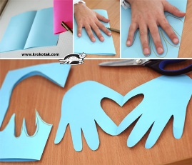  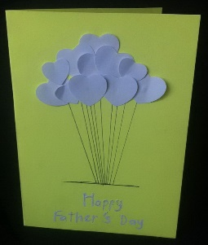  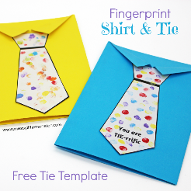  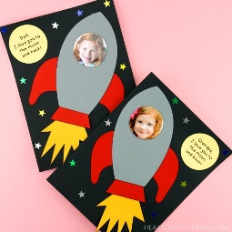 | Communication and Language  At home helicopter stories.  You will need a pen and paper. Ask a grown up to write down your story as you tell it. (Grown ups make sure your write down exactly what your child has said even if their grammar is incorrect). Once you have finished telling your story, ask the grown up to read it back to you to check it is correct.  Then if you have enough people in your household, act your story out. If not, send it in an email to Miss Traviss so we can act it out in school when we are back together. | Writing  Can you write a sentence about the picture?  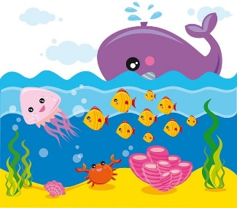 | PSED/HSC  Play animal bingo

