Acorn Class Home Learning Plans – 01.06.20 (week 8)
Thank you to all those parents who have been in contact via email or Tapestry or have contacted the school to say they need further support. So far I have had 10 out of 30 parents post on Tapestry since the start of ‘lockdown’ 6 of these have been at least twice a week. Only 5 out of 30 children have accessed work via Purple Mash. It would be great if we could get these figures much higher!
Please continue to upload anything you do at home on to Tapestry or email them to acorn@st-barnabas.kent.sch.uk , we would love to see what you and your child have been getting up to
If you need any advice or support email – acorn@st-barnabas.kent.sch.uk and I will do my best to help.
Paper copies of plans and resources can be obtained from School Office on Mondays between 1pm – 3pm.
Here is our ‘usual’ class timetable if you would like the follow this at home:
 | Monday | Tuesday | Wednesday | Thursday | Friday
8.45-9.10 | Morning activities and daily mile (6 laps running or walking round the playground)
9.10-9.40 | Phonics | Phonics | Phonics | PE | Phonics
9.40-11.20 | Child Initiated Learning Time |  |  | PE | Child Initiated Learning Time
11.20-11.45 | Teacher directed activity – Story | Teacher directed activity – Writing | Teacher directed activity – RE | Teacher directed activity – Story | Teacher directed activity – Maths
11.45-12 | Get ready for lunch – sing counting songs, nursery rhymes or watch Geraldine the Giraffe
12-12.45 | Lunchtime
12.45-1 | Chat about lunch, Wake and Shake
1-1.30 | Maths | Maths | Maths | Phonics | Library
1.30-2.30 | Child Initiated Learning Time
2.30-3 | Get ready for home, story

- Use the teacher directed story times to share a story with your child and discuss some of the questions listed on the Acorn Class Home Learning Weekly Schedule (sent out in week 1)
- Use the daily mile and PE times to do Joe Wick’s PE lessons via https://www.youtube.com/user/thebodycoach1 at 9am each day or some Yoga via https://www.youtube.com/user/CosmicKidsYoga

- Use the ‘Wake and Shake’ time to do some of ‘Just Dance’ routines or GoNoodle which can be found on www.youtube.com or make up your own dance routines to a song
- Use the child initiated learning time to allow your child access to the toys, games and resources they have at home. You may wish to use any of the resources sent out in previous weeks.

Things highlighted in yellow were sent home on Thursday 19th March in brown envelopes for ‘home learning’
Things written in red have been included with this week’s pack.
 | Monday 1st | Tuesday 2nd | Wednesday 3rd | Thursday 4th | Friday 5th
Phonics | Recap letter names, sounds and high frequency (see below) learnt so far.  You do not have to practise all of them at once and may wish to choose a few each day to focus on.  You can use the flashcards or Phonics Play (flashcards or tricky word trucks).  Teach ai  Using the flashcard remind yourself of the sound, what two letters make that sound, can you think of any words containing that sound?  Activity  Play pick a picture on Phonics Play (using phase 2 or phase 3 sounds) https://new.phonicsplay.co.uk/resources/phase/2/pick-a-picture  or  Write some ai words for your child to read, can they draw a picture to demonstrate their understanding.  Extension  Write a sentence using an ai word. | Recap letter names, sounds and high frequency (see below) learnt so far.  Teach ee  Using the flashcard remind yourself of the sound, what two letters make that sound, can you think of any words containing that sound?  Activity  Complete ai and ee words worksheet.  or  Complete the rhyming words worksheet.  Or  Read a story containing rhyming words (Julia Donaldson’s are a good starting point and write a list of the rhyming words that you find.  Extension  Write a sentence using an ee word. | Recap letter names, sounds and high frequency (see below) learnt so far.  Teach igh  Using the flashcard remind yourself of the sound, what three letters make that sound, can you think of any words containing that sound?  Activity  Complete igh workbook  Or  Play Alien Escape (phase 3) https://www.phonicsbloom.com/uk/game/alien-escape?phase=3  Extension  Write a sentence using an igh word. | Recap letter names, sounds and high frequency (see below) learnt so far.  Teach said  Using the flashcard, show you child the word. Do they know what it says? (if not tell your child the word), Then talk about the part that is tricky, how do you think you should spell it based on how it sounds? (s-e-d)  Activity  Choose an activity to complete from the reading tricky words sheet. | Recap letter names, sounds and high frequency (see below) learnt so far.  As explained before half term, Friday’s phonics are going to be sentence writing based around a picture we willl draw.  Watch the Tapestry video ‘Writing 3’  or use the how to draw demonstration and use the sentence ‘a snail has a shell’ or create your own.  There are two writing templates, one with phoneme frames which match the above sentence and one with a line so you can choose your own sentence.
Maths | Number 15  Recap Practise counting to 20, forwards and backwards  Teach  Watch the video ‘Number 15’ on Tapestry  Or introduce the number 15 using the flashcard, talk about what numbers are used to make it. Can you remember how much the 1 represents?  Count to 15, find 15 on a number line, count out 15 objects.  Watch https://www.bbc.co.uk/iplayer/episode/m00029tw/numberblocks-series-3-fifteen  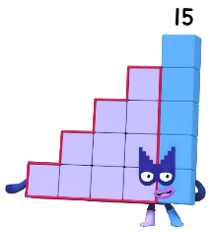  Complete ‘All about number 15’ worksheet  or  Create a poster about number 15 | Number 16  Recap Give your child a number to 10 and ask what is one more or one less than that number  Teach  Watch the video ‘Number 16’ on Tapestry  Or introduce the number 16 using the flashcard, talk about what numbers are used to make it. Can you remember how much the 1 represents?  Count to 16, find 16 on a number line, count out 16 objects.  Watch https://www.bbc.co.uk/iplayer/episode/m0005yfs/numberblocks-series-4-sixteen  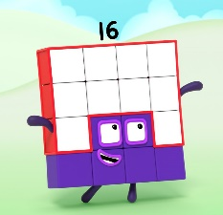  Complete ‘All about number 16’ worksheet  Or  Create a poster about number 16 | Number 17  Recap Give your child some verbal number sentences totalling up to 10, can they use their fingers to work them out?  Teach  Watch the video ‘Number 17’ on Tapestry  Or introduce the number 17 using the flashcard, talk about what numbers are used to make it. Can you remember how much the 1 represents?  Count to 17, find 17 on a number line, count out 17 objects.  Watch https://www.bbc.co.uk/iplayer/episode/m00063vv/numberblocks-series-4-seventeen  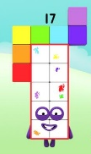  Complete All about number 17 worksheet  Or  Create a poster about number 17 | Number 18  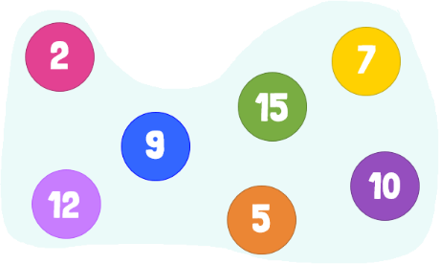  Recap Put these numbers in order  Teach  Watch the video ‘Number 18’ on Tapestry  Or introduce the number 18 using the flashcard, talk about what numbers are used to make it. Can you remember how much the 1 represents?  Count to 18, find 18 on a number line, count out 18 objects.  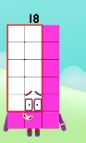  Watch https://www.bbc.co.uk/iplayer/episode/m00064tz/numberblocks-series-4-eighteen  Complete All about number 18 worksheet  Or  Create a poster about number 18 | Number 19  Recap Play Teddy Numbers using numbers to 15  https://www.topmarks.co.uk/learning-to-count/teddy-numbers  or  Using a teddy and a selection of objects, give your child a number of objects to give to their teddy  Teach  Watch the video ‘Number 19’ on Tapestry  Or introduce the number 19 using the flashcard, talk about what numbers are used to make it. Can you remember how much the 1 represents?  Count to 19, find 19 on a number line, count out 19 objects.  Watch https://www.bbc.co.uk/iplayer/episode/m000663t/numberblocks-series-4-nineteen  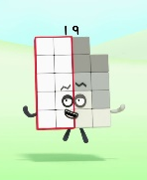  Complete All about number 19 worksheet  Or  Create a poster about number 19
RE | What can we learn from the old Testament?  Play a trust exercise, using a blind to cover your eyes and ask a family member to lead you around the room. How does it feel to trust someone?  Talk about siblings, who are your brothers and sisters? Are you an only child? What are good and bad things about having siblings? What happens when they fall out?  Remind yourself of last weeks story about Abraham and Sarah’s baby Isaac. When Isaac grew up he had twin sons.  Share part 1 of the story of Jacob and Esau or watch https://www.youtube.com/watch?v=hGs1WfRKIoM - What happens when people don’t keep to what they say? How do people feel when they are cheated? Why should promises be kept?  Share part 2 of the story and explain this is how Christians see their relationship with God. When they ask God for forgiveness, he gives it to them and is always there for them - Draw a picture of some twins to remind you of the story.
Challenge 1 | Reading/Writing  Using the Oxford Owl website https://www.oxfordowl.co.uk/ (see class login below)  Read the story ‘The King and his Wish’  Answer the questions….  - What did the King want?  - What happened when the red box was added?  Use the story map at the back of the book to retell the story  There are also two activities you may like to complete. | HSC  Talk about how often and when we should wash our hands.  Why is it important?  Complete the picture sequencing for hand washing. | Communication and Language  At home helicopter stories.  You will need a pen and paper. Ask a grown up to write down your story as you tell it. (Grown ups make sure your write down exactly what your child has said even if their grammar is incorrect). Once you have finished telling your story, ask the grown up to read it back to you to check it is correct.  Then if you have enough people in your household, act your story out. If not, send it in an email to Miss Traviss so we can act it out in school when we are back together. | PE  Start Mr Luckhurst’s challenge of Go to Greece! | Creative  Start the 30 day Lego challenge. We would love to see your models uploaded to Tapestry!
Challenge 2 | Creative  Have a go at making your own crown.  What colour might you choose?  How are you going to decorate it?  What rules would you make if you were the King or Queen? | The world  Make a passport for your teddy, you will need to add some blank pages to the template. Create a stamp for each country they visit, ask a member of your family to helo you find about a fact from the coutnries your teddy goes to.  You may also want to create your dinner using food that is eaten from that country. | Technology  Have a look at Miss Traviss’ picture on Purple Mash. https://www.purplemash.com/sch/stbarnabastn1  She has used her sounds to write the sentence, can you read it?  Now have a go at drawing your own picture and writing about it using your sounds. | Maths  Can you find three of the same objects in your house (e.g. teddy, cars, chairs) and put them in order from smallest to largest? | PSED  Learn to play snap or pairs with a member of your family.  If you don’t own a set of cards then you can always make your own by drawing pictures, make sure each pair of pictures is exactly the same!

You may want to watch the video ‘Phonics with Miss Traviss – Full Phase 3 recap’ on Tapestry (uploaded 4th May).
Sound pronunciation - https://www.youtube.com/watch?v=IwJx1NSineE
Sounds taught so far - s a t p i n m d g o c k ck e u r h b f ff l ll ss j v w x y z zz qu ch sh th ng ai ee igh oa oo ar or ur ow oi ear air ure er
Tricky words taught so far - The I to a to go no into put of he she we me be my was you they all are
High frequency words taught so far – mum in at on an if off his had it got back can dad get him big and up as but not will see now for her down look that too with them then this

Oxford Owl
Using Oxford Owl for School, this is our class login:
Class login – stbacornclass1
Password – dog123

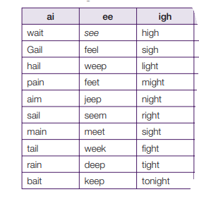
Suggested words:

