Picture | Actors | Action | Key Vocabulary
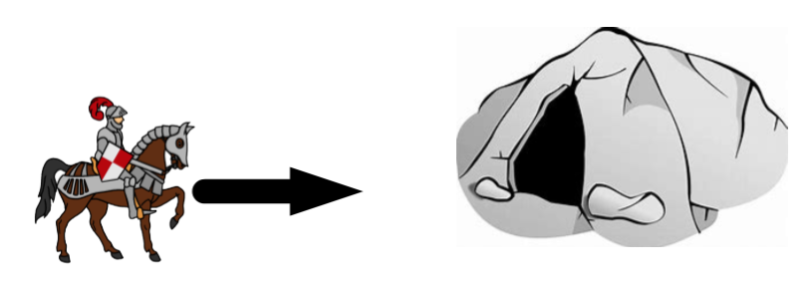 | Lady Glacier | saw  travelled  rode | cave
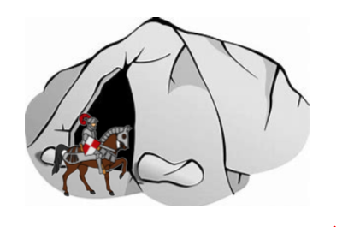 | Lady Glacier | went  entered  crept | cave  entrance
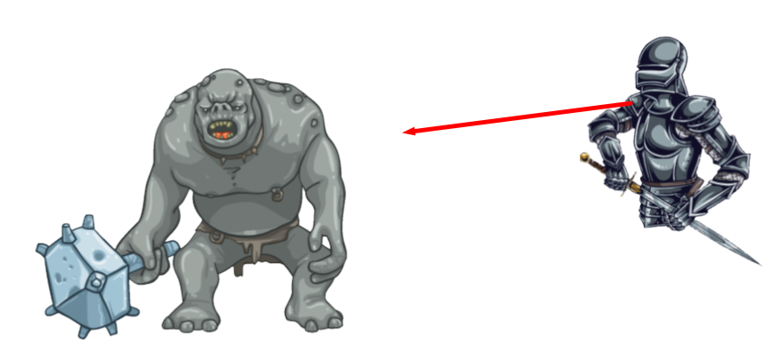 | Lady Glacier | saw  noticed  spotted  identified | disgusting  awful  hideous  the Stone Troll
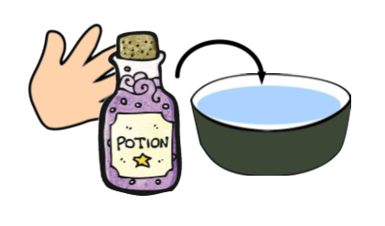 | Lady Glacier | poured  put  tipped | potion  drinking bowl  water
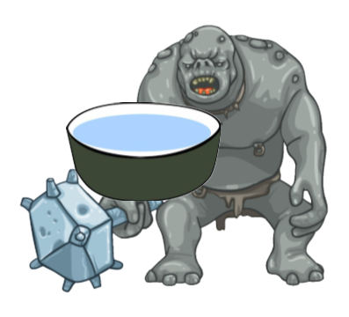 | the Cave Troll | drank  guzzled  slurped | drinking bowl  water
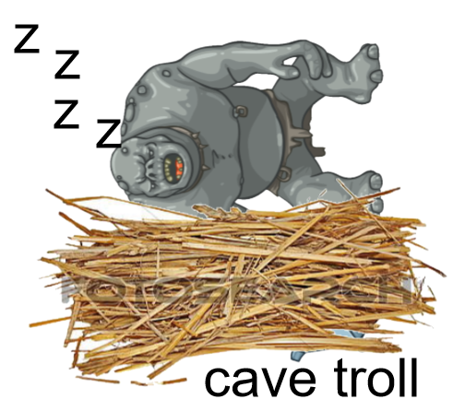 | the Cave Troll | fell asleep | bed  snored
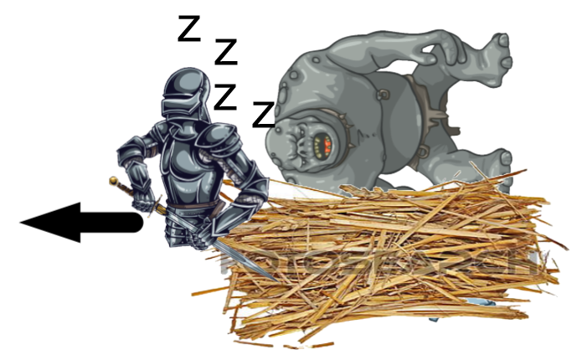 | Lady Glacier | crept  tiptoed  passed | bed  quietly  sneakily
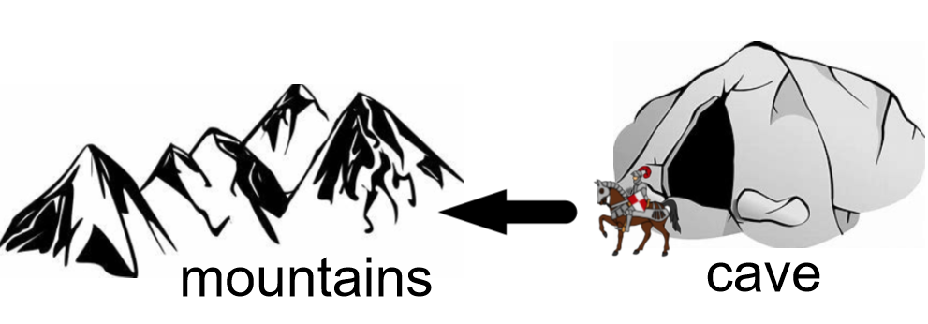 | Lady Glacier | continued  rode  travelled | cave  mountains  quest

