Beech Home Learning
(Due in Tuesday 3rd June- After Half Term)

In English and Communication this term we are learning about recount writing. For your home learning, we would like to recount something special that happened over the half term holidays. In order to help you, we have included a recount that Mr M wrote about a trip he took to Scotland.

Feel free to add pictures of other mementos from your trip to help add detail.

We can’t wait to find out about what you got up to!

Beech Home Learning
(Due in Tuesday 3rd June- After Half Term)

In English and Communication this term we are learning about recount writing. For your home learning, we would like to recount something special that happened over the half term holidays. In order to help you, we have included a recount that Mr M wrote about a trip he took to Scotland.

Feel free to add pictures of other mementos from your trip to help add detail.

We can’t wait to find out about what you got up to!

I can use subheadings to organise my ideas.
I can start sentences with adverbials which express time.
I can use conjunctions to join clauses.
I can use adjectives to create expanded noun phrases.
I can use exclamation sentences.
I can include sentences which communicate directly to the reader.

A Trip to Scotland
Getting on the Train
The day after we finished building the shed, my wife, baby Alfred and I went on a trip to Scotland. First of all, we got the train into London and got the underground to Euston train station. It was really good fun because Alfred had never been on a train before. The station was big, busy and exciting.
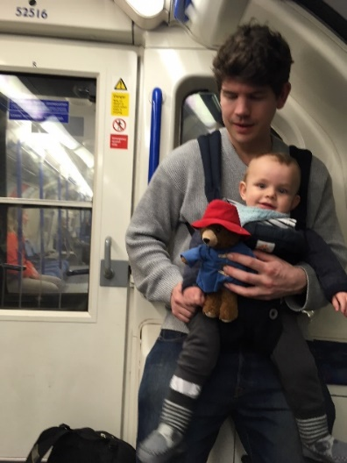
At 9pm, we got on the sleeper train. The carriage was tiny and cramped but we all managed to fit in. Alfred was very tired because it was past his bedtime so we all went to sleep straight away.
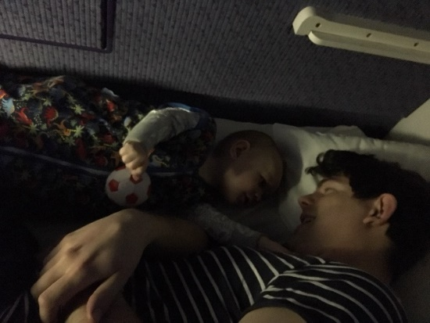
Arriving in Scotland
The next day, we woke up at sunrise and realised that we were in the snowy highlands of Scotland. When we were all dressed and ready, we went to the dining car and ate delicious bacon sandwiches for breakfast. The views were amazing!
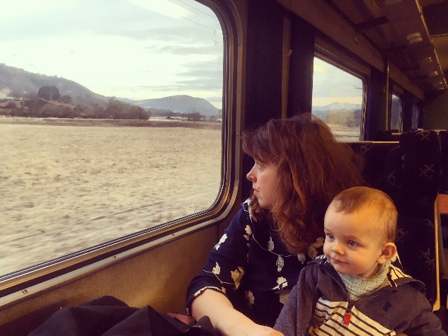
Visiting my Aunty
As soon as we arrived in Scotland, we travelled to my auntie’s house. Fred loved meeting her because she read lots of stories to him.
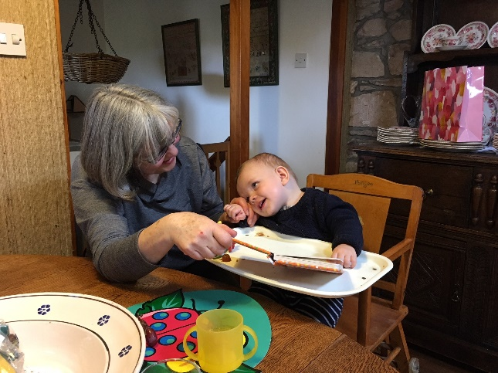
Fun Activities
During our trip to Scotland, we did some really interesting activities. We visited Loch Ness but we didn’t see the monster. We went to the beautiful, sandy beach and played with a football. One day, we even go to make a snowman because it snowed so much!
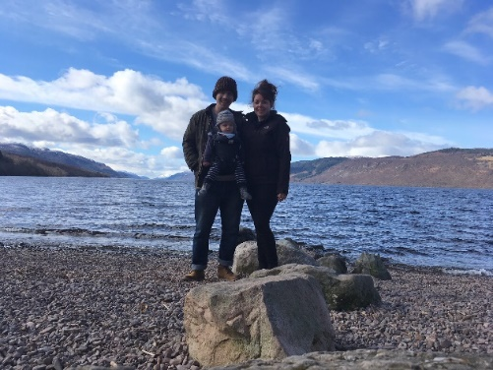

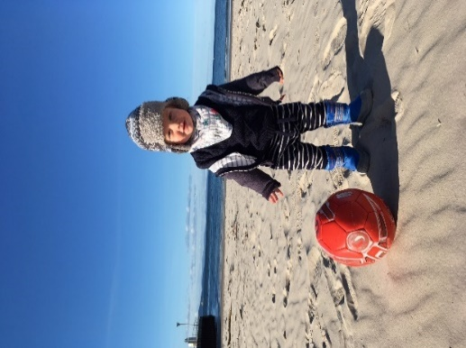 | 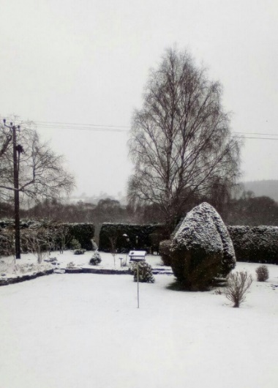
Returning Home
Finally, we flew back home. It was Alfred’s first time on an aeroplane so we were a bit nervous but he really enjoyed it.
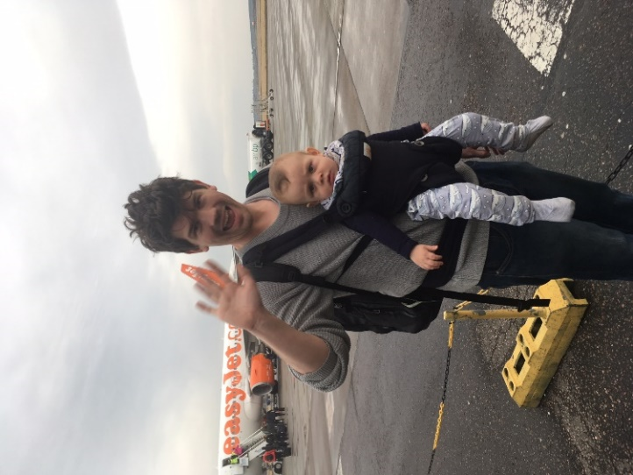
What a fantastic trip it was! Have you ever visited anywhere interesting in the holidays? Could you write a recount of your experiences?

