Acorn Class Home Learning Plans - 27.04.2020
Things written in red have been sent home with week 1 plans or detailed on Acorn Class Home Learning Weekly Schedule or Wider Curriculum Home Learning Matrix
Things written in green have been sent home with week 2 plans
Things highlighted in yellow were sent home on Thursday 19th March in brown envelopes for ‘home learning’
Things written in pink have been sent home with week 3 plans
Things written in blue have been sent home with week 4 plans
Please continue to upload anything you do at home on to Tapestry or email them to acorn@st-barnabas.kent.sch.uk , we would love to see what you and your child have been getting up to
If you need any advice or support email – acorn@st-barnabas.kent.sch.uk and I will do my best to help.
Paper copies of plans and resources can be obtained from School Office.
Here is our ‘usual’ class timetable if you would like the follow this at home:
 | Monday | Tuesday | Wednesday | Thursday | Friday
8.45-9.10 | Morning activities and daily mile (6 laps running or walking round the playground)
9.10-9.40 | Phonics | Phonics | Phonics | PE | Phonics
9.40-11.20 | Child Initiated Learning Time |  |  | PE | Child Initiated Learning Time
11.20-11.45 | Teacher directed activity – Story | Teacher directed activity – Writing | Teacher directed activity – RE | Teacher directed activity – Story | Teacher directed activity – Maths
11.45-12 | Get ready for lunch – sing counting songs, nursery rhymes or watch Geraldine the Giraffe
12-12.45 | Lunchtime
12.45-1 | Chat about lunch, Wake and Shake
1-1.30 | Maths | Maths | Maths | Phonics | Library
1.30-2.30 | Child Initiated Learning Time
2.30-3 | Get ready for home, story

- Use the teacher directed story times to share a story with your child and discuss some of the questions listed on the Acorn Class Home Learning Weekly Schedule. Please refer to the document title ‘Reading’ to support you further. The story ‘Coronavirus – A Book for Children’ has been included in this weeks resources.

- Use the teacher directed writing time to do a piece of writing or mark making (refer to the Acorn Class Home Learning Weekly Schedule for ideas). There is also the ‘how to draw’ pictures we use in class, your child can then write a short sentence about their picture

- Use the daily mile and PE times to do Joe Wick’s PE lessons via https://www.youtube.com/user/thebodycoach1 at 9am each day or some Yoga via https://www.youtube.com/user/CosmicKidsYoga or use the PE challenges cards or use the ‘Keep Well and Active at Home’ poster

- Use the ‘Wake and Shake’ time to do some of ‘Just Dance’ routines or GoNoodle which can be found on www.youtube.com or make up your own dance routines to a song

- Use the child initiated learning time to allow your child access to the toys, games and resources they have at home or pick some activities from the:
- Wider Curriculum Home Learning Matrix – Week 1
- Wider Curriculum Home Learning Matrix – Week 3
- Practical ideas booklet
- Any of the other activities that are sent home via Parentmail or in the home learning pack.
- Any of the Easter holiday activities uploaded to Tapestry
- Some of the activities added to the ‘activity’ tab on Tapestry

- The following social media pages may be helpful for other ideas to do with your child:

Facebook

Mrs Smiths Online Phonics

Instagram

Miss_funro

Seize.the.play

Sarahjudge27

Mrs_simmons_says_

Leighwoodseyfs

Minicheddarz0412

Youtube.com

Woolro & Co

Mr Mc
RE –How can we help others when they need it?
Talk about the two great commandments that Jesus gave – Love God and Love your neighbour as you love myself. Talk about what these commandments mean.
Read the story of ‘The Good Samaritan’ (Luke 10:25-37) or https://www.youtube.com/watch?v=osfQg4yKtq8 and talk about what the phrase ‘a good Samaritan’ might mean (it is a term for someone who does a good deed). Talk about who is the hero in the story? What does the story teach about helping?
Talk about what grown-ups or children could do to be ‘good Samaritans’ during this time, for example, shopping for elderly or vulnerable friends and neighbours, listening to grown-ups or doctors and nurses looking after ill people in hospital and at risk of getting ill themselves.
Other activities you could do….
- Dress up as a superhero and talk about what your superhero would be like
- Read ‘The Snail and the Whale’ by Julia Donaldson or watch https://www.bbc.co.uk/iplayer/episode/m000cslw/the-snail-and-the-whale. Who is the hero in this story?
- Christians talk to God when they need help. Think about who you would talk to.

Monday 27th April
Phonics
Recap
Put the flash cards in alphabetical order and sing the alphabet while pointing to the correct letter or listening to https://www.youtube.com/watch?v=jPVbJ-IaHIw
Recap sounds and words taught so far using the flash cards or www.phonicsplay.co.uk (see week 1 home learning plans)
Sound pronunciation - https://www.youtube.com/watch?v=IwJx1NSineE
Sounds taught so far - s a t p i n m d g o c k ck e u r h b f ff l ll ss j v w x y z zz qu ch sh th ng ai ee igh oa oo ar or ur ow oi
Words taught so far - The I to a to go no into put of he she we me be my was you

Teach
ear as in the word beard.
Use the flashcard and discuss with your child which three letters make this sound.
See pronunciation link above to ensure you are pronouncing the sound correctly.
Watch ‘Geraldine the Giraffe Learns ear’ https://www.youtube.com/watch?v=EneZ1UubxSA or ‘Mr Thorne Does Phonics’ https://www.youtube.com/watch?v=dHe3Ripnt08
Or
Watch ‘Phonics with Miss Traviss – ear (as in ear) on Tapestry

Can your child think of any words with the ear sound in? – make a list of words together, if they cannot think of any give them some ideas and it may spur them on to think of some more.
If you child thinks of a word with the ear sound in that is not the same spelling (e.g. here, beer, pier) then congratulate them on hearing the or sound and explain that there are different ways of writing it.
Practise and Apply
Choose one of these activities…….
- Dictate some of the following words for your child to write (either using pencil/pen or magnetic letters)
- Write out some of the words for your child to read and they can draw a picture to show they have understood what they have read
- Think of a sentence with these words in and write the sentence together with your child
- Dictate a sentence for your child to write
- Pick game to play from www.phonicsplay.com
- Play one of the games from Phase 2 or Phase 3 on http://www.letters-and-sounds.com/
Complete one of the activities from this week’s pack….
- Read and match phase 2
- Phase 3 i-spy and read
- Initial sounds worksheet
- Ear booklet
- ear real and nonsense words colouring – encourage your child to read the words, if they think it is a real word, ask them to put it into a sentence to prove it
- Play what’s in the box –use the word cards and pictures or objects. Put the words in a box, children read the words and find the matching picture or object

Suggested words and sentences:
- ear
- tear
- beard
- gear
- dear
- hear
- near
- year
- rear

- It has been hot this year.
- The man has a big beard.

Maths

Recap
Practise counting to 20 – do this allowed or using one of the following videos:
https://www.youtube.com/watch?v=0VLxWIHRD4E
https://www.youtube.com/watch?v=_MVzXKfr6e8
https://www.youtube.com/watch?v=D0Ajq682yrA
Teach
This week we are looking at adding. The children need to understand that the amount changes when you add more.
At first your child may need to recount all of the items to see how many altogether. E.g. 1 2 3 4 5 6 7 When they are ready encourage your child to count 4 5 6 7.
To practise this….
- Start counting at different numbers, does your child know what comes next?
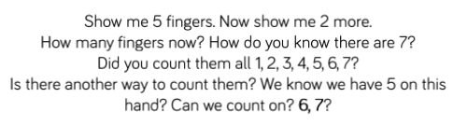
- Start counting e.g 1 2 3 then ask your child to say the next three numbers. Continue taking turns to count

Share the bus maths story with your child or watch the video on Tapestry called Simple Maths Story 1
Then use the bus, people and the 10s frame to create your own simple maths story. Can you have a go at counting on from the last number you got to?

Tuesday 28th April
Phonics
Recap
Put the flash cards in alphabetical order and sing the alphabet while pointing to the correct letter or listening to https://www.youtube.com/watch?v=jPVbJ-IaHIw

Recap sounds and words taught so far using the flash cards or www.phonicsplay.co.uk (see week 1 home learning plans)
Sound pronunciation - https://www.youtube.com/watch?v=IwJx1NSineE
Sounds taught so far - s a t p i n m d g o c k ck e u r h b f ff l ll ss j v w x y z zz qu ch sh th ng ai ee igh oa oo ar or ur ow oi ear
Words taught so far - The I to a to go no into put of he she we me be my was you

Teach
air as in the word hair.
Use the flashcard and discuss with your child which three letters make this sound.
See pronunciation link above to ensure you are pronouncing the sound correctly.
Watch ‘Geraldine the Giraffe Learns air’ https://www.youtube.com/watch?v=NcHIX2xK--A or ‘Mr Thorne Does Phonics’ https://www.youtube.com/watch?v=f3X0SrSeIas
Or
Watch ‘Phonics with Miss Traviss – air (as in hair) on Tapestry

Can your child think of any words with the air sound in? – make a list of words together, if they cannot think of any give them some ideas and it may spur them on to think of some more.
If you child thinks of a word with the air sound in that is not the same spelling (e.g. pear, care) then congratulate them on hearing the or sound and explain that there are different ways of writing it.
Practise and Apply
Choose one of these activities…….
- Dictate some of the following words for your child to write (either using pencil/pen or magnetic letters)
- Write out some of the words for your child to read and they can draw a picture to show they have understood what they have read
- Think of a sentence with these words in and write the sentence together with your child
- Dictate a sentence for your child to write
- Pick game to play from www.phonicsplay.com
- Play one of the games from Phase 2 or Phase 3 on http://www.letters-and-sounds.com/
Complete one of the activities from this week’s pack….
- Read and match phase 2
- Phase 3 i-spy and read
- Initial sounds worksheet
- air booklet
- air real and nonsense words colouring – encourage your child to read the words, if they think it is a real word, ask them to put it into a sentence to prove it
- Play what’s in the box –use the word cards and pictures or objects. Put the words in a box, children read the words and find the matching picture or object

Suggested words and sentences:
- air
- fair
- hair
- lair
- pair
- chair

- I sat on a chair.
- She has long hair.
- It is a pair of socks.

Maths
Recap
Choose one of the counting activities from yesterday’s lesson – start from different numbers, counting with someone etc

Teach
Watch the video Addition 1 on Tapestry where Miss Traviss explains how to keep a number in our head then count on.
or
Give your child an amount of objects (pens, Lego bricks etc) to count out. Roll a dice, keep the number in your head that you have already counted out and count on the number you rolled on the dice. How many have you got altogether?

If you don’t have a dice, you could make one using a cube shape box and add your own numbers or a random number generator with numbers 1-5 such as http://www.random.org
Continue to practise the above activity with different numbers. Your child may find it easier to use a number line to help them.

Wednesday 29th April
Phonics
Put the flash cards in alphabetical order and sing the alphabet while pointing to the correct letter or listening to https://www.youtube.com/watch?v=jPVbJ-IaHIw
Recap sounds and words taught so far using the flash cards or www.phonicsplay.co.uk (see week 1 home learning plans)
Sound pronunciation - https://www.youtube.com/watch?v=IwJx1NSineE
Sounds taught so far - s a t p i n m d g o c k ck e u r h b f ff l ll ss j v w x y z zz qu ch sh th ng ai ee igh oa oo ar or ur ow oi ear air
Words taught so far - The I to a to go no into put of he she we me be my was you

Teach
ure as in the word pure.
Use the flashcard and discuss with your child which two letters make this sound.
See pronunciation link above to ensure you are pronouncing the sound correctly.
Watch ‘Geraldine the Giraffe Learns ure’ https://www.youtube.com/watch?v=YwCzf71flBA or ‘Mr Thorne Does Phonics’ https://www.youtube.com/watch?v=IK8m-5JQmso
Or
Watch ‘Phonics with Miss Traviss – ure (as in pure) on Tapestry

Can your child think of any words with the ure sound in? – make a list of words together, if they cannot think of any give them some ideas and it may spur them on to think of some more.
Practise and Apply
Choose one of these activities…….
- Dictate some of the following words for your child to write (either using pencil/pen or magnetic letters)
- Write out some of the words for your child to read and they can draw a picture to show they have understood what they have read
- Think of a sentence with these words in and write the sentence together with your child
- Dictate a sentence for your child to write
- Pick game to play from www.phonicsplay.com
- Play one of the games from Phase 2 or Phase 3 on http://www.letters-and-sounds.com/
Complete one of the activities from this week’s pack….
- Read and match phase 2
- Phase 3 i-spy and read
- Initial sounds worksheet
- Play what’s in the box –use the word cards and pictures or objects. Put the words in a box, children read the words and find the matching picture or object

Suggested words and sentences:
- mature
- pure
- insure
- cure
- secure
- manure

- I can insure my car.
- I can smell the manure.

Maths
Recap
Give your child some verbal addition sentences….
e.g.
“If I had 2 dogs and 2 more came along, how many do I have altogether?”
Remind your child to keep the 2 in their head and count on 2 more using their fingers.
Then show your child the + sign, can they remember what is means.
Teach
Watch the video Addition 2 on Tapestry where Miss Traviss explains how to count on when adding.
or
Using the number cards put a number (1-5) out for your child. The write an + sign, leave a gap and wreit =. Then roll a dice or ask them to count out a number of stones/bricks/counters etc and put them inbetween the + and =
Remind your child to keep the number in their head and count on with the objects you have counted out. Once they have worked out the answer they can write is next to =
Continue to practise the above activity with different numbers.

Thursday 30th April
Phonics
Put the flash cards in alphabetical order and sing the alphabet while pointing to the correct letter or listening to https://www.youtube.com/watch?v=jPVbJ-IaHIw
Recap sounds and words taught so far using the flash cards or www.phonicsplay.co.uk (see week 1 home learning plans)
Sound pronunciation - https://www.youtube.com/watch?v=IwJx1NSineE
Sounds taught so far - s a t p i n m d g o c k ck e u r h b f ff l ll ss j v w x y z zz qu ch sh th ng ai ee igh oa oo ar or ur ow oi ear air ure
Words taught so far - The I to a to go no into put of he she we me be my was you

Teach
Tricky word – they
Use your created flashcard and discuss with your child what the ‘tricky’ part of this word is (e and y, it sounds like the word should be spelt they)
Can your child think of a sentence with the word you in?
Practise and Apply
Choose one of these activities…….
- Practise writing was and other tricky and high frequency words learnt so far
- Make tricky and high frequency words using the flash cards or magnetic letters
- Make tricky word snap
- Hide tricky words around the house for your children to find and say/write
- Think of a sentence with this week’s tricky word in and write the sentence together with your child
- Dictate a sentence for your child to write
- Play Phase 2 or Phase 3 Tricky Word Bingo
- Listen to ‘The Tricky Word’ songs – Phase 2 https://www.youtube.com/watch?v=TvMyssfAUx0 Phase 3 https://www.youtube.com/watch?v=R087lYrRpgY
- Some activities on this website - https://www.phonicshero.com/tricky-words-activities/
- Make tricky word hopscotch

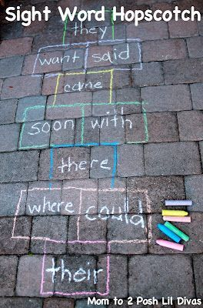

Suggested sentences:
- They can get fish and chips.
- They peck up the corn in the farmyard.
- They can sing songs.

Friday 1st May
Phonics
Put the flash cards in alphabetical order and sing the alphabet while pointing to the correct letter or listening to https://www.youtube.com/watch?v=jPVbJ-IaHIw
Recap sounds and words taught so far using the flash cards or www.phonicsplay.co.uk (see week 1 home learning plans)
Sound pronunciation - https://www.youtube.com/watch?v=IwJx1NSineE
Sounds taught so far - s a t p i n m d g o c k ck e u r h b f ff l ll ss j v w x y z zz qu ch sh th ng ai ee igh oa oo ar or ur ow oi ear air ure
Words taught so far - The I to a to go no into put of he she we me be my was you they

Teach
Recap the three sounds taught this week – ear air ure
These sounds children often find difficult to remember so please do not worry if your child is struggling to retain them.
Practise and Apply
Choose one of the activities listed on Monday – Thursdays lessons.

Maths
Recap
Using the number cards (0-10), put a selection in the correct order. Then take some away. Can your child tell your which numbers are missing?
Or
Give your child a selection of 5 numbers (0-10, they don’t have to be consecutive), can they put them in the correct order from smallest to largest.

Teach
Watch the video adding on a number line on Tapestry.
Or
Create some number sentences to 10 e.g.
5+2=
3+1=
4+4=
Ask your child to find the first number in the number sentence on their number line. Then demonstrate ‘jumps’ to add on the next number. What is the answer?
Ensure your child is doing accurate jumps that land on the next number before doing the next jump.
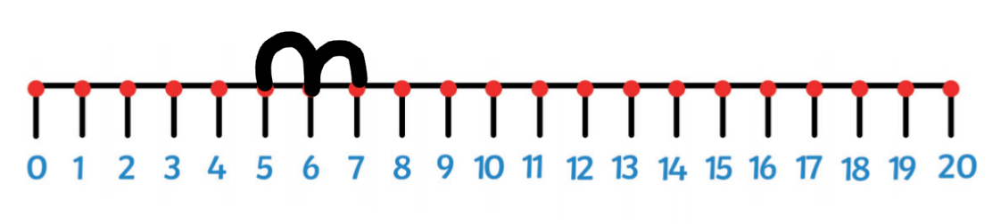

You could create a life size number line so your child can do the jumping.
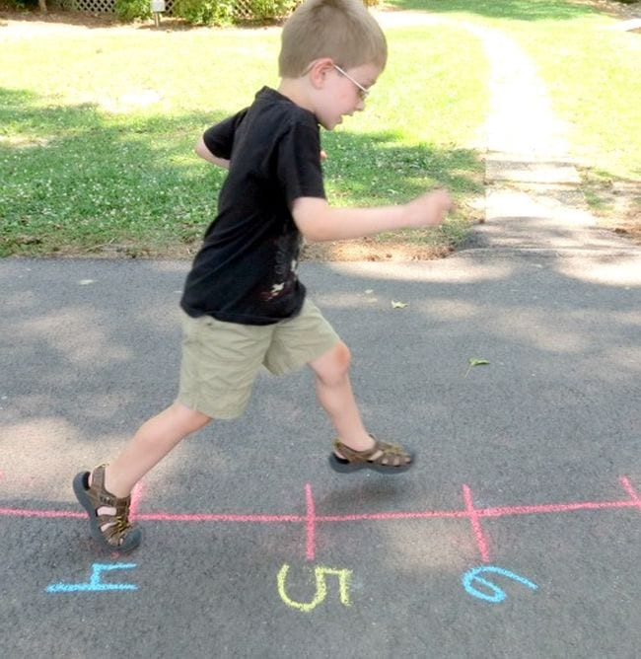

Continue to practise the above activity with different number sentences.

Further ideas to support…..



