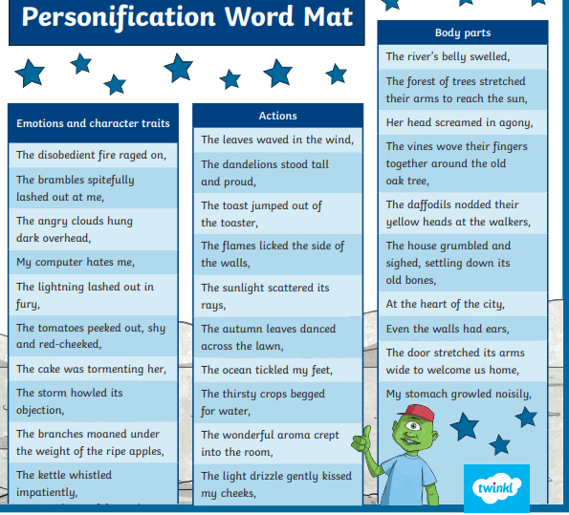
Homework due on Monday 24th March

We have been having lots of fun with personification in poetry. Choose an example of personification from the list above and illustrate it literally. You can do as many of these as you would like!

MATHS - you have a fractions activity on Purple Mash

