Lilac Class became programmers using a Crumble Kit
Lilac Class created a simple circuit and connected it to a microcontroller (the Crumble Controller). We programmed our Crumble to make an LED switch on. A Sparkle is a multi-colour LED designed to work with the Crumble. The crocodile leads connected the Sparkle to the Crumble. These connections provide power to light the LED and data for its colour.

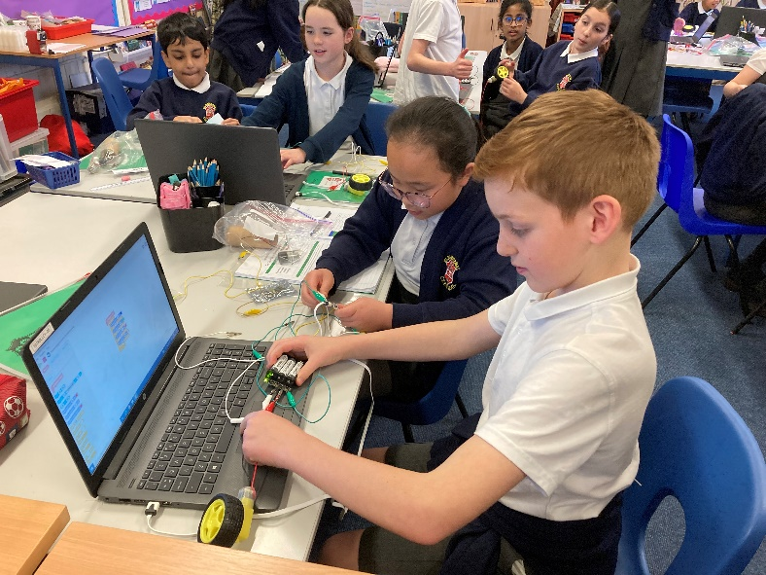
We also connected a motor as well as a Sparkle to our Crumble. We designed sequences that use count-controlled loops.


