During our Drama Geezers workshop (based on The Crown by Emily Kapff) we embarked on a journey to protect our planet with ‘Mission: Save our Planet’. The workshop involved storytelling that delved into the realities of climate change and environmental challenges.

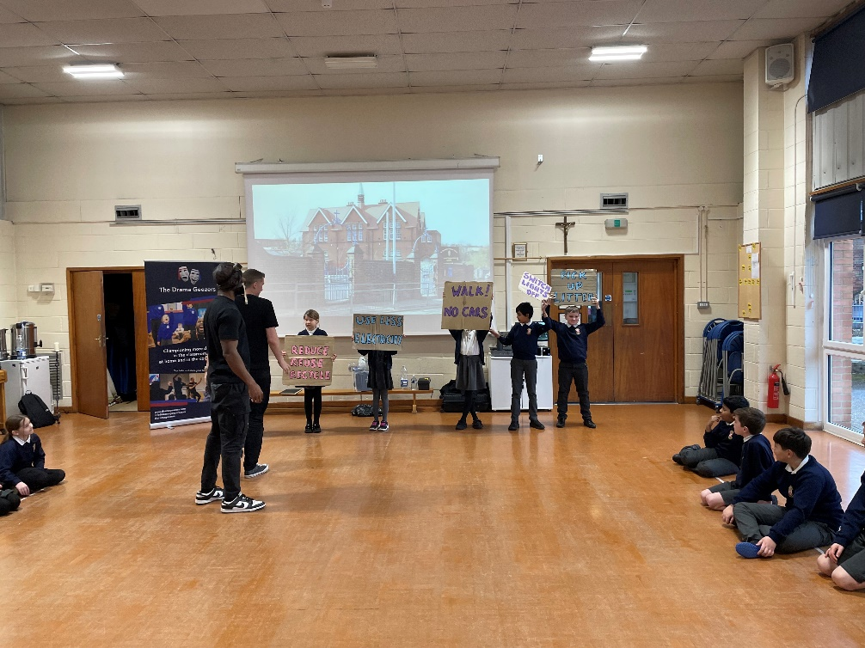
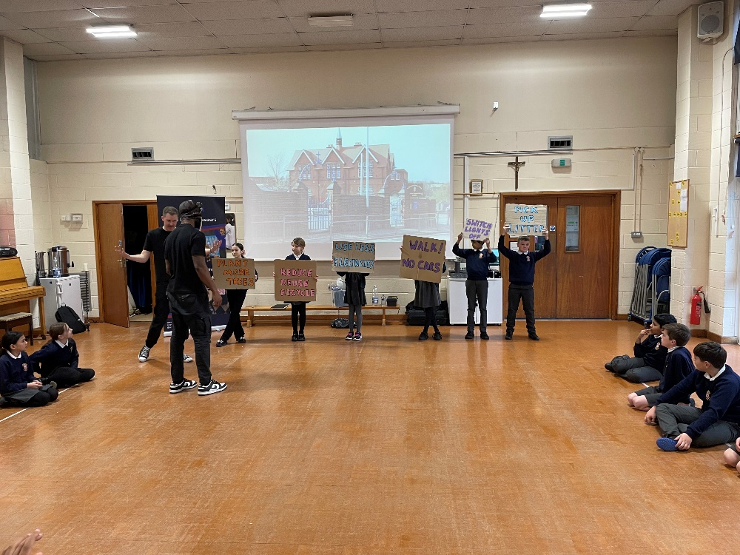
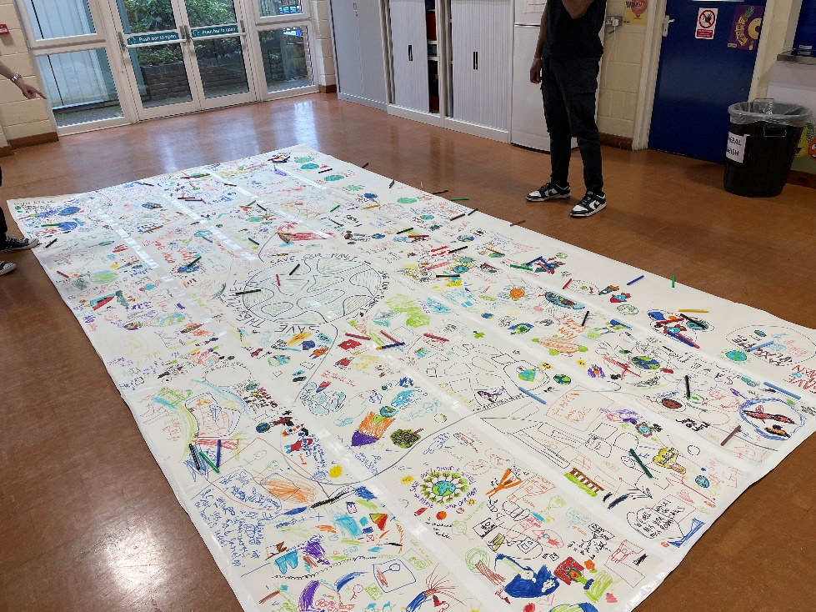

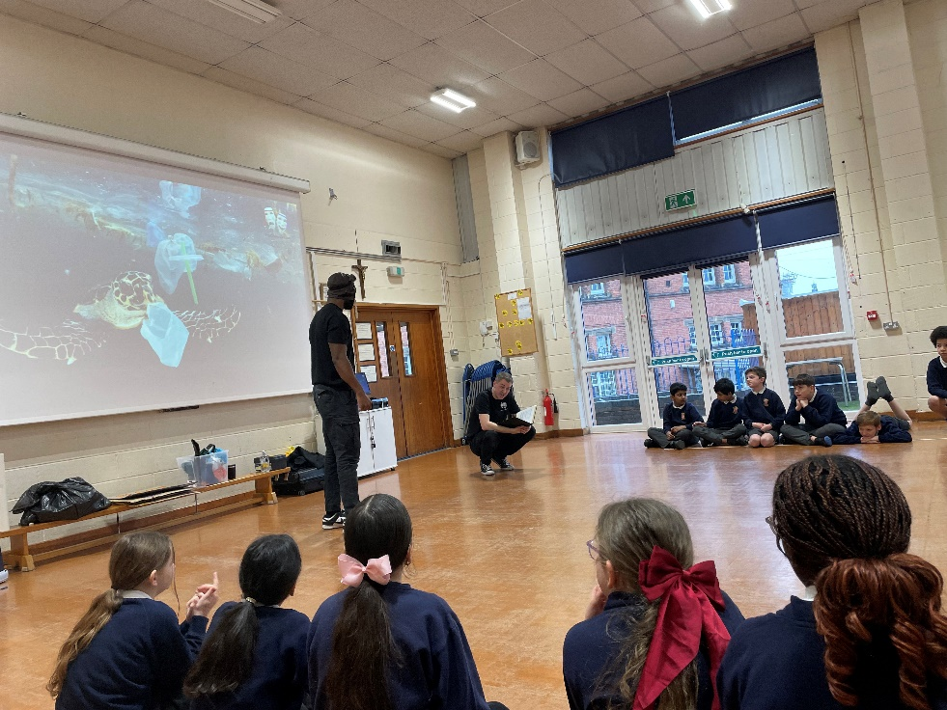

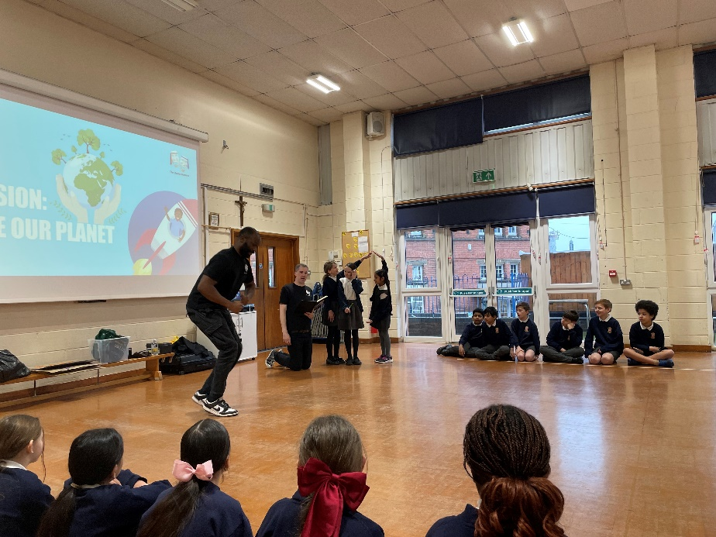

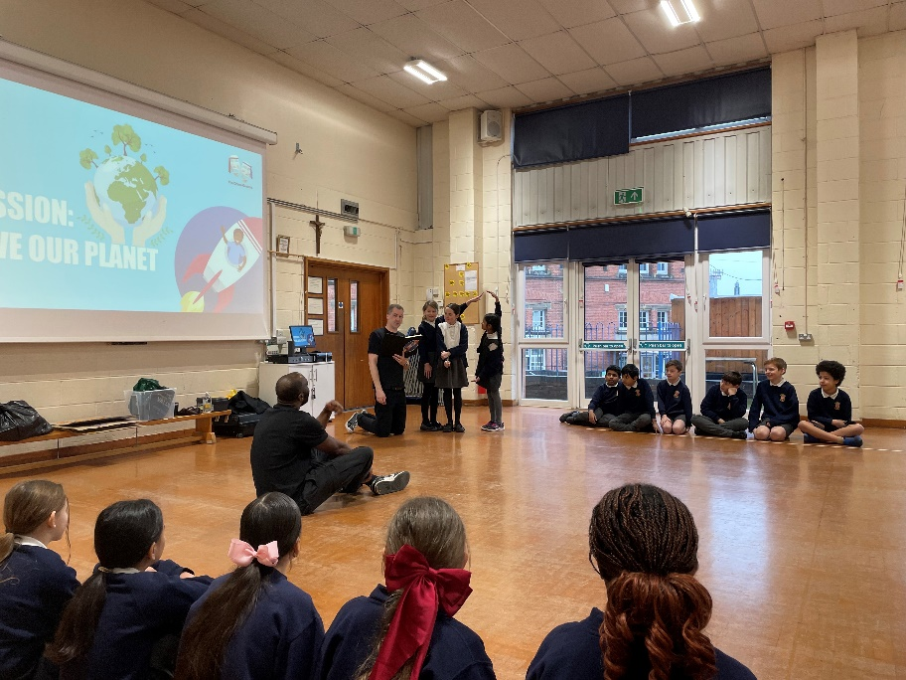

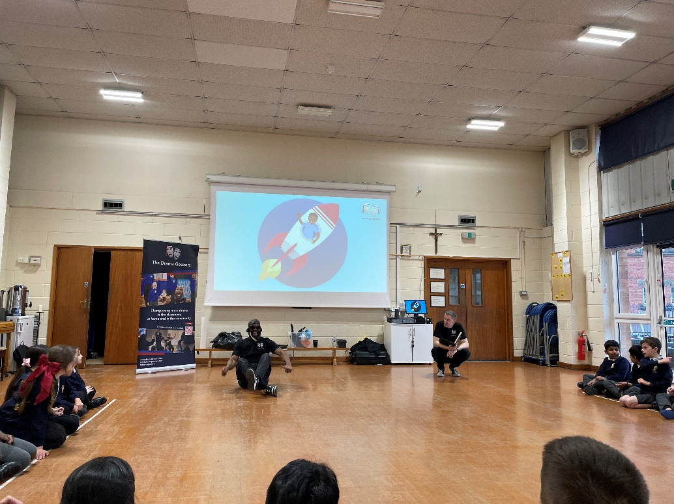

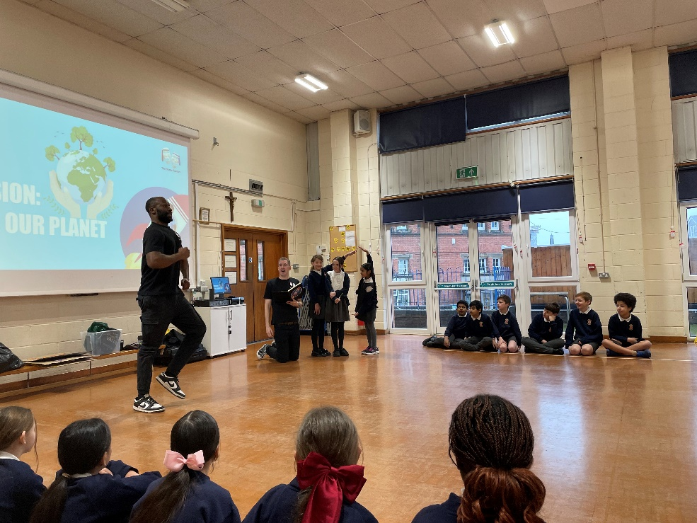

Lilac Class in the Drama Workshop were transported into animated diverse landscapes and ecological dilemmas, from deforestation to recycling, pollution, and the plight of polar ice caps. Lilac Class then drew ideas from their workshop about planetary change onto a huge piece of paper

We designed our own ‘crowns’ that we would wear made of all the beautiful things on planet Earth. We then painted what was precious to us on our planet and created a whole class freize.


