Beech Home Learning
(Due in Monday 7th October)
This week, we would like you to write a first-person description of the Great Fire of London.
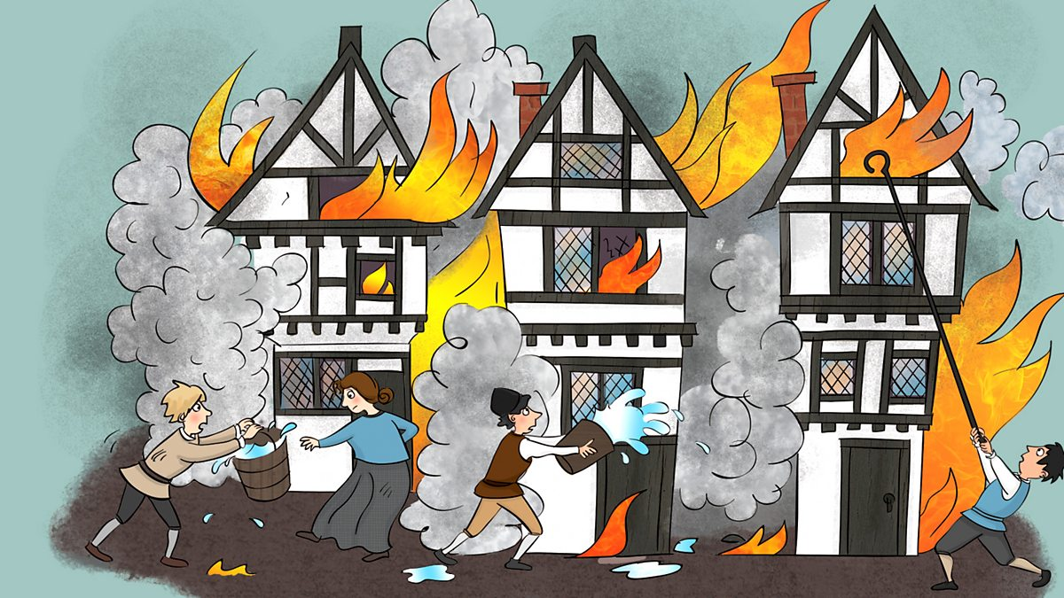
Here is Mr M’s first-person description of the Great Fire of London.

“In front of me I spotted an enormous, terrifying, black wall of smoke. All around me, I heard deafening shouts and screams. In front of my face, I felt tall, boiling, red flames. On the floor, I saw thick, sweltering, black ash. I felt scared…very scared. What an awful fire it was!”

TOP TIP: Use Mr M’s model and the sentence construction help sheet to help create your piece of writing.

