How to find the scheduled reading task on Purple Mash.
Use the following steps if the notification does not take you to the task.

1 On the home page, click on the Reading tab.


2 Next, click on the Serial Mash tab.

3 Click on the Schedule tab along the top of the screen.
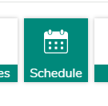
This should take you to the scheduled task. You will then be able to click on ‘Go to task’.


