Beech Class Home Learning
(Due in Monday 29th April)
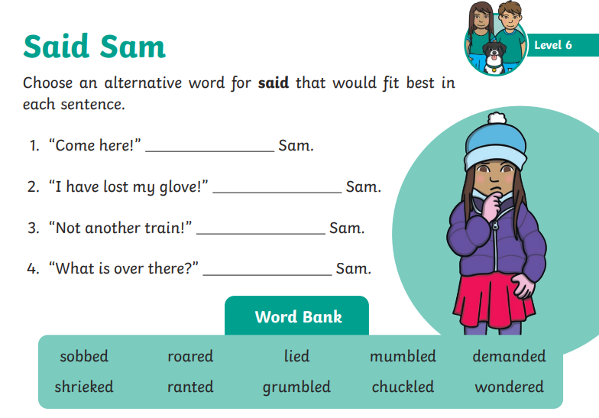
Now use 4 of these words for said to create your own short sections of speech for Sam.
e.g.
“I didn’t take the cookie” lied Sam.

