Beech Class Home Learning
(Due in Monday 9th October)
This week we would like you to write some first-person descriptive sentences about the Great Fire of London. Imagine you are Toby standing above the city. What can you see, smell and hear?
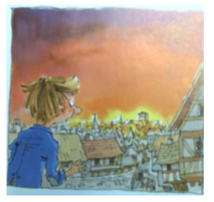
Step 1: Pick a noun-phrase to describe from the attached sheet and stick it in your home learning book.
e.g. wall of smoke
Step 2: Highlight a verb phrase and adjectives from the attached help sheet.
e.g. I saw, huge, terrifying, black
Step 3: Use the highlighted vocabulary to create your descriptive sentence.
e.g. I saw a huge, terrifying, black wall of smoke.

Extra Challenge: Can you use a prepositional phrase to add even more detail to your writing?
e.g. In the distance, I saw a huge, terrifying, black wall of smoke.

