Maple Class Homework (Due in Monday 18th September)
Here is a picture of one of the scenes that we have been focusing on this week during our English lessons.
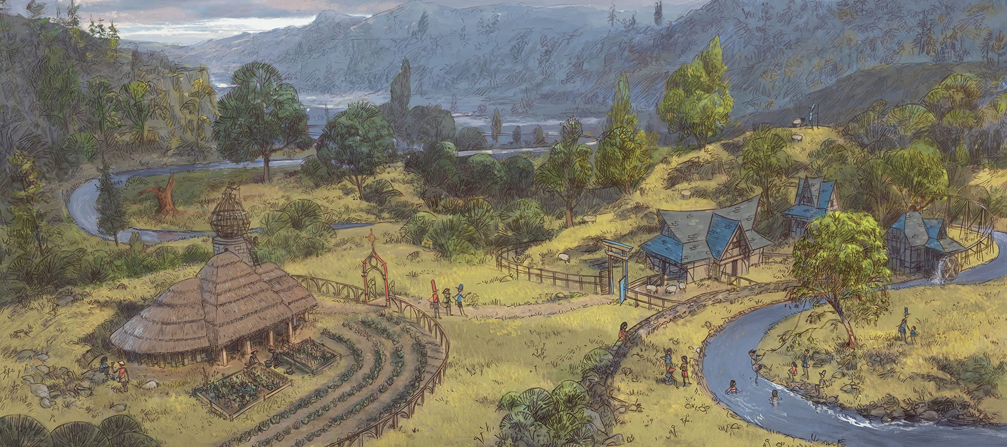
Can you think of any adjectives (describing words) that can be used to describe each noun-phrase? Try to think of at least three for each, but you can always challenge yourself to think of more for some of them!
the tree | e.g.: green, healthy
the building

the mountains

the people

the river

the sky

