Wider Curriculum Home Learning: Terms 5 and 6
This is a set of extra home learning activities for Year 1 pupils to complete. They are totally optional and families can complete as many of these activities as they like. If you complete an activity, you can either send it in via the home learning book or send it to us via the class email address. A digital copy of this document is included on the Year 1 Blog on the school website.
If you have any questions or need help with anything, please contact us using the class email address (willow@st-barnabas.kent.sch.uk).

 | Get Creative! | Let’s Find Out!
Science and Computing | Design a mini garden  Design your own mini-garden. Which plants would you include? What else would you include?  You could use an old box (a shoe box or a delivery box), some natural materials (twigs, loose tree bark, dry leaves, petals, moss, pebbles) or collage materials (newspapers, magazines) to create a 3D model.  Alternatively you could use some paper and pencils to create your design. | Investigating the parts of a plant  Find out about the different parts of a plant and why they are important. You could watch: https://www.bbc.co.uk/bitesize/topics/zpxnyrd/articles/z2vhxbk  Create a diagram or piece of explanation writing which explains about the different parts of a plant. We would love to see what you come up with!
Time and Place | Create a map of your local area  Create a map of your journey to school or of the things in the area around your home. You could use Google Maps to explore what your immediate surroundings look like from above. Consider using a map key to tell people about what you have drawn and to tell people significant locations in your area. | Write a fact file about one of the continents  Pick one of the continents (Asia, Africa, North America, South America, Antarctica, Europe or Australia) and research some information about it. Find out 3 interesting facts about it. Make a poster or write a fact file to share.
Design and the Arts | Create your own Land Art  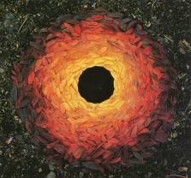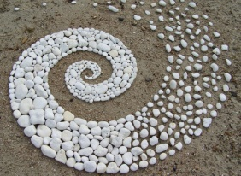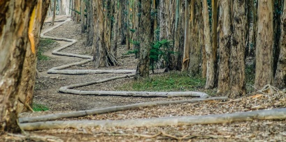  Watch the video below to see some examples of Andy Goldsworthy’s land art: https://www.youtube.com/watch?v=I59Ar1s4ZZE  Create your own artwork like Andy Goldsworthy’s using natural materials. You could make your artwork in the woods or collect sticks, leaves and stones to complete your artwork at home. | Find Out About Katerina Apale’s artwork  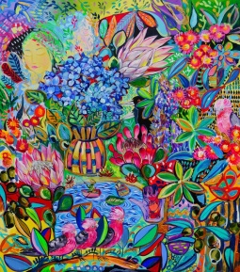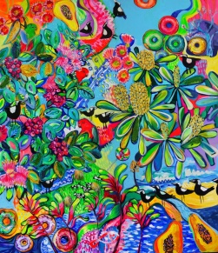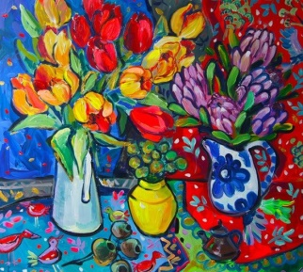  Katerina Apale uses vibrant colours and designs featuring flowers and animals. Look at some of her artwork and talk about what you like with a grown up. Find out some information about Katerina Apale and write a fact file or make your own picture/painting inspired by her artwork.
Religion and Values | Retell one of the stories you have heard  Hindu story: Rama and Sita  Retell the story of Rama and Sita to a member of your family. You could make paper puppets or draw pictures to help you tell the story.  Watch this clip to remind you of the story:  https://www.bbc.co.uk/teach/class-clips-video/religious-studies-ks1-the-hindu-story-of-rama-and-sita/zdtmnrd  You could pick another story we have learnt about if you prefer (Jonah and The Whale, David and Goliath, The Ants and The Prophet, The Crying Camel). | Caring for Animals  Some of the stories we have been talking about in RE this term are about caring for animals and showing compassion towards them.  Find out some of the things you should do to take care of animals. Design a poster to tell people what you have found out or how they can be kind to animals and avoid hurting them.
Sport, Exercise and Health | Plan Your Own Sports Day event  This term we are going to be focusing on athletic events as we get ready for Sports Day. Athletic events focus on the fundamental skills of running, throwing and jumping.  Create your own Sports Day event that can be played in your home or garden with things that you have in your home. Challenge a member of your family to a game. Remember to include a lot of moving around as it is important that your activity will keep us fit! | Find out about staying safe in the sun  Investigate the different ways of staying safe in the sun.  Watch this video to help:  https://www.bbc.co.uk/cbeebies/watch/sun-safety-for-kids  Explain to a member of your family what people should do. You could design a poster to tell people about keeping themselves safe in the sun.
Outdoor Learning | Grow your own plant  In class we have been talking about what plants need to grow (water, light, the right temperature and air). Try growing your own plants. You will need to decide what plant you want to grow and buy some seeds or bulbs. Once you have planted your seeds or plants in some soil or compost, remember to take care of them by watering them regularly. Plants can take many weeks to grow so be patient. Please take lots of photos and keep us updated on how your plants are getting on as they grow. | Investigating leaves  How many different shaped leaves can you find in the area around your home?  Use the leaf identifier to help you find out which trees they come from:  https://www.woodlandtrust.org.uk/blog/2020/03/tree-id-kids/  Which leaf did you find the most of? Which leaf did you find the least of?  You could make a graph to show what you found.

