Beech Home Learning
(Due in Monday 6th March)

Here is the description that we created to describe Sir Jake.

Long ago, in a land of monsters and mystery there lived a Knight named Sir Jake. He was a brave and fearless Knight. He was the sort of knight who helped people and saved kings. He was the sort of knight who charged into battle and killed his enemies. He was as fierce as a tiger and as clever as a fox. In his hand, he held a razor-sharp sword which he used to kill dragons. On his head, there was a shiny helmet which protected him from harm. Below him, was a strong, brown horse which he used to charge into battle. What an incredible Knight he was! However, Sir Jake had a problem. On top of a bubbling volcano, there lived…a Dragon!

For you home learning this week, we would like for you to use this model as well as the attached help sheet to create a description of the Dragon:
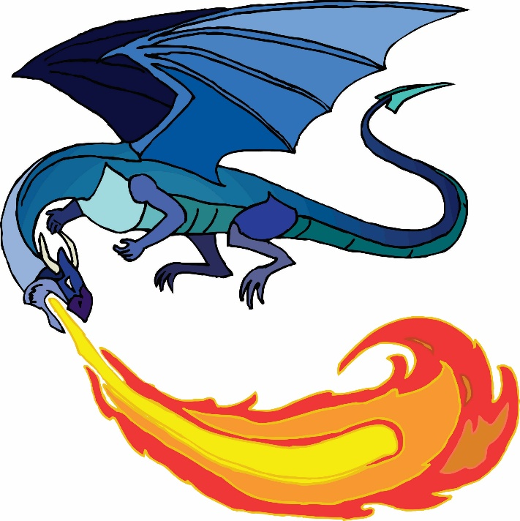

On top of a volcano | On the far side of | In a deep, dark cave
In the distance | Below the surface of the Volcano, | In the West of the island
doom | destruction | terror
monsters | beasts | fear
nightmares | horror | harm
pain | suffering | loneliness
nasty | mean | hurtful
thoughtless | horrible | destructive
evil | violent | brutal
repulsive | terrible | awful

It was the sort of dragon who ____ and ___
It was the sort of dragon who ____ and ___

It was as ______________ as a _____________________ and as ______________ as a _____________________
It was as ______________ as a _____________________ and as ______________ as a _____________________

On its body…
Covering its body…
On its head…
which it used to…
Along its back…
On its hands and feet…
In its mouth…
On its wings…

What a _______________ dragon it was!

