Autumn Term:
Year 2 Curriculum Information

Working with your child this term will be Mr Mackinnon, Mrs Banner, Mrs Johnson and Mr Borland.

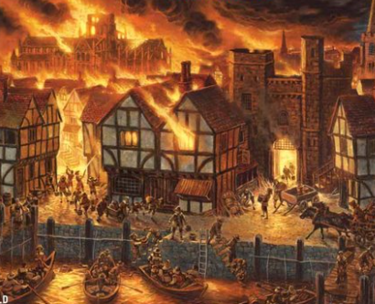

Fire and Ice: What was it like to live in London in 1666?
This unit of study looks at the city of London in the Year 1666- a year of Fire and Ice! 1666 saw the Great Fire of London and The Freezing of the River Thames. We will use skills of historical enquiry to explore a variety of sources of information to learn about 17th Century London. We will also use skills of geographical enquiry to use aerial photographs and maps to recognise landmarks and the physical and natural features of London. We will also make comparisons between modern and 17th Century London. We will examine the chroniclers of the age by examining and analysing primary evidence. We will focus our attention on two specific moments in history and learn about them in detail. We will use our writing skills to produce pieces of descriptive writing and first-person recounts charting these events. We will learn about the properties of different materials, their suitability for different purposes and the effect that extreme heat and cold can have on them.

In addition, your child will be learning about the following:

Maths – Understanding place value, Addition and Subtraction, Multiplication and Division and Fractions.
ICT – Computing systems and networks, IT around us and creating media using digital photography.
Science- Properties of everyday materials.
RE – Creation and Incarnation
Design and the Arts – Creating pieces of mixed media art.
PE- Core skills and movement, invasion games, gymnastics and infant agility, dance.

Please support your child’s learning with:

Home Learning – Home Learning books will be sent home in the week beginning 12th September. We are aiming to provide an integrated programme of home learning which utilises your child’s reading record, homework book, class blog and class email. Full details of exactly what your child’s home learning programme will look like in Beech class will be sent home in a separate home learning letter. All relevant usernames and passwords will be stuck into your child’s home learning book.

Reading – In Beech Class, we expect pupils to read at home for at least 10 minutes, 5 times per week. We ask that parents sign the reading record each time their child reads and indicate when a new reading book is required. We will change pupils reading books twice each week- on a Tuesday and a Friday. However, we ask that book bags and books are brought to school every day. New book bags can be purchased from the school office. If there is a problem with your child’s book, reading record or reading in general, please contact us via the class email address.

Just a few reminders:

PE Kit – It is essential that your child has a house T-shirt, shorts and plimsolls or trainers in school every day so that they can participate in PE activities. In addition, long tracksuit type trousers are useful in the Winter months for outside PE. Long hair needs to be tied back for PE so please ensure your child wears a hairband to school. Also, earrings need to be removed or covered with tape during PE lessons. If your child is unable to remove their own earrings, please provide some microporous tape to cover them. This term, PE will be on a Wednesday and Thursday. Please ensure that your child’s belongings are labelled.

Water Bottles
In order to help your child stay hydrated and be ready to learn, please make sure that they bring a labelled water bottle to school with them every day. We kindly ask that bottles are filled with water only- rather than juices or squash.

Pencil Cases
There is no need for your child to bring in any additional stationary. If your child requires any additional resources for a specific learning task or activity we will let you know in advance so it can be arranged.

Toys and Games
In order to help us avoid any unnecessary distractions from our learning and stay safe, we kindly request that toys and games from home are not brought into school.

If you have any concerns or queries about information included in this letter or any other matter relating to your child’s education, please do not hesitate to contact us via the class email address: beech@st-barnabas.kent.sch.uk

Many thanks,
The Beech Team

