I have written a paragraph based on a page from Journey. However, I have made lots of mistakes with punctuation and full stops. I would like you to identify and correct them.

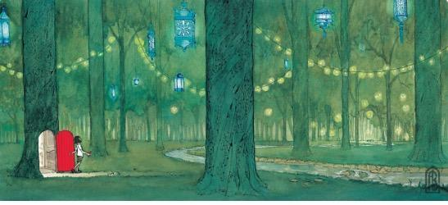
The girl opened the mysterious red door that she had

drawn she stepped out into a magical forest strung

with tiny Golden glowing lights, she was amazed. All

around were hung lanterns of different sizes that gave

made the forest seem welcoming she felt safe. A river

ran slowly in and out of the tall trees she followed it

it took her to a little wooden jetty she saw her

reflection. she also noticed the magic pen glowing

she decided that she need to draw something to help

her explore further she drew a small red wooden boat

