Beech Homework (Due in Monday 5th July)
As part of our topic learning this week, we are learning to make maps.
For homework this week, we would like you to make a map of the place where you live.
Your map could show the rooms on a floor in your house, your garden or even your local neighbourhood.
You can make the map in anyway that you want and use whatever materials you like.
Here is a video and a picture that might inspire you:
Neighbourhood Map for Kids : 7 Steps (with Pictures) - Instructables
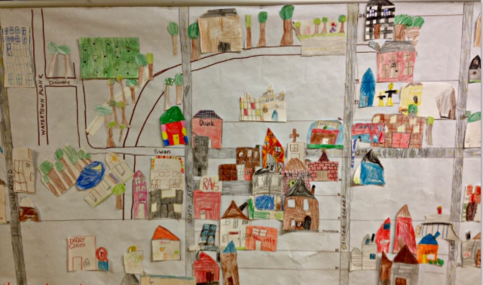

We can’t wait to see what maps you create!

