Beech Homework (Due in Monday 21st June)
This week we want you to plan a section of dialogue between Lady Emma and the Goblin.

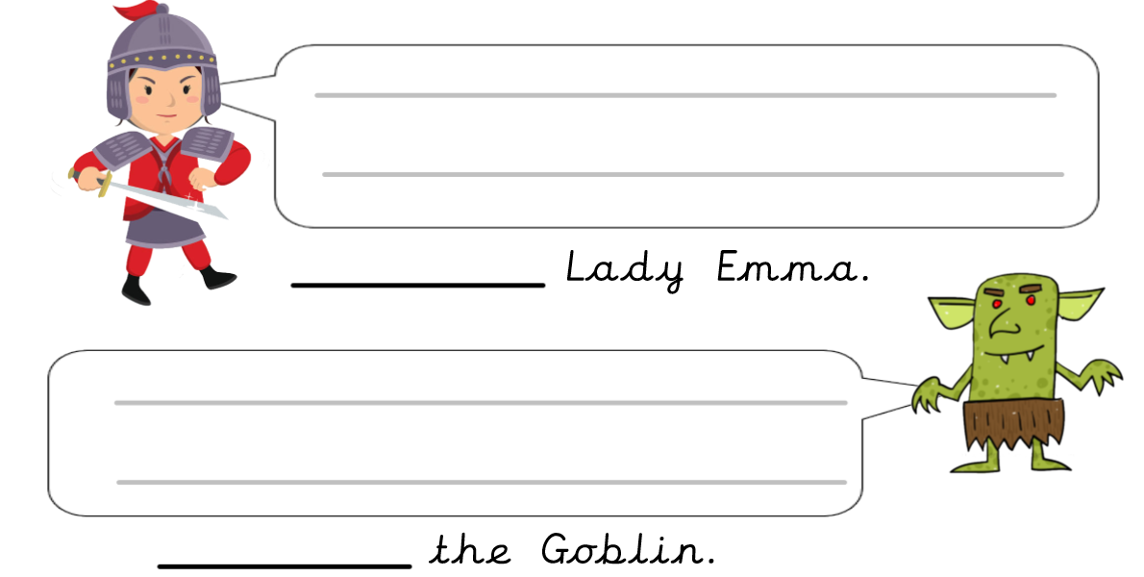

Top Tip: If you want to make your dialogue more interesting, try carefully selection a variety of synonyms for ‘said’.
EXTENSION: Can you use the rules of speech punctuation to turn this plan into a complete piece of dialogue?

