Beech Home Learning (Due in Monday after Half-Term holidays)

This week we want you to focus on making historical discoveries.

We want you to use the Bayeux Tapestry as a source of information.
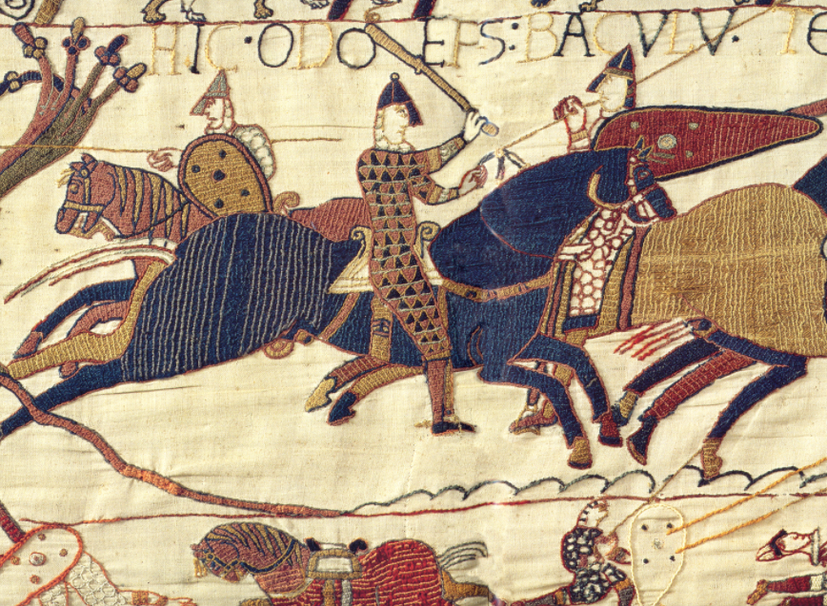

You can explore the entire tapestry by using the following link:
Explore the Bayeux Tapestry online - Bayeux Museum

Or you can watch this animated version:
The Animated Bayeux Tapestry - YouTube
(Remember- this document is on the blog so you can follow these webs by opening the digital version of the document.)

Use the tapestry to make discoveries about the Norman Invasion of England:

How did the Normans prepare to invade England?
How did the Norman army get to England?
What weapons did the Norman army use?
What did the Norman army do when it arrived in England?
Who won the battle? How do you know?

EXTENSION: Find out more about the Bayeux Tapestry. Who made it? When was it made?
Now you know more about the tapestry. How reliable do you think it is for teaching us about the Norman invasion? Can we trust it? Why? Why not?

