Build a Wheeled Vehicle
This week your challenge is to design and build a vehicle with wheels. Once toy have built the body of the vehicle and added the wheels. Think carefully about how you want the vehicle to be powered. You might want the vehicle to be powered by pushing or gravity powered. However, if you are looking for an extra challenge:
- You might like to build a wheeled vehicle powered by wind:
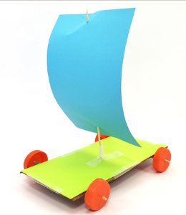
- You might like to build a wheeled vehicle powered by a balloon:
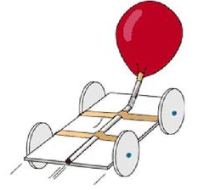
- You might like to build a wheeled vehicle powered by an elastic band:
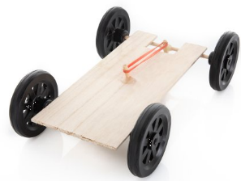
- You might even like to try and build a car which is powered by a small motor or battery:
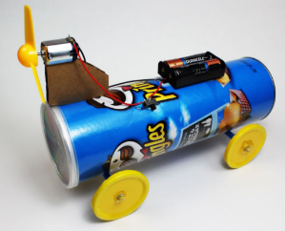
If you complete a design or build a wheeled vehicle, please send us in a picture so we can post it on your class blog and share your work in celebration assembly.

